

STOCK MARKET PREDICTION USING MULTI-SOURCE MULTIPLE INSTANCE LEARNING
QuantPulse: Short-term stock trend forecasting with LSTM, attention, news sentiment and simulated federated learning
A project report submitted in partial fulfilment of the requirements for the award of the degree of
BACHELOR OF TECHNOLOGY
in
COMPUTER SCIENCE AND ENGINEERING
Submitted by
POTTEPAKA LINGASWAMY | 23K91A05J7
MADUNA NAVEEN KUMAR | 23K91A05D7
MEEDIGERI KEERTHI | 24K95A0517
MAREDDY SAI KARTHIK | 23K91A05E8
Batch C4 (CSE-C)
Under the esteemed guidance of
K ANUSHA
[DESIGNATION]
DEPARTMENT OF COMPUTER SCIENCE AND ENGINEERING
[COLLEGE NAME]
[COLLEGE ADDRESS]
Academic year [ACADEMIC YEAR]

CERTIFICATE
This is to certify that the project report entitled "Stock Market Prediction Using Multi-Source Multiple Instance Learning" is a bonafide record of the work carried out by POTTEPAKA LINGASWAMY (23K91A05J7), MADUNA NAVEEN KUMAR (23K91A05D7), MEEDIGERI KEERTHI (24K95A0517), MAREDDY SAI KARTHIK (23K91A05E8), in partial fulfilment of the requirements for the award of the degree of Bachelor of Technology in Computer Science and Engineering, during the academic year [ACADEMIC YEAR], under my supervision.

Project Guide | Head of the Department | Principal
K Anusha | [HOD NAME] | [PRINCIPAL NAME]
[DESIGNATION] | Department of Computer Science and Engineering | [COLLEGE NAME]

External Examiner: [NAME AND SIGNATURE]
Place: [PLACE]
Date: [DATE]

DECLARATION
We hereby declare that the project report entitled "Stock Market Prediction Using Multi-Source Multiple Instance Learning", submitted to the Department of Computer Science and Engineering, [COLLEGE NAME], in partial fulfilment of the requirements for the award of the degree of Bachelor of Technology in Computer Science and Engineering, is a record of original work carried out by us under the guidance of K Anusha, [DESIGNATION]. The results embodied in this report have not been submitted to any other university or institution for the award of any degree or diploma.

POTTEPAKA LINGASWAMY 23K91A05J7
MADUNA NAVEEN KUMAR 23K91A05D7
MEEDIGERI KEERTHI 24K95A0517
MAREDDY SAI KARTHIK 23K91A05E8

Place: [PLACE]
Date: [DATE]

ACKNOWLEDGEMENT
We express our sincere gratitude to our project guide, K Anusha, [DESIGNATION], for valuable guidance, encouragement and constructive suggestions throughout this project.
We thank [HOD NAME], Head of the Department of Computer Science and Engineering, for providing the facilities and support needed to complete this work, and [PRINCIPAL NAME], Principal, [COLLEGE NAME], for the encouragement given to us.
We thank the project coordinators and all faculty and staff members of the department for their help, and our families and friends for their constant support.
We also acknowledge the authors of the base paper and of the multiple-instance-learning papers that this work builds on, the creators of the FNSPID news dataset used in the offline study, and the maintainers of the open-source software used in this project (TensorFlow, PyTorch, scikit-learn, statsmodels, Prophet, Hugging Face Transformers, yfinance, FastAPI, React, Vite, Recharts, pandas and Playwright).

POTTEPAKA LINGASWAMY
MADUNA NAVEEN KUMAR
MEEDIGERI KEERTHI
MAREDDY SAI KARTHIK

ABSTRACT
Short-term stock forecasts are wanted by investors and analysts, but price history alone ignores the news that moves markets, and labelling every article is impractical. This project builds QuantPulse, a working forecasting product that implements the pipeline of the base paper (Nejatbakhsh and Aliasgari, IEEE Access, 2026): an LSTM over twenty-day price windows, a four-head attention layer, a FinBERT-tone sentiment channel and a simulated federated-averaging stage, compared with ARIMA, SARIMAX, Prophet, random forest and SVR on ten tickers. A FastAPI service with seven endpoints and a six-screen React website present 5- and 30-day forecasts with confidence bands, model comparison and sentiment.
Measured honestly, the shipped models do not beat repeating yesterday's close: over five seeds the best deep tier has a mean absolute error of $29.37 per share against $6.24 for persistence, and its directional accuracy on real closes is 53 %, not the 67 % the application displays, because the application clips test targets to the training range. A forward test of the stored 5-day forecasts against the closes that followed found a mean forecast change of -14.8 % against a realised -0.4 % and a correct trend flag for 4 of 10 tickers. The base paper's R2 of 0.91 was not reproduced; the datasets and protocols differ. The sentiment channel of the product rests on synthetic template headlines because no news key was set.
Multiple Instance Learning, the formulation named in the title, is not implemented in the product. It was studied offline on real FNSPID headlines, treating each ticker-day as a bag with a bag-level next-day direction label: over 1,309 test days on 7 tickers, mean, max and gated-attention pooling reached 48.8-50.1 % accuracy, like the price-only LSTM, while always predicting up scores 53.6 %. No evidence of a gain from news was found at this sample size. 56 automated tests and 26 smoke checks pass.
Keywords: stock market prediction, multiple instance learning, LSTM, attention, FinBERT sentiment, federated averaging, financial news, forecast evaluation.

TABLE OF CONTENTS
CERTIFICATE i
DECLARATION ii
ACKNOWLEDGEMENT iii
ABSTRACT iv
TABLE OF CONTENTS v
LIST OF FIGURES viii
LIST OF TABLES x
LIST OF ABBREVIATIONS xi
1. INTRODUCTION 1
1.1 Domain Overview 1
1.2 Background and Motivation 1
1.3 Problem Statement 2
1.4 Need for the Project 2
1.5 Objectives 2
1.6 Scope of the Work 3
1.7 Contributions 3
1.8 Limitations and Assumptions 4
1.9 Status of the Objectives 5
1.10 Organisation of the Report 5
2. LITERATURE SURVEY 6
2.1 Overview 6
2.2 Base Paper Analysis 6
2.3 Related Work by Theme 7
2.4 Datasets and Algorithms Used in the Surveyed Work 9
2.5 Strengths and Limitations of Existing Approaches 9
2.6 Research Gap 10
3. FEASIBILITY STUDY 11
3.1 Introduction 11
3.2 Technical Feasibility 11
3.3 Economic Feasibility 12
3.4 Operational Feasibility 13
3.5 Schedule Feasibility 13
3.6 Risk Analysis 13
3.7 Advantages and Constraints 14
4. SYSTEM REQUIREMENTS AND ANALYSIS 15
4.1 Existing System and its Limitations 15
4.2 Proposed System and its Advantages 15
4.3 Functional Requirements 16
4.4 Non-Functional Requirements 16
4.5 Hardware Requirements 17
4.6 Software Requirements 17
4.7 User Roles 18
4.8 Data Requirements 18
4.9 Interface Requirements 18
4.10 Use Cases 19
4.11 Existing and Proposed Systems Compared 19
4.12 Constraints and Assumptions 19
5. SYSTEM DESIGN 20
5.1 Design Goals and Architecture 20
5.2 High-Level Workflow 22
5.3 Data Flow Diagrams 23
5.4 Module, Sequence and Use-Case Design 25
5.5 Data Design 27
5.6 Core Algorithm Design 28
5.7 Module Design of the Website 30
5.8 API Design 31
5.9 User Interface Design 31
5.10 Design Trade-offs and Known Weaknesses 32
6. METHODOLOGY AND SOFTWARE IMPLEMENTATION 33
6.1 Overall Methodology 33
6.2 Dataset 34
6.3 Preprocessing 35
6.4 Algorithm Choice and Justification 36
6.5 Mathematical Formulation 36
6.6 Model Architecture and Training 38
6.7 Multiple-Instance Learning Study (Offline) 39
6.8 Evaluation Protocol 39
6.9 Application Architecture 40
6.10 API Design 41
6.11 Front-End Implementation 41
6.12 Security and Error Handling 42
6.13 Installation and Execution 42
7. SYSTEM TESTING 44
7.1 Testing strategy 44
7.2 Unit testing 44
7.3 Integration testing 45
7.4 Functional testing of the screens 46
7.5 Security testing 46
7.6 Validation and edge cases 46
7.7 Performance testing 47
7.8 User acceptance 49
7.9 Findings from testing 49
7.10 Limits of the testing done 49
8. RESULTS AND OUTPUT SCREENS 51
8.1 Experimental set-up 51
8.2 Output screens 51
8.3 Model performance as shipped 54
8.4 Re-run on the same training rows: true scoring, persistence and seeds 55
8.5 Forward test: the stored forecasts against the closes that followed 57
8.6 What the sentiment channel contains 58
8.7 Comparison with the base paper 59
8.8 Multiple-instance learning on real headlines (offline study) 60
8.9 Sample inputs and outputs 63
8.10 Success and failure analysis 63
8.11 Limitations of the results 64
8.12 Objectives against outcomes 64
9. CONCLUSION 66
9.1 Summary of the work 66
9.2 Objectives achieved and not achieved 66
9.3 Key findings 67
9.4 Lessons learned 70
9.5 Practical applications 70
9.6 Known limitations 70
10. FUTURE SCOPE 71
10.1 Improvements to the existing system 71
10.2 Additional features 71
10.3 Scalability and deployment 72
10.4 Further research 73
10.5 A suggested order of work 73
REFERENCES 75
APPENDIX A: IMPORTANT CODE 77
A.1 Windows and scalers (`models_dl.py`) 77
A.2 Attention tier and training (`models_dl.py`) 77
A.3 Federated averaging (`federated.py`) 77
A.4 Recursive forecast with confidence band (`forecast.py`) 78
A.5 Aligning sentiment to trading dates (`sentiment.py`) 78
A.6 Scoring against the real closes (`scripts/run_experiments.py`) 78
A.7 Gated-attention pooling of a bag of headlines (`scripts/mil_study.py`) 78
APPENDIX B: INSTALLATION AND USER GUIDE 79
B.1 Requirements 79
B.2 One-click start 79
B.3 Manual start 79
B.4 Using the screens 79
B.5 Checking, retraining and experiments 80
B.6 Troubleshooting 80
APPENDIX C: ADDITIONAL SCREENS 81

LIST OF FIGURES
Figure 1: Four-tier architecture of QuantPulse: React website, FastAPI application with seven JSON endpoints, pipeline modules, and JSON / CSV / Keras files, with three external services. 21
Figure 2: Offline training pipeline (python -m backend.train) in two stages, then serving of the JSON artefacts to the website. 22
Figure 3: Context diagram (DFD level 0): one process, the trader or analyst, the evaluator or developer, and three external data sources. 23
Figure 4: DFD level 1: seven processes (acquire prices, score sentiment, fit baselines, train deep tiers, federated averaging, forecast and write artefacts, serve) and three data stores. 23
Figure 5: DFD level 2: process 4.0, training of one deep tier, expanded into seven sub-processes. 24
Figure 6: UML class diagram: the backend is a set of function modules, so modules are drawn as boxes with their functions, together with the React API client, ApiError and the useAsync hook. 25
Figure 7: Sequence diagram: the user opens the Forecast screen; the page calls /api/tickers, then /api/forecast and /api/history in parallel; history goes live to Yahoo Finance. 26
Figure 8: Use-case diagram with the trader or analyst, the evaluator or developer, and three external services. 27
Figure 9: Logical entity-relationship diagram: QuantPulse has no database, so the entities are rows inside CSV and JSON files. 27
Figure 10: Flowchart of recursive_forecast: predict, roll the window, repeat, inverse-scale, add the 1.96 x residual std x sqrt(h) band and set the trend. 29
Figure 11: Flowchart of get_daily_sentiment: live NewsAPI headlines or the labelled synthetic fallback, FinBERT-tone or lexicon scoring, and alignment to the trading dates. 29
Figure 12: Architecture of the two network families (LSTM, and LSTM with four-head attention) and of the simulated FedAvg stage. 30
Figure 13: Landing page in the light theme. 32
Figure 14: Landing page in the dark theme. 32
Figure 15: Offline training pipeline (python -m backend.train) in two stages, then serving of the JSON artefacts to the website. 34
Figure 16: Architecture of the two network families (LSTM, and LSTM with four-head attention) and of the simulated FedAvg stage. 38
Figure 17: Sequence diagram: the user opens the Forecast screen; the page calls /api/tickers, then /api/forecast and /api/history in parallel; history goes live to Yahoo Finance. 40
Figure 18: Median and 95th-percentile response time of each endpoint (log scale). 48
Figure 19: Landing page: live price chart and entry to the application. 52
Figure 20: Method and data screen: universe, pipeline and model table. 52
Figure 21: Dashboard: one card per ticker with last close, trend, 5-day outlook and data mode. 52
Figure 22: Dashboard scrolled to the ticker grid. 52
Figure 23: Forecast screen for NVDA: close at forecast, day-5 forecast, band, trend, controls and the notice about the training date. 52
Figure 24: TSLA 5-day forecast: actual closes (solid), forecast (dashed), band. 53
Figure 25: TSLA forecast table: predicted close, band, actual close and forecast miss. 53
Figure 26: MSFT 30-day forecast (horizon = long). 53
Figure 27: Model comparison for NVDA: best-model tiles and deep-model ablation chart. 54
Figure 28: Deep-model metrics table for NVDA with the best MAE highlighted. 54
Figure 29: Training tab: loss curves and federated rounds. 54
Figure 30: News sentiment for TSLA: source, headlines scored, average score. 54
Figure 31: True-target MAE of LSTM + attention (five seeds) against persistence, per ticker. 56
Figure 32: Share of test closes above the training maximum per ticker, and shipped against true directional accuracy. 56
Figure 33: Predicted against actual 5-day change per ticker. 57
Figure 34: Actual closes and the stored 30-day forecast for each ticker (forecast starts at the 8 September close). 58
Figure 35: Non-zero sentiment rows in the training and test parts for each ticker, and the TSLA channel over time. 59
Figure 36: Base paper's reported figures next to the measured ones. The datasets and protocols differ, so the bars are not a like-for-like comparison. 60
Figure 37: Accuracy of each model in the MIL study; the dashed line is the always-up rate (53.6 %). 61
Figure 38: Precision, recall and F1 of the models in the MIL study. 62
Figure 39: True-target MAE of LSTM + attention (five seeds) against persistence for each ticker. 68
Figure 40: Stored 5-day forecast change against the realised change for each ticker (forward test from 2026-09-08). 68
Figure 41: Offline MIL study: accuracy of each model against the always-up rate on the pooled test quarters. 69
Figure 42: Offline MIL study: accuracy difference to the price-only LSTM with 95 % bootstrap intervals. 69
Figure 43: Additional screen: dashboard, dark theme. 81
Figure 44: Additional screen: AAPL forecast, dark theme. 81
Figure 45: Additional screen: Method and data, with the modelling pipeline timeline, the live installation facts and the research-and-education notice (the per-ticker data table is below the fold). 81

LIST OF TABLES
Table 1: Abbreviations used in this report xi
Table 2: Status of the six batch objectives 5
Table 3: Literature summary 9
Table 4: Strengths and limitations of the main approaches 9
Table 5: Technical risks and the measurements that addressed them 12
Table 6: Cost view of the project 12
Table 7: Project phases and status 13
Table 8: Project risks and mitigations 13
Table 9: Functional requirements 16
Table 10: Non-functional requirements and their status 17
Table 11: Hardware used and recommended 17
Table 12: Software versions used 17
Table 13: User roles 18
Table 14: Data used by the system 18
Table 15: API interface 18
Table 16: Principal use cases 19
Table 17: Comparison of the existing practice and QuantPulse 19
Table 18: Backend modules and their roles. 25
Table 19: Contents of one ticker's record in artifacts/metrics.json. 28
Table 20: Website modules. 30
Table 21: API routes. 31
Table 22: Screens and their data sources. 32
Table 23: Datasets used and their roles. 35
Table 24: Algorithms, the reason for each and what was observed. 36
Table 25: Hyper-parameters (config.py, models_dl.py, federated.py, forecast.py). 38
Table 26: Design of the study. 39
Table 27: Routes, parameters and responses. 41
Table 28: Test levels, tools and results. 44
Table 29: Unit tests of the pipeline modules, grouped (tests/test_pipeline.py). 44
Table 30: Edge cases and their handling. 47
Table 31: API response times (milliseconds, 127.0.0.1, one uvicorn worker). 48
Table 32: Data used in the evaluation. 51
Table 33: Shipped test metrics, mean over ten tickers (MAE and RMSE in dollars; direction is the product's own figure). 54
Table 34: Re-run, ten-ticker mean per seed, then mean ± std over 5 seeds (dollars). 55
Table 35: Stored 5- and 30-day forecasts against what happened (change in % from the 8 September close; MAE in dollars over the horizon). 57
Table 36: Forward test of the re-trained tiers (ten tickers x five seeds) and of the shipped artefact: mean absolute error in dollars and mean predicted 5-day change. 58
Table 37: Sentiment channel per ticker in the training run (rows of the 501-row series). 59
Table 38: Base paper against this project: what is comparable and what is not. 59
Table 39: Directional prediction on 1,309 pooled test samples (mean ± std over 5 seeds; threshold 0.5; positive class = up). 61
Table 40: Paired bootstrap against the same-window price-only LSTM: accuracy difference in percentage points (95 % interval, 2,000 resamples of the seed-averaged predictions). 62
Table 41: The six objectives of the batch against what was achieved. 64
Table 42: Batch objectives against the outcome 66
Table 43: Headline measurements behind the findings 69
Table 44: Roadmap 73
Table 45: Screens and how to use them 79
Table 46: Common problems 80

LIST OF ABBREVIATIONS
Table 1: Abbreviations used in this report
Abbreviation | Expansion
AI | Artificial Intelligence
API | Application Programming Interface
ARIMA | Autoregressive Integrated Moving Average
AUC | Area Under the ROC Curve
CORS | Cross-Origin Resource Sharing
CPU | Central Processing Unit
CSV | Comma-Separated Values
DFD | Data Flow Diagram
EMH | Efficient-Market Hypothesis
ER | Entity-Relationship
FedAvg | Federated Averaging
FL | Federated Learning
FNSPID | Financial News and Stock Price Integration Dataset
GAP | Global Average Pooling
HTTP | Hypertext Transfer Protocol
JSON | JavaScript Object Notation
LSTM | Long Short-Term Memory
MAE | Mean Absolute Error
MAPE | Mean Absolute Percentage Error
MIL | Multiple Instance Learning
ML | Machine Learning
MSE | Mean Squared Error
OHLCV | Open, High, Low, Close, Volume
PCA | Principal Component Analysis
R2 | Coefficient of determination
RF | Random Forest
RMSE | Root Mean Squared Error
SARIMAX | Seasonal ARIMA with eXogenous variables
SPA | Single-Page Application
SVR | Support Vector Regression
UI | User Interface
UML | Unified Modeling Language

1. INTRODUCTION

1.1 Domain Overview
Stock-market prediction is the task of estimating how the price of a listed share will move. Prices are set continuously by buyers and sellers who react to company results, macro-economic data, market mood and news, so the series is noisy, non-stationary and, according to the efficient-market hypothesis [23], hard to forecast from its own past alone. Even so, short-horizon forecasts are wanted by retail investors, portfolio managers and risk teams, and the field has moved from statistical models such as ARIMA [27] and additive decomposition [24], through machine-learning regressors such as random forests [25] and support vector regression [26], to recurrent networks [12], [18] and attention-based sequence models [13]. Systematic reviews [19], [20] show that deep learning dominates recent work while also warning that reported gains depend heavily on the evaluation protocol.
A second thread of research adds text. Media tone has been linked to returns [21], social-media mood has been used to predict an index [22], and domain-specific language models such as FinBERT [17], [16] turn a headline into a positive, neutral or negative score. This project belongs to the intersection of the two threads: prices are a numeric sequence, headlines are text, and the question is whether combining them gives a better short-term forecast than prices alone.

1.2 Background and Motivation
The batch title, Stock Market Prediction Using Multi-Source Multiple Instance Learning, is taken from the work of Zhang et al. [6], who combined price data, news events and social-media sentiment for a Chinese index and treated the day's news as a set of instances whose individual labels are unknown. Multiple Instance Learning (MIL) [9] is the natural formulation for news: on a given day a company may appear in dozens of articles, only a few of which matter, and nobody labels each article as bullish or bearish. The learner receives a bag of articles with a single outcome label (the price moved up or down) and must work out which instances carried the signal. Attention-based pooling [10] lets a network learn that weighting, and it also shows which headlines the model relied on.
The base paper named for this batch, Y. Nejatbakhsh, M. Aliasgari - IEEE Access, vol. 14, 2026 [1], is a more recent and more practical design: an LSTM over twenty-day price windows, a multi-head attention layer, a FinBERT-tone sentiment channel, and a simulated federated-averaging stage over ten stocks, reported to reach an average R2 of 0.91. QuantPulse, the product built for this batch, implements that pipeline as a working website, and the project then asks what the title asks: does a multi-source, multiple-instance treatment of daily news add anything? The motivation is therefore twofold: to turn a research pipeline into something a trader or analyst can open in a browser, and to test its claims on data the base paper did not use.

1.3 Problem Statement
Price-only models miss the news and sentiment that move markets; labelling each news article individually is impractical and noisy; financial data is volatile and non-stationary, so models degrade quickly; and a prediction that is not explained is not actionable for an investor. The problem is to build a system that forecasts short-term stock movement from historical prices together with financial news, that is evaluated honestly against simple baselines, and that presents its forecasts, errors and caveats clearly to a user.

1.4 Need for the Project
Three needs motivate the work. First, a research result is of little use until it can be run and inspected: the base paper reports its figures but offers no application, so QuantPulse provides one, with ten tickers, five classical baselines, four deep-model tiers and 5- and 30-day forecasts with confidence bands. Second, the base paper's sentiment experiments rest on thirty days of headlines, because the news service it uses returns about a month of history [1]; the need is to see what happens when the sentiment channel is exercised properly. Third, forecasts are easy to publish and hard to check: a forecasting tool should be tested against the prices that actually followed and against a no-change forecast, and this project does both.

1.5 Objectives
The six objectives set in the batch document are:
1. Collect historical prices together with financial news and social-media text for the target stocks
2. Preprocess and align the multi-source data into daily instances grouped per trading day
3. Represent each trading day as a bag of news instances under the Multiple Instance Learning formulation
4. Train a hybrid model combining sequence learning over prices with attention over news content
5. Predict directional movement and evaluate with accuracy, precision, recall and F1-score
6. Compare multi-source performance against a price-only baseline
Section 1.9 and Chapter 8 state, objective by objective, what was achieved. In short, the product covers prices, a daily sentiment channel, a hybrid LSTM-attention model and a four-tier ablation, while the multiple-instance formulation, the social-media source and the precision, recall and F1 evaluation are not part of the product and were examined in a separate offline study.

1.6 Scope of the Work
In scope: daily Yahoo Finance prices for ten technology-heavy tickers (TSLA, AAPL, AMZN, MSFT, GOOGL, NVDA, META, FDX, IBM, ORCL); five classical baselines (ARIMA, SARIMAX, Prophet, random forest, SVR); an LSTM, an LSTM with four-head attention, the same with a daily FinBERT-tone sentiment channel, and a hybrid trained by simulated federated averaging; 5- and 30-day forecasts with a confidence band; a FastAPI service with seven JSON endpoints; a six-screen React website; unit, API and smoke tests; and an offline multiple-instance study on real headlines.
Out of scope: trading, order execution or portfolio advice (QuantPulse is a research and education tool, not financial advice); intraday data; social-media text, for which no data source was available; authentication; a database; real federated deployment across institutions; and any claim of profitability.

1.7 Contributions
1. A working end-to-end implementation of the base paper's hybrid pipeline for ten tickers, with a FastAPI service and a six-screen React website that shows forecasts, bands, model comparison and sentiment.
2. A pinned-data, five-seed re-run of the shipped pipeline with a persistence baseline, showing that no deep tier beats "tomorrow equals today" on real closes (persistence MAE $6.24 against $29.37 for the best deep tier).
3. A forward test of the shipped forecasts against the closes that followed: the stored 5-day forecasts averaged -14.8 % against a realised -0.4 %, and the trend flag was right for 4 of 10 tickers.
4. Identification of three evaluation defects in the shipped pipeline (clipped test targets, an empty training sentiment channel, differently scaled federated clients), documented rather than hidden.
5. An offline multiple-instance-learning study on real FNSPID headlines, with mean, max and gated-attention pooling, a flat-sentiment baseline, a shuffled-bag placebo and precision, recall and F1 reported over five seeds.
The findings in brief. On the ten tickers the stored deep-model scores look respectable when read from the application: the best deep tier shows a directional accuracy of 67 %. In a five-seed re-run of the same pipeline scored against the real closes, it falls to 53 %, because the application clips the test targets to the training price range. The mean absolute error of the best deep tier is $29.37 per share, against $6.24 for repeating yesterday's close. In the forward test the 5-day forecasts missed by $59.04 on average, against $11.09 for a no-change forecast, and 9 of 10 tickers were flagged as falling although the realised mean change was -0.4 %. These are results of the shipped pipeline as the base paper describes it, measured on two years of data rather than one month, and they do not reproduce the paper's R2 of 0.91.
For the multiple-instance question, 1,309 test days across 7 tickers were used. Accuracy ranged from 48.8 % to 50.1 % for the price-only LSTM, the flat-sentiment model, the three pooling variants and the shuffled-bag placebo, while predicting "up" every day scores 53.6 %. No evidence was found that a bag of real headlines improves next-day direction at this sample size. The result is reported as it came out; it is a statement about this data and this sample, not about whether news matters.

1.8 Limitations and Assumptions
The limitations that matter most are listed here and developed in Chapters 7 to 9. Multiple Instance Learning is not implemented in the product. The sentiment channel of the product is built from template headlines generated by a fallback, because no NewsAPI key was configured, and these headlines exist only for the last 90 trading days of each series. Forecast quality was measured and is poor. The MIL study uses seven tickers, two years of dense news and 1,309 test samples, so differences smaller than about three accuracy points cannot be told from noise. Federated learning is simulated in one process, as in the base paper.
The assumptions are that Yahoo Finance daily bars are accurate and complete, that trading days are the unit of prediction, that a chronological 80/20 split reflects deployment, that headlines with a day-level time stamp were available before the next day's close, and that the machine used for all measurements (Intel Core i5-12500, 15.7 GB of memory, no graphics card, Windows 11) is representative of an ordinary workstation.

1.9 Status of the Objectives
Table 2: Status of the six batch objectives
No. | Objective | Status in this project
1 | Collect prices, news and social-media text | Partly: prices yes; news only as NewsAPI headlines when a key is set, otherwise synthetic template headlines; no social-media source
2 | Align into daily instances per trading day | Partly: daily alignment yes, but headlines are averaged into one number per day in the product; bags exist only in the offline study
3 | Represent each day as a bag (MIL) | Not in the product. Done offline: mean, max and gated-attention MIL on real headlines (Chapter 8)
4 | Hybrid sequence model with attention | Yes: LSTM + four-head attention + sentiment channel + simulated FedAvg (attention is over the price window, not over news)
5 | Directional prediction with accuracy, precision, recall, F1 | Product: price level and an up/down flag only. Precision, recall and F1 reported in the offline study
6 | Multi-source versus price-only baseline | Product ablation exists but its sentiment is synthetic; the valid comparison is the offline study, which found no gain

1.10 Organisation of the Report
Chapter 2 surveys the literature and analyses the base paper. Chapter 3 assesses feasibility and Chapter 4 sets out the requirements and the existing and proposed systems. Chapter 5 presents the design, with architecture, data-flow, UML, entity and interface designs. Chapter 6 describes the methodology and the software implementation, including the mathematical formulation. Chapter 7 reports system testing. Chapter 8 gives the results and output screens, including the re-run, the forward test and the multiple-instance study, and compares them with the base paper. Chapter 9 concludes and Chapter 10 outlines future scope. The report ends with the references and three appendices: important code, installation and user guide, and additional screens.

2. LITERATURE SURVEY

2.1 Overview
The survey has four purposes: to understand the base paper in depth, to place it among earlier work on price forecasting, text-based sentiment and multiple-instance learning, to identify the datasets and algorithms worth reusing, and to find the gap this project addresses. The base paper, the two companion papers archived with this batch (Zhang et al. [6] and Liao et al. [7]) were read in full from their PDFs. The arXiv abstract of Deng and Yiu [8] was read. The batch literature survey lists four further papers, [2] to [5]; their bibliographic records were checked, but no abstract or full text could be read, so they appear below by title only and nothing is claimed for their results. Items quoted from the base paper's own related-work section are marked as reported there.

2.2 Base Paper Analysis
Title. Enhancing Stock Market Prediction With Hybrid Deep Learning: Integrating LSTM, Transformer Attention, Federated Learning, and Sentiment Analysis. Authors and venue. Y. Nejatbakhsh, M. Aliasgari - IEEE Access, vol. 14, 2026 (pp. 3926-3942, doi 10.1109/ACCESS.2025.3649668) [1].

2.2.1 Aim and approach
The paper benchmarks traditional forecasters (ARIMA, SARIMAX, Prophet, random forest, support vector regression, exponential smoothing) against an LSTM on ten technology and logistics companies, then enlarges the LSTM in three steps: a multi-head Transformer-style attention layer for long-range dependence, a FinBERT-tone sentiment channel computed from financial headlines, and a simulated federated-learning stage in which each company is a client and the global model is formed by weighted averaging (FedAvg [14]). The argument is that price history alone cannot show news-driven shocks, that attention helps select informative time steps, and that federated training preserves the privacy of institutional data.

2.2.2 Data and preprocessing
Daily open, high, low, close, adjusted close and volume were downloaded from Yahoo Finance [33] for Tesla, Apple, Airbnb, Amazon, FedEx, IBM, Microsoft, Nvidia, Oracle and Google. Two windows were used: the full history up to 4 January 2024 for 30-day forecasts, and a six-month window from 6 July 2023 to 4 January 2024 (127 trading days) for short-term work. Because the news service returned only thirty days of headlines, the hybrid model was trained on a one-month window. Features were scaled to [0, 1] with Min-Max scaling and turned into supervised samples with a sliding window of previous trading days; baselines used an 80/20 chronological split and the hybrid a 70/15/15 split. Headline scores from FinBERT-tone were aligned to trading days and concatenated with the price features.

2.2.3 Models
The baseline LSTM has one LSTM layer of 64 units, batch normalisation and a single linear output neuron that predicts the next close. The enhanced model passes the sequence through an LSTM, a dropout layer and a multi-head attention layer, pools the result by global average pooling, applies dense layers and concatenates the sentiment features; the federated stage averages the clients' weights in proportion to their sample counts, wt+1 = sum_i (n_i / n) w_i, once per communication round. The paper reports that LeakyReLU worked better than sigmoid, tanh or ReLU in its trials.

2.2.4 Reported results
The hybrid model is reported to reach an average R2 of 0.91 over the ten companies, with every company above 0.84; for Tesla the paper gives MSE 0.039, MAE 0.179 and R2 0.888 in scaled units. The baseline LSTM's average 5-day trend accuracy is 65.36 % over 100 runs per company, with large spread (Airbnb 94 %, Google 86 % at the top and Tesla 34.9 %, IBM 18 % at the bottom). Prophet scored a 5-day R2 of -0.7126, worse than a mean predictor. In the ablation, adding attention is said to reduce the MSE by nearly 20 % against the baseline, and each further component (sentiment, federated averaging) to improve it again; the ablation table itself is an image in the paper and its figures are not quoted here.

2.2.5 Strengths and limits stated by the paper
The strengths are the breadth of the comparison, the modular design and the explicit directional metric. The authors themselves list four limitations: the unpredictability of markets in stress periods, sentiment restricted to a thirty-day window by the news API, federated learning that is only simulated, and results that vary between companies. The reported metrics are on very short test spans (the last part of a one-month window for the hybrid model), which is why the paper's R2 values cannot be compared directly with any longer test set.

2.3 Related Work by Theme

2.3.1 Statistical and machine-learning forecasters
ARIMA and SARIMAX [27] model a series by its own lags and seasonality; Prophet [24] fits an additive trend and seasonality decomposition; random forests [25] and support vector regression [26] learn non-linear maps from lagged prices. They are cheap and a necessary baseline, but the base paper itself notes that they are ill-suited to abrupt moves. A central caution from the literature on market efficiency [23] is that a one-step forecast that repeats the last price is hard to beat, so any new model should be compared with a no-change forecast, which the text of the base paper does not report and this project does.

2.3.2 Deep sequence models
LSTM networks [12] became the standard deep baseline for price sequences; Fischer and Krauss [18] applied them to market prediction at scale, and the surveys [19], [20] review dozens of variants. Attention [13] lets a model weight time steps, and the base paper stacks it on an LSTM. The surveys also point to the main hazard: results depend strongly on the split, the window length and the scaling, and it is easy to evaluate a model on a test range the scaler has not seen.

2.3.3 Text and sentiment
Tetlock [21] linked the tone of a newspaper column to market returns and Bollen et al. [22] used Twitter mood to predict an index. FinBERT [17], [16] is a BERT model further trained on financial text; the fine-tuned tone version used here outputs the probability that a sentence is positive, neutral or negative. The usual way to feed it to a price model, followed by the base paper, is to average a day's headline scores into one number per day.

2.3.4 Multiple-instance learning and news fusion
Multiple-instance learning was introduced by Dietterich et al. [9] for problems in which labels attach to bags of instances; Ilse et al. [10] added a learned attention weight over the instances. Zhang et al. [6] applied it to the stock market with three sources: index-level price data, news events and Xueqiu social-media sentiment. On the Shanghai Composite Index for 2015 and 2016, using 38,727 and 39,465 news articles and about 6.2 million posts, their multi-source MIL model is reported to improve F1 by 6.9 % and 9.2 % over their nMIL baseline for the two years. Deng and Yiu [8] treat each trading day as a bag of news instances with a bag-level label for S&P 500 direction. Liao et al. [7] pool the daily news with self-attention for six Taiwan Stock Exchange stocks plus a US set and report that pooling lowers the mean absolute error on normalised prices from 0.1913 to 0.1777, a 7.11 % reduction.
The remaining batch survey items [2], [3], [4], [5] concern hybrid models with news and social-media sentiment, a language-model approach to news and price data, multimodal fusion for the Chinese market and text mining of news with investor sentiment. They indicate the direction of recent work, but they could not be read beyond their titles and are not used for any comparison.

2.3.5 Federated learning
Federated averaging [14] trains a shared model across clients without moving the clients' data, and Yang et al. [15] survey the concept. In the base paper each company is one client in a single-process simulation. That demonstrates the algorithm but not communication cost, client drift or privacy guarantees.
Table 3: Literature summary
Work | Year | Approach | Finding / limitation
Nejatbakhsh, Aliasgari [1] (base paper) | 2026 | LSTM + multi-head attention + FinBERT-tone sentiment + simulated FedAvg; ten companies | Average R2 0.91; baseline LSTM trend accuracy 65.36 %; sentiment limited to 30 days
Zhang et al. [6] | 2018 | Multi-source MIL model: news events, Xueqiu sentiment, index data; Shanghai index | F1 +6.9 % / +9.2 % over nMIL (2015 / 2016); one Chinese index, event extraction needed
Deng, Yiu [8] | 2022 | Each trading day is a bag of news instances, bag-level label; S&P 500 direction | Reports better trend accuracy than baselines (abstract); news only, no price branch stated
Liao et al. [7] | 2026 | Attentive pooling of all daily news with stock-name queries; one model for many stocks | 7.11 % lower MAE (0.1913 to 0.1777) with pooling; six TWSE stocks plus BigData23
Officioso et al. [3] | 2026 | Large-language-model news sentiment combined with market data (title only) | Batch survey item; abstract not available, results not quoted
Chang [4] | 2025 | Financial sentiment and feature fusion for Chinese-market prices (title only) | Batch survey item; abstract not available, results not quoted
Xiao [5] | 2024 | Financial news, text mining and investor sentiment for prediction (title only) | Batch survey item; abstract not available, results not quoted
Batch item [2] | 2024 | Hybrid AI with news, social-media sentiment and corporate indicators (title only) | Authors not in Crossref; abstract not available, results not quoted
Fischer, Krauss [18] | 2018 | LSTM networks for financial market prediction (cited by the base paper for LSTM) | LSTM suited to price sequences; used here only as the LSTM reference, no numbers quoted
Dong et al. (FNSPID) [11] | 2024 | Large public dataset of financial news aligned with stock prices | Source of the real headlines in this project's offline MIL study

2.4 Datasets and Algorithms Used in the Surveyed Work
Prices come from Yahoo Finance [33] in the base paper and in this project; the FNSPID dataset [11] supplies more than a decade of headlines tagged with ticker symbols and is the real-news source for the offline study in this project. Headlines are scored with FinBERT-tone [35]. The algorithms reused are the LSTM, multi-head attention, FedAvg, gradient-based optimisers [28], [29], the five classical baselines, and, for the offline study, mean, max and gated-attention pooling in the multiple-instance setting [10]. Implementation uses TensorFlow [30], PyTorch [31] and scikit-learn [32].

2.5 Strengths and Limitations of Existing Approaches
Table 4: Strengths and limitations of the main approaches
Approach | Strength | Limitation
Classical statistical / ML [27], [25] | Cheap, fast, interpretable baselines | Weak on abrupt moves; level forecasts rarely beat no-change
LSTM [12] | Captures non-linear sequence dependence | Sensitive to window, scaling and split; many seeds needed
LSTM + attention + sentiment [1] | Combines price and news tone; modular | Daily average of headlines; sentiment window of 30 days; short test span
Simulated FedAvg [14] | Shows decentralised training in principle | One process; no communication cost or privacy analysis
Multi-source MIL [6] | Bag formulation avoids article-level labels | Event extraction; one Chinese index; not an LSTM price branch
Attentive news pooling [7] | Weights relevant articles; one model for many stocks | Price regression on normalised prices; small stock set

2.6 Research Gap
Reading the literature against the batch objectives yields the following gaps, which define what this project attempts.
1. The base paper averages a day's headlines into one number; it does not treat the day's news as a bag of instances with only a bag-level label
2. As far as their descriptions show, the day-bag multiple-instance models [8], [6] are not paired with an LSTM price branch and multi-head attention as in the base paper
3. Sentiment is tested over a 30-day window only in the base paper; archived multi-year headline data are not used there [1], [11]
4. Reported gains are mostly price-level errors; a direction metric with precision, recall and F1 against a price-only baseline is the project's stated objective
5. Evaluation against a naive no-change forecast is rarely reported next to R2, although a level forecast one step ahead can score a high R2 by tracking the last price
QuantPulse covers the first part of that gap by implementing the base paper's pipeline as a product and testing it on two years of data. The multiple-instance formulation is not part of the product; it is examined in an offline study on real headlines, whose design and outcome are reported in Chapters 6 and 8.

3. FEASIBILITY STUDY

3.1 Introduction
This chapter asks whether QuantPulse can be built, run and maintained with the resources at hand. The question is answered partly by argument and partly by measurement: the system was built and run on a single office desktop with no graphics card, and the figures below were taken on that machine.

3.2 Technical Feasibility
Hardware. Every measurement in this report was taken on an Intel Core i5-12500 (6 cores, 12 threads) with 15.7 GB of memory, integrated graphics and Windows 11. No CUDA device was used, so the training pipeline (ten tickers, three deep tiers and a federated stage) runs on the CPU. Smaller machines were not tested; the machine was shared with other jobs during several runs, so timings are indicative.
Software. All components are mature open-source packages: Python 3.11, TensorFlow and Keras for the LSTM and attention models, scikit-learn, statsmodels and Prophet for the baselines, transformers with PyTorch for FinBERT-tone inference, yfinance for prices, FastAPI with uvicorn for the service, and React with Vite and Recharts for the website. They install from public package indexes, and run.bat creates the environment, trains the models if the artefacts are missing, and starts both servers.
Data. Daily prices are free through Yahoo Finance [33]. News is the weak point: the news service used by the base paper [34] returns about a month of history on its free tier and needs a key. Without a key QuantPulse falls back to labelled synthetic headlines. A public alternative with real headlines exists (FNSPID [11]); it was used for the offline study but not inside the product.
Model size and training effort. The models are small by current standards. Each ticker supplies 501 rows, which become 481 windows of twenty days, of which 384 are used for training (about 330 after the validation hold-out), and the networks have one 64-unit LSTM layer with, in the attention tiers, a four-head attention layer. Early stopping with a patience of seven epochs ended training after 20 epochs on average for the plain LSTM and 17 for the attention tier in the five-seed re-run, and in the five-seed re-run the four single-ticker tiers of one ticker trained in about a minute or less on the shared CPU machine. This is the main reason the technical side of the project is feasible without a graphics card; it is also a warning, because a few hundred windows are a small sample for a deep network.
Evidence from measurement. The technical risks were tested directly:
Table 5: Technical risks and the measurements that addressed them
Risk | Measurement | Verdict
Training too slow without a GPU | A full five-seed re-run of ten tickers, four deep tiers and the federated stage took 34 minutes on the shared CPU machine; the README quotes 5-10 minutes for one training run | Feasible
API too slow for a live website | Stored-result endpoints answer in about 11 ms (median), the 76 KB all-metrics payload in 13 ms | Feasible
Live price download inside a request | /api/history re-downloads from Yahoo Finance on every call: median 139 ms, first call 680 ms | Feasible but wasteful
Sentiment scoring on demand | /api/sentiment scores headlines with FinBERT on each call: median 4.6 s, first call 6.0 s | Slow; the UI shows a loading state
Forecast accuracy good enough to use | Mean 5-day MAE $59.04 against $11.09 for a no-change forecast; trend flag right for 4 of 10 tickers | Not feasible as shipped
Real news available for training | None in the product (synthetic fallback); 46,532 real FNSPID headline rows were obtained for the offline study | Partly feasible

Environment risks that did occur. TensorFlow fails to initialise its libraries on this Windows machine if scikit-learn or SciPy are imported before it, so the tests and experiment scripts import TensorFlow first. Newer NumPy releases are incompatible with this TensorFlow version, which pins NumPy 1.26 and in turn limits the parquet library that could be used for the news data. Both were solved by import order and version pins; neither affects a user who runs the application through run.bat.

3.3 Economic Feasibility
The software is free of licence cost, the price source is free, and the whole project ran on one existing workstation. The only optional paid item is a news API key for live headlines; the free tier is enough for a demonstration but covers a single month. Hosting needs one process and no database or GPU. The recurring cost of a production deployment would be dominated by a licensed news and price feed, which the project does not include. Development effort was student time.
Table 6: Cost view of the project
Item | Cost | Comment
Python, TensorFlow, PyTorch, scikit-learn, FastAPI, React | Free (open source) | Installed from public package indexes
Daily prices | Free | Yahoo Finance through yfinance; terms of use apply and the data are for research and education
Live news headlines | Free tier or paid key | NewsAPI free tier covers about a month; not set in this project
Historic headlines for the offline study | Free | FNSPID subset read from a public mirror; licence listed as 'other' on the mirror card, used for research only
Compute | Existing workstation | No GPU or cloud instance was rented

3.4 Operational Feasibility
The intended users are a trader or analyst who wants to read forecasts and an evaluator or developer who wants to retrain and inspect the models. The first group needs only a browser: the website has six screens with ticker tabs, a horizon switch and tables that can be sorted. The second group needs Python 3.11 and Node.js 20 and runs python -m backend.train or run.bat. The service has no authentication and no database, which makes it easy to run and unsuitable for exposure to the internet as it stands. 56 automated tests and 26 smoke checks pass, which makes day-to-day maintenance practical.

3.5 Schedule Feasibility
The work was organised in the phases below. The batch calendar was not recorded in the project files, so no dates or durations are claimed; the table shows the order of the phases and their status.
Table 7: Project phases and status
Phase | Content | Status
1 | Literature survey, base-paper reading, objectives | Done
2 | Data loader, ten-ticker universe, five classical baselines | Done
3 | LSTM, attention tier, sentiment module, federated averaging, training pipeline | Done
4 | FastAPI service with seven endpoints | Done
5 | React website, six screens, light and dark themes | Done
6 | Automated tests, smoke test, screenshots | Done
7 | Evaluation: five-seed re-run, forward test, multiple-instance study on real news | Done in the documentation run
8 | Documentation: decks, chapters, report, paper | Done

3.6 Risk Analysis
Beyond the technical risks above, the project carries risks that are about the data and the interpretation of results rather than the software. They are listed with the mitigation actually used.
Table 8: Project risks and mitigations
Risk | Effect | Mitigation used
Live price download fails or changes the data window | Artefacts older than the CSVs; inconsistent charts | Bundled CSV fallback; a banner on the forecast screen; a pinned snapshot for the experiments
No news key | Sentiment channel is synthetic | Source shown on screen (built-in fallback); documented as a limitation; real headlines used only offline
Short, trending series | Test prices above the training range; clipped scaling | Identified and reported; true-target scoring added in the re-run
Over-reading a small test set | Spurious gains reported as findings | Five seeds, bootstrap intervals, placebo and always-up baselines in the offline study
Misuse as financial advice | Losses to users | Disclaimer on the site and in the report: research and education only

3.7 Advantages and Constraints
The advantages are that the whole pipeline is reproducible on modest hardware, uses only open components, and is fast to serve because it stores its results. The constraints are the news data (a month of live headlines, synthetic fallback otherwise), the short two-year price history, the absence of a social-media source, the CPU-only training, and the fact that the forecasts themselves are not accurate enough to act on. These constraints are carried into the limitations in Chapters 7 to 9.

4. SYSTEM REQUIREMENTS AND ANALYSIS

4.1 Existing System and its Limitations
In practice the existing approaches are of three kinds. Retail investors use charting platforms and statistical indicators that look only at prices. Researchers use statistical and machine-learning forecasters such as ARIMA, Prophet, random forests and support vector regression [27], [24], [25], [26] or LSTM networks [12], usually as scripts or notebooks. The base paper [1] adds attention, a FinBERT-tone sentiment channel and simulated federated learning, again without an application. Multi-source multiple-instance models [6], [8] treat news as bags but are research systems.
1. Price-only forecasters ignore the news and opinion that move prices
2. The base paper's sentiment experiments cover only 30 days because the news API returns a month of history [1]
3. The base paper's federated learning is a single-process simulation, and its hybrid results rest on a one-month window [1]
4. The multiple-instance stock models surveyed use event extraction for one Chinese index [6] or financial news alone [8]
5. Several surveyed systems are known to us by title only; their results could not be verified [2]-[5]

4.2 Proposed System and its Advantages
QuantPulse turns the base paper's pipeline into a usable system: one command trains ten tickers and writes artefacts; a FastAPI service serves metrics, forecasts, history and sentiment; and a six-screen website shows the forecast chart with its confidence band, the actual closes that followed, the comparison of nine models, and the sentiment channel with its source. Compared with the scripts it replaces it offers an inspectable interface, a stored set of results, explicit labelling of data and news sources, and automated tests. It also exposes its own errors: the forecast table shows the actual close and the forecast miss for every day since the forecast date.
The proposed system deliberately differs from the batch title in one respect that has to be stated clearly: it does not implement Multiple Instance Learning. Its attention layer operates over the twenty-day price window, its sentiment is one averaged score per day, and it has no social-media source. The multiple-instance formulation was therefore studied in a separate offline experiment on real headlines, which found no evidence of a gain over a price-only LSTM (accuracy between 48.8 % and 50.1 % for all variants against 53.6 % for always predicting up).
In operation the system has five stages. Data loading obtains two years of daily bars per ticker and labels their origin. The baseline stage fits the classical models on the first 80 % of rows. The deep stage scales the features to the unit range with scalers fitted on the training part, cuts twenty-day windows, trains the three tiers with early stopping, and then trains the federated hybrid by averaging ten client models over two rounds of three local epochs. The forecast stage rolls the last window forward five and thirty steps and widens a confidence band with the square root of the horizon. The serving stage writes everything to JSON artefacts, which the API returns and the website draws. Separating training from serving is what makes the application fast, and it is also why it can show forecasts that are older than the latest price, a situation the forecast screen explains with a banner.

4.3 Functional Requirements
The functional requirements follow from the objectives and from the scope in Chapter 1. Each is traced to the module that implements it, so that the testing chapter can check them one by one.
Table 9: Functional requirements
ID | Requirement | Where implemented
FR-1 | Load daily OHLCV for each ticker of the configured universe (default ten), preferring a live download, then a bundled CSV, then a labelled synthetic series | data_loader.py; mode returned with every record
FR-2 | Train and evaluate five baselines (ARIMA, SARIMAX, Prophet, random forest, SVR) on a chronological 80/20 split | baselines.py
FR-3 | Train an LSTM, an LSTM with four-head attention, the same with a sentiment channel, and a federated hybrid | models_dl.py, federated.py
FR-4 | Compute a daily sentiment score from news headlines with FinBERT-tone, using NewsAPI when a key is set and a labelled synthetic fallback otherwise | sentiment.py
FR-5 | Produce 5- and 30-day close forecasts with a confidence band and an up/down trend flag per ticker | forecast.py, /api/forecast
FR-6 | Report MAE, MSE, RMSE, R2 and directional accuracy for every model and ticker | metrics.json, /api/metrics
FR-7 | Serve price history with the forecast overlay | /api/history
FR-8 | Serve daily sentiment and recent headlines per ticker | /api/sentiment
FR-9 | Reject malformed tickers (400), unknown tickers (404), bad horizons or ranges (422) and missing artefacts (503) with a clear message | main.py
FR-10 | Provide six website screens: landing, dashboard, forecast, model comparison, news sentiment, method and data | frontend/src/pages
FR-11 | Allow retraining with one command and regeneration of all artefacts | python -m backend.train

4.4 Non-Functional Requirements
The non-functional requirements describe how well the functions must work. The status column is honest about the one that is not met: accuracy. A forecasting product that is not more accurate than a no-change forecast does not satisfy its main quality requirement, and the report does not hide this.
Table 10: Non-functional requirements and their status
ID | Quality | Criterion and evidence | Status
NFR-1 | Responsiveness | Stored-result endpoints under 50 ms median; measured 11-13 ms | Met
NFR-2 | Reproducibility | Fixed seeds, pinned data snapshot for the experiments, chronological splits; synthetic headlines need PYTHONHASHSEED fixed | Partly met
NFR-3 | Honesty of display | Data mode (live / csv / synthetic) and news source shown on screen; stale-artefact banner on the forecast screen | Met
NFR-4 | Portability | Windows 10/11 with Python 3.11 and Node 20; Docker files provided but not exercised in this run | Partly met
NFR-5 | Testability | 56 pytest tests and 26 smoke checks pass | Met
NFR-6 | Security | Input validation on ticker symbols and ranges; CORS limited to localhost; no authentication, no TLS in the demo | Partly met
NFR-7 | Accuracy | Forecast error below a no-change forecast: 5-day MAE $59.04 versus $11.09 | Not met

4.5 Hardware Requirements
Table 11: Hardware used and recommended
Item | Used for all measurements | Minimum suggested
Processor | Intel Core i5-12500, 6 cores / 12 threads | 4 cores
Memory | 15.7 GB | 8 GB (FinBERT and TensorFlow load about 2-3 GB together)
Graphics | Integrated; not used | None required
Disk | About 3 GB for environment and models | 5 GB free
Network | Needed for Yahoo Finance and the first FinBERT download | Broadband

The "minimum suggested" column is an estimate, not a tested minimum; only the first column was measured.

4.6 Software Requirements
Table 12: Software versions used
Component | Version
Python | 3.11.9
FastAPI / uvicorn | 0.141.1 / 0.52.4
TensorFlow / Keras | 2.16.2 / 3.15.1
scikit-learn | 1.9.0
statsmodels / Prophet | 0.15.0 / 1.4.0
transformers / PyTorch (CPU) | 4.47.1 / 2.5.1
yfinance | 1.7.0
pandas / NumPy | 3.0.5 / 1.26.4
React / Vite / Recharts | 19 / 8 / 3
Node.js | 20 or newer

The operating system was Windows 11. The browser used for screenshots and checks was Chromium / Chrome. A Python 3.11 virtual environment and Node.js are created or required by run.bat.

4.7 User Roles
Table 13: User roles
Role | Needs | Interface
Trader / analyst | Read forecasts, bands and trend flags; compare models; see the news tone; check how earlier forecasts fared | Website (six screens)
Evaluator / developer | Retrain, run tests, inspect artefacts, re-run experiments, call the API directly | Command line, JSON API, /docs

There are no accounts and no login screen; any visitor to the running site sees everything. This is acceptable for a local demonstration but would have to change before any shared deployment, where at least authentication, request limits and transport security would be needed. The evaluator role is deliberately separate from the trader role because the experiments (the five-seed re-run, the forward test and the multiple-instance study) are run from the command line against pinned data and are not available from the website.

4.8 Data Requirements
Table 14: Data used by the system
Data | Source | Granularity and size | Use
Prices (Open, High, Low, Close, Adj Close, Volume) | Yahoo Finance via yfinance | Daily; 501 rows per ticker for the shipped artefacts (2024-09-09 to 2026-09-08); ten tickers | Training, evaluation, charts
Headlines for the sentiment channel | NewsAPI if a key is set, otherwise 11 built-in templates | 166-191 synthetic headlines per ticker for the last 90 trading days | Daily FinBERT-tone mean as one extra input
Pinned price snapshot for experiments | Yahoo Finance | 534 rows per ticker (2024-09-09 to 2026-10-23) | Re-run and forward test
Real headlines for the offline study | FNSPID news portion | 46,532 headline rows for seven tickers, dense from 2022 | Multiple-instance study
Stored results | artifacts/ JSON, Keras and plots | metrics.json (76 KB), forecasts.json, ten serving models | Served by the API

4.9 Interface Requirements
Table 15: API interface
Method and path | Purpose | Errors
GET /api/health | Status, tickers, news source | -
GET /api/tickers | Universe with last close, trend and data mode | -
GET /api/metrics, /api/metrics/{ticker} | Per-ticker baselines, deep tiers, histories, forecasts | 400, 404, 503
GET /api/forecast/{ticker}?horizon=short|long | 5 or 30 forecast rows with bands | 400, 404, 422
GET /api/sentiment/{ticker} | Sentiment meta, 30 daily scores, headlines | 400
GET /api/history/{ticker}?days=20..500 | OHLCV plus forecast overlay | 400, 422

The website talks to the service only through this JSON interface, from the same origin (the development server proxies /api). The interface has no write operations: users cannot change models, data or settings from the browser, which keeps the attack surface small.

4.10 Use Cases
Table 16: Principal use cases
ID | Use case | Actor | Outcome
UC-1 | See the forecast universe | Trader / analyst | Dashboard shows last close, trend and 5-day outlook per ticker
UC-2 | Inspect one forecast | Trader / analyst | Chart with confidence band, forecast table and, where available, the actual closes since the forecast date
UC-3 | Compare models | Trader / analyst | Nine models ranked by MAE, R2 and direction; training curves and federated rounds
UC-4 | Check news tone | Trader / analyst | Daily sentiment series, source label and headline list with tone
UC-5 | Retrain and test | Evaluator / developer | New artefacts, test and smoke results, experiment JSON files

4.11 Existing and Proposed Systems Compared
Table 17: Comparison of the existing practice and QuantPulse
Aspect | Existing practice | QuantPulse
Access | Scripts and notebooks | Browser website and JSON API
Models shown together | One or two per study | Five baselines and four deep tiers for ten tickers
Data labelling | Rarely stated | Mode (live / csv / synthetic) and news source on screen
Checking forecasts | Offline, by the author | Actual closes and forecast miss shown for each day since the forecast date
News handling | Daily average score, or bags in MIL research systems | Daily average score in the product; bags only in the offline study
Testing | Seldom described | 56 unit/API tests, 26 smoke checks

4.12 Constraints and Assumptions
The system is constrained by the availability and quality of free data (Yahoo Finance prices, a month of live news or synthetic headlines), by CPU-only training, by a two-year price history that gives about 400 training rows per ticker, and by the absence of a social-media source. It assumes that daily bars are complete, that a chronological split approximates deployment, and that users understand the forecasts are statistical estimates for research and education and not financial advice.

5. SYSTEM DESIGN
This chapter describes how QuantPulse is built: the architecture and workflow, the data flow, the module, sequence and use-case design, the data design, the three core algorithms, the module and API design and the user interface. Every diagram was drawn from the code in backend/ and frontend/src/ and is reproduced with an explanation; the full set is also collected in the Block Diagrams document. Two facts about the design are stated at the outset because they shape everything below. QuantPulse has no database and no authentication: all state is files, and the website is open. And it has no multiple-instance-learning component: news enters the model as one averaged sentiment number per trading day, so the design follows the base paper [1] rather than the multiple-instance formulation that the project title and objectives describe. The offline study that addresses that formulation is a separate script, described in Chapter 6.

5.1 Design Goals and Architecture
Five goals shaped the design. First, reproduce the base paper's pipeline as a usable product: ARIMA, SARIMAX, Prophet, Random Forest and SVR baselines, an LSTM, a multi-head-attention LSTM, a sentiment channel from FinBERT-tone headlines and a simulated federated-averaging stage, all on ten technology and logistics tickers [1]. Second, fast screens: training takes minutes on a CPU, so it is run offline once and the web tier serves stored JSON, which is why most endpoints answer in about ten milliseconds (Chapter 7). Third, say where the data came from: every ticker carries a mode label (live, csv or synthetic), the sentiment source is shown on its own screen, and the Forecast screen warns when the stored forecast starts before the newest price. Fourth, run on a laptop without a GPU, which fixed the choice of CPU TensorFlow, PyTorch for FinBERT inference only, and small networks. Fifth, keep it replaceable: every hyper-parameter is in config.py, and the ticker universe is an environment variable.
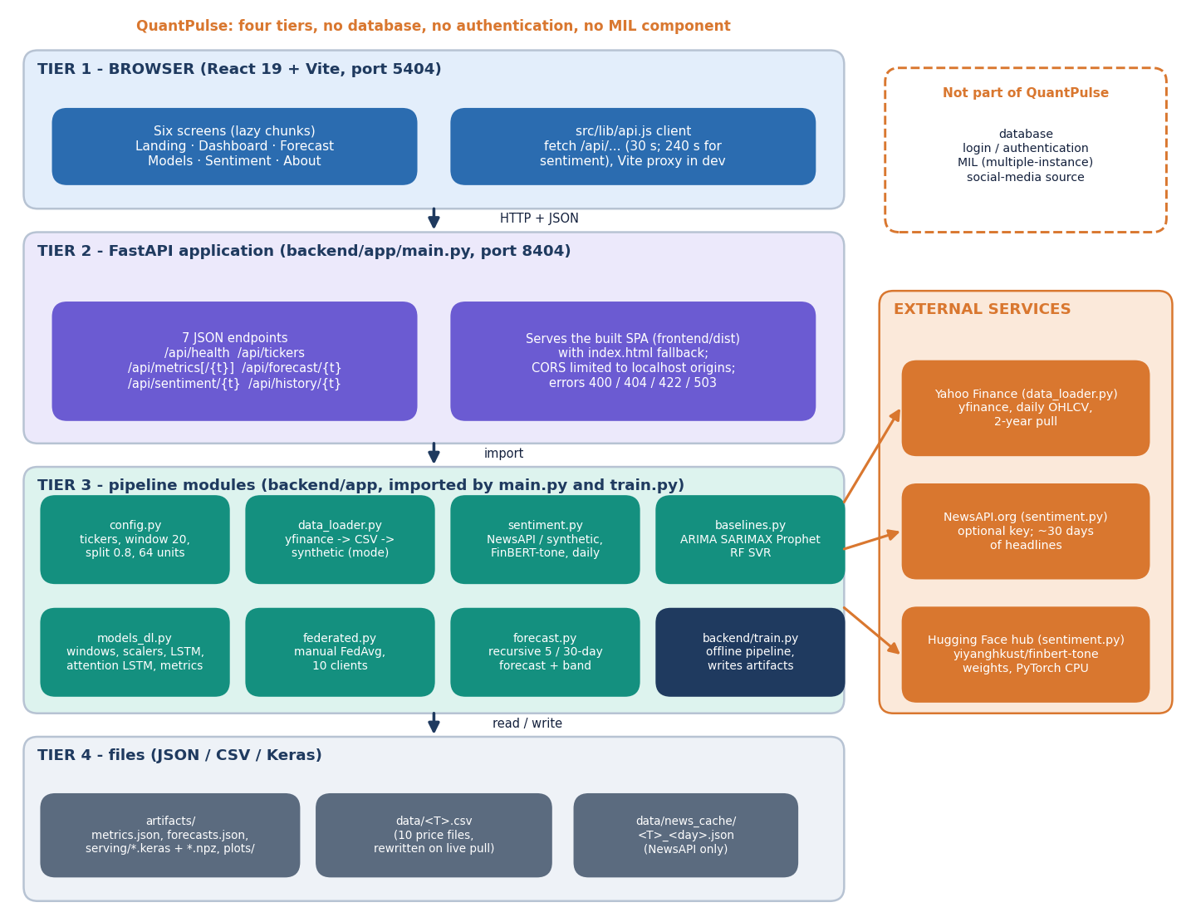
Figure 1: Four-tier architecture of QuantPulse: React website, FastAPI application with seven JSON endpoints, pipeline modules, and JSON / CSV / Keras files, with three external services.
The browser tier is a React 19 and Vite single-page website on port 5404 with six screens; its api.js client calls the backend under /api and Vite proxies the calls in development. The FastAPI application on port 8404 offers seven JSON endpoints (health, tickers, metrics, per-ticker metrics, forecast, sentiment and history) and also serves the built website with an index.html fallback. Underneath, the pipeline modules config, data_loader, sentiment, baselines, models_dl, federated and forecast are imported by main.py and by the offline training script train.py. State lives only in files: artifacts/ (metrics, forecasts, Keras models, plots), data/ (price CSVs) and data/news_cache/. Yahoo Finance, the optional NewsAPI service and the Hugging Face hub (FinBERT-tone weights) are outside the system. QuantPulse has no database, no authentication and no multiple-instance-learning component.
Ports are fixed by the batch: the API listens on 127.0.0.1:8404 and the website on 5404. Cross-origin calls from the localhost origins on ports 5173, 5404, 8000 and 8404 (and from 127.0.0.1 on 5173 and 5404) are allowed, so the Vite development server, the prebuilt site and the Docker image all work. The pipeline modules contain no web code, and main.py contains no model code: it never loads the saved Keras files, it only reads artifacts/metrics.json and forecasts.json. The Keras models and scalers are written by training so that a forecast could be regenerated, but nothing in the running application uses them.

5.2 High-Level Workflow
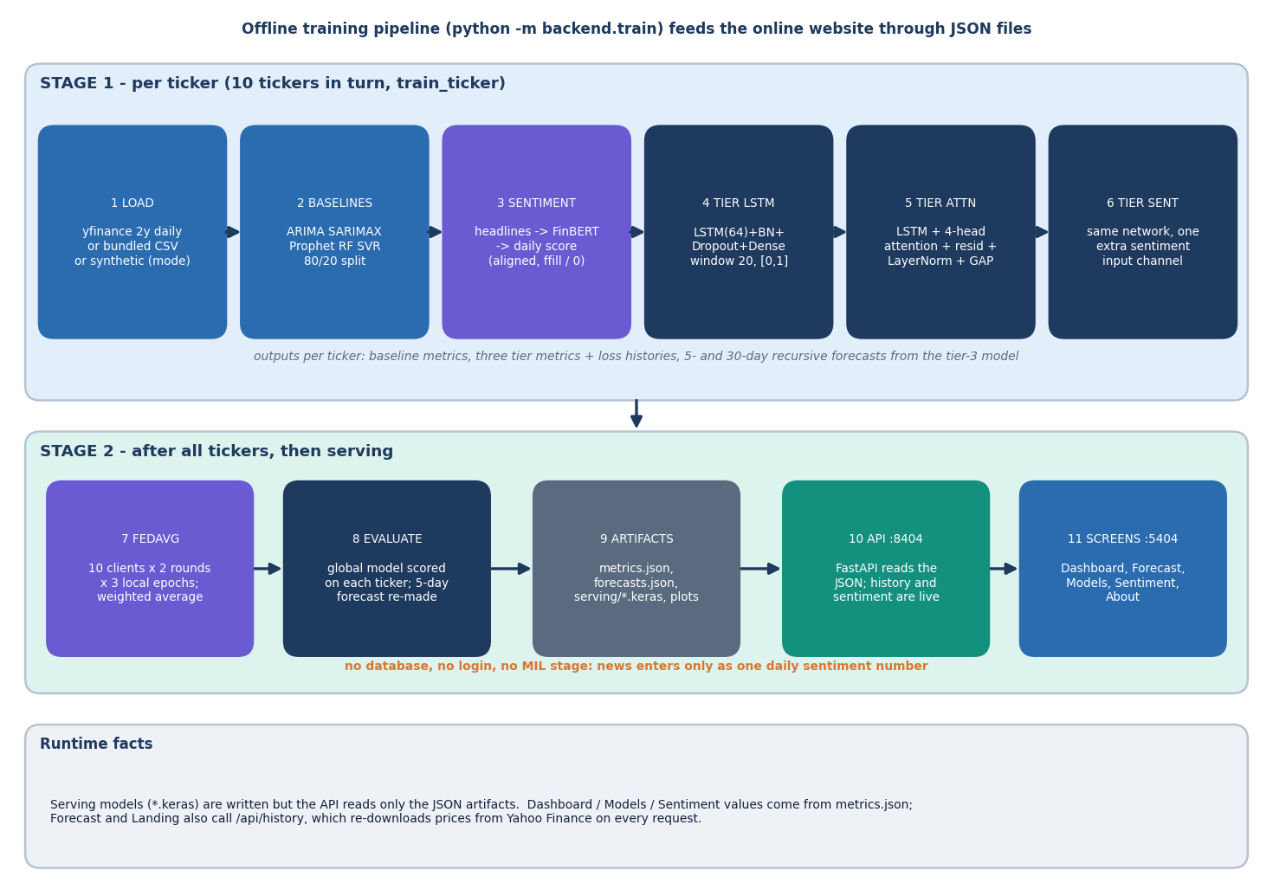
Figure 2: Offline training pipeline (python -m backend.train) in two stages, then serving of the JSON artefacts to the website.
Stage 1 runs once per ticker for the ten tickers in turn. The prices are loaded from Yahoo Finance, the bundled CSV or a labelled synthetic series; five classical baselines are scored on an 80/20 chronological split; daily sentiment is built from headlines scored by FinBERT-tone; and three deep tiers (LSTM, LSTM with four-head attention, and the same network with a sentiment channel) are trained on 20-day windows scaled to [0, 1]. The recursive 5- and 30-day forecasts come from the third tier. Stage 2 starts after all tickers are done: the third-tier network is averaged across the ten tickers by FedAvg, scored on each ticker, and its 5-day forecast replaces the local one; the results are written to metrics.json, forecasts.json, the serving models and the plots. At run time the API reads only the JSON files, except that the history and sentiment endpoints go back to Yahoo Finance and FinBERT. News enters only as one daily sentiment number, so the workflow has no database, no login and no multiple-instance stage.
The workflow has two time scales. The training pipeline is a command-line program, python -m backend.train, which takes five to ten minutes on a CPU and writes everything the website shows. The serving path is a few lines of FastAPI. The only operations that leave the machine at run time are the history call, which re-downloads prices from Yahoo Finance, and the first sentiment call, which loads the FinBERT-tone model from the Hugging Face cache.

5.3 Data Flow Diagrams

5.3.1 Level 0: context
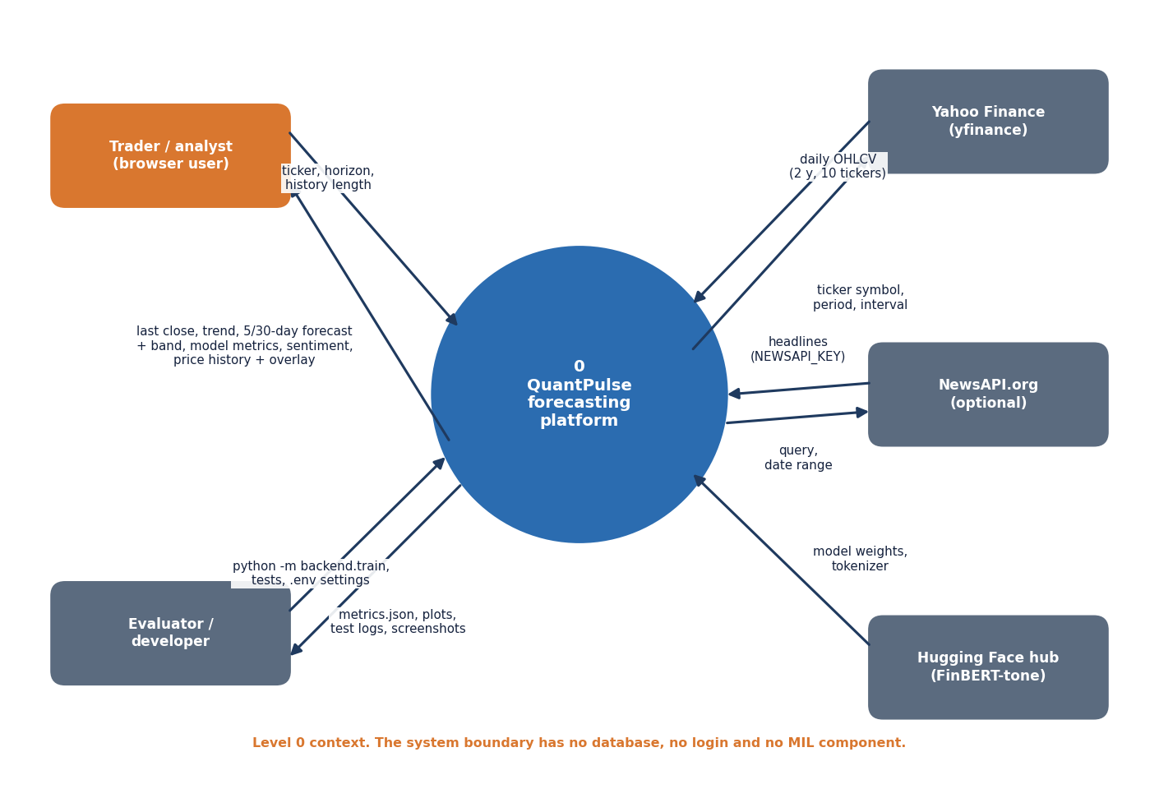
Figure 3: Context diagram (DFD level 0): one process, the trader or analyst, the evaluator or developer, and three external data sources.
At level 0 the product is one process with three kinds of neighbour: the trader or analyst (browser), the evaluator or developer (scripts and tests) and three external services (Yahoo Finance, NewsAPI and the Hugging Face hub for FinBERT-tone).

5.3.2 Level 1: seven processes
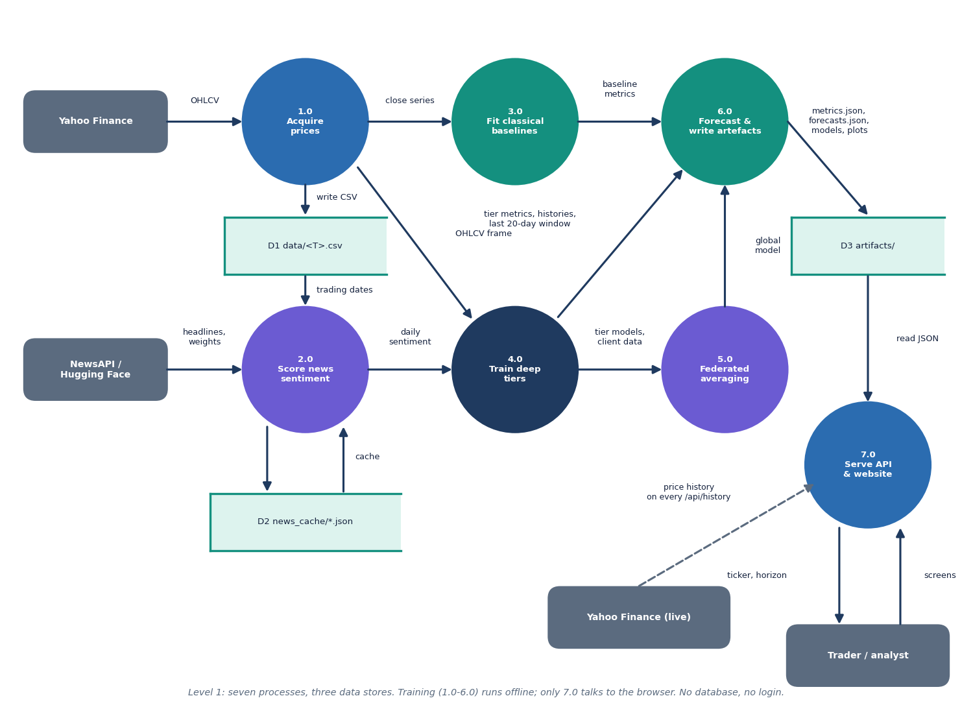
Figure 4: DFD level 1: seven processes (acquire prices, score sentiment, fit baselines, train deep tiers, federated averaging, forecast and write artefacts, serve) and three data stores.
Process 1.0 downloads prices and writes them to the CSV files (D1); the close series goes to the baselines (3.0) and the OHLCV frame goes to the deep-tier training (4.0). Process 2.0 reads the trading dates, fetches or generates headlines (cached in D2), scores them with FinBERT-tone and hands a daily sentiment series to 4.0. Process 4.0 passes its trained models and client data to the federated averaging (5.0) and its metrics, loss histories and last 20-day windows to process 6.0. Process 6.0 combines baseline metrics, tier metrics and the global model, makes the recursive forecasts and writes the artefacts (D3). Process 7.0, the FastAPI application and website, reads D3 for the trader and goes to Yahoo Finance on every history request. Processes 1.0 to 6.0 run offline; only 7.0 faces the browser.
Processes 1.0 to 6.0 are one offline script (acquire prices, score sentiment, fit baselines, train deep tiers, average federatedly, forecast and write artefacts); process 7.0 is the FastAPI application. The three stores are files: D1 data/<T>.csv, D2 data/news_cache/ (only with a NewsAPI key) and D3 artifacts/.

5.3.3 Level 2: training one deep tier
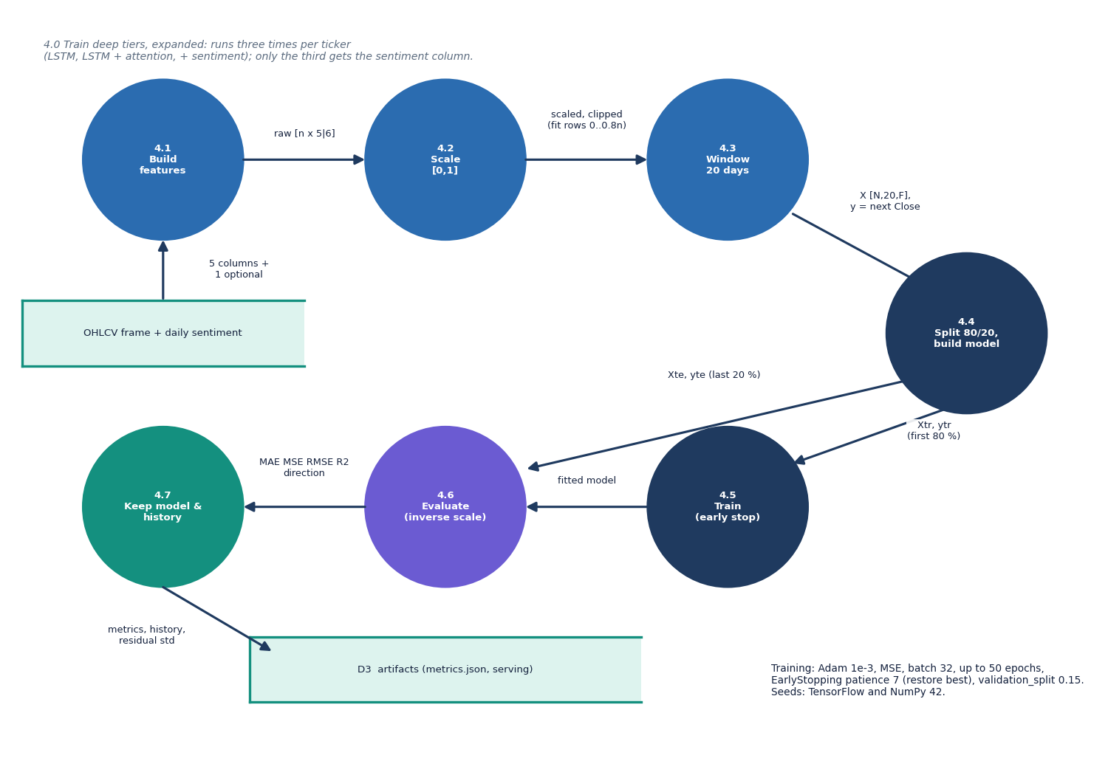
Figure 5: DFD level 2: process 4.0, training of one deep tier, expanded into seven sub-processes.
Level 2 expands the training of one deep tier into seven steps. Step 4.2 carries the design's most consequential choice: the scalers are fitted on the first 80 % of the rows but applied to every row and clipped to [0, 1], so a test price above the training maximum is flattened to 1.0 (Chapter 8 shows this matters).

5.4 Module, Sequence and Use-Case Design

5.4.1 Module (class) diagram
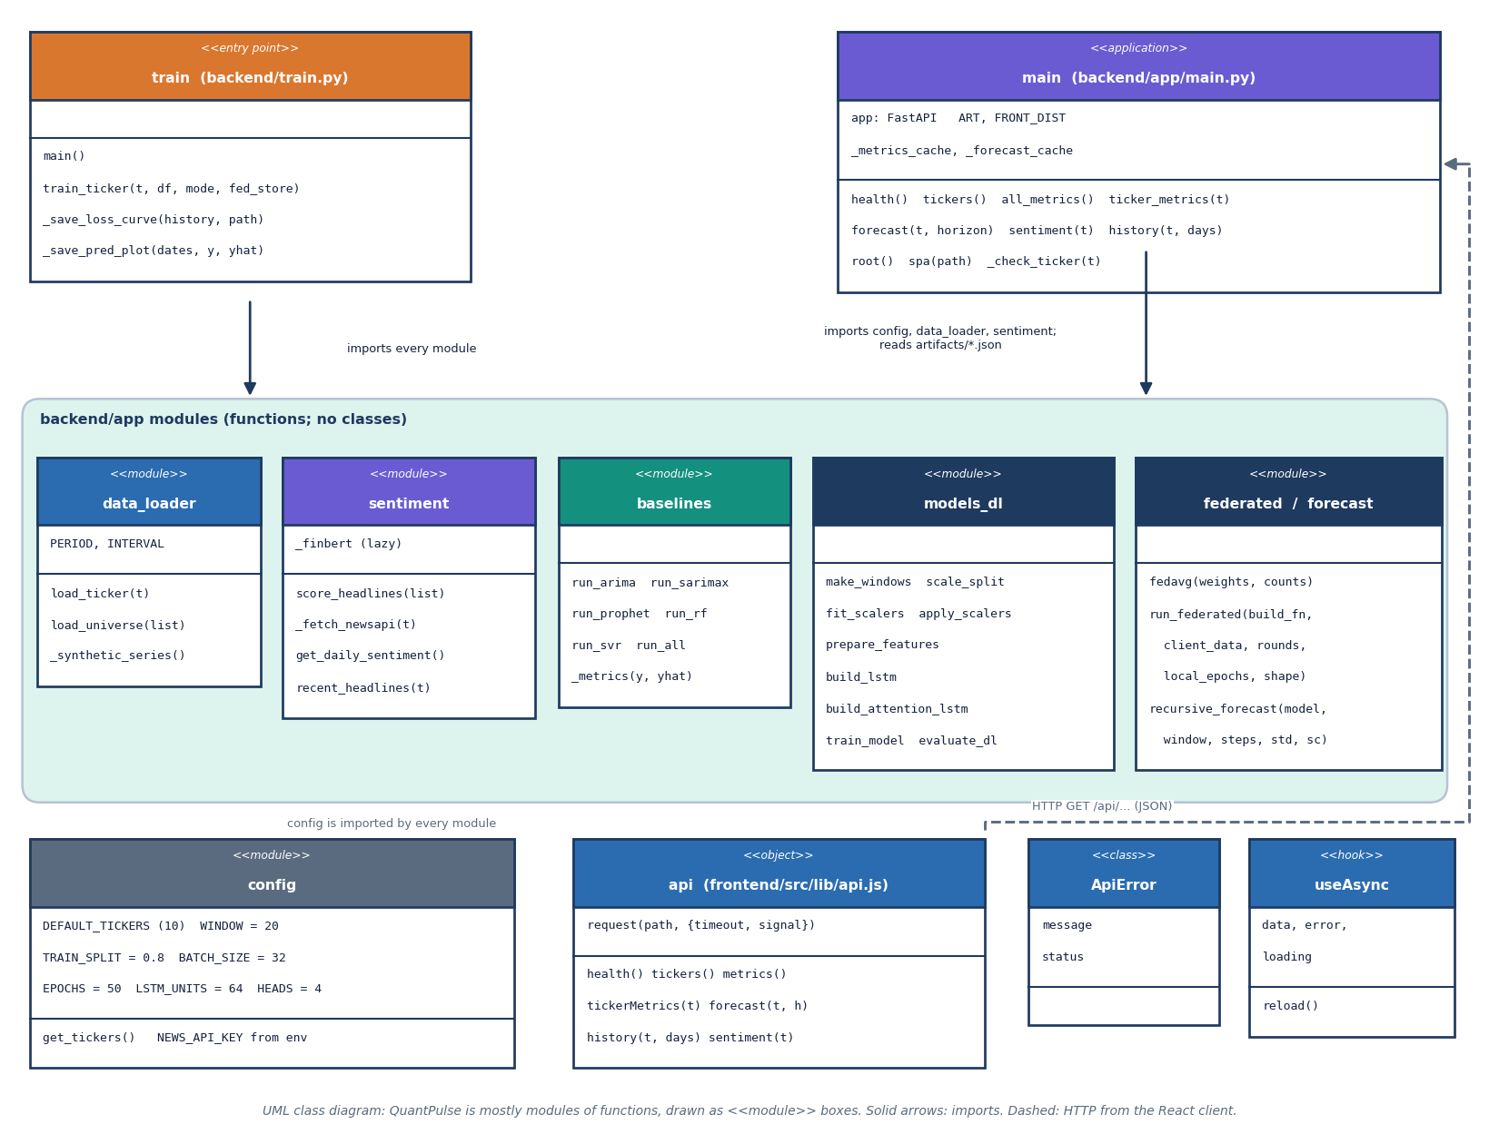
Figure 6: UML class diagram: the backend is a set of function modules, so modules are drawn as boxes with their functions, together with the React API client, ApiError and the useAsync hook.
QuantPulse is written mostly as modules of functions, so the diagram draws each module as a box listing its constants and functions. The entry script train.py imports every module under backend/app; main.py, the FastAPI application, imports config, data_loader and sentiment and reads the artefact JSON through a cached loader. config holds the ticker list and hyper-parameters, data_loader the three-step price source, sentiment the NewsAPI, FinBERT and synthetic-headline logic, baselines the five classical models, models_dl the windowing, scaling, the two Keras architectures, training and evaluation, federated the manual FedAvg loop and forecast the recursive forecast with its confidence band. On the browser side the api object wraps fetch with a timeout and raises ApiError; useAsync is the hook the screens use to call it. The only genuine classes are ApiError and the FastAPI application object.
The backend is deliberately a set of function modules, each small and testable on its own (the tests in tests/ call the functions directly); the only true classes are the front end's ApiError and the FastAPI application object.
Table 18: Backend modules and their roles.
Module | File | Role | Main functions
Configuration | backend/app/config.py | Tickers, window, split, batch, epochs, units, heads, horizons, paths, NewsAPI key | get_tickers
Price source | backend/app/data_loader.py | Live Yahoo download, bundled CSV, labelled synthetic series | load_ticker, load_universe, _synthetic_series
Sentiment | backend/app/sentiment.py | NewsAPI fetch and cache, FinBERT-tone or lexicon scoring, synthetic headlines, daily alignment | get_daily_sentiment, score_headlines, recent_headlines
Baselines | backend/app/baselines.py | ARIMA, SARIMAX, Prophet, Random Forest, SVR with one metric helper | run_all, _metrics
Deep models | backend/app/models_dl.py | Windows, scalers, two Keras architectures, training, evaluation | make_windows, build_lstm, build_attention_lstm, evaluate_dl
Federated | backend/app/federated.py | Manual FedAvg over per-ticker clients | fedavg, run_federated
Forecast | backend/app/forecast.py | Recursive multi-step forecast with confidence band | recursive_forecast
API | backend/app/main.py | Seven JSON routes, static site, validation | _check_ticker, forecast, history
Training script | backend/train.py | Runs the whole pipeline and writes artefacts and plots | train_ticker, main

5.4.2 Sequence diagram
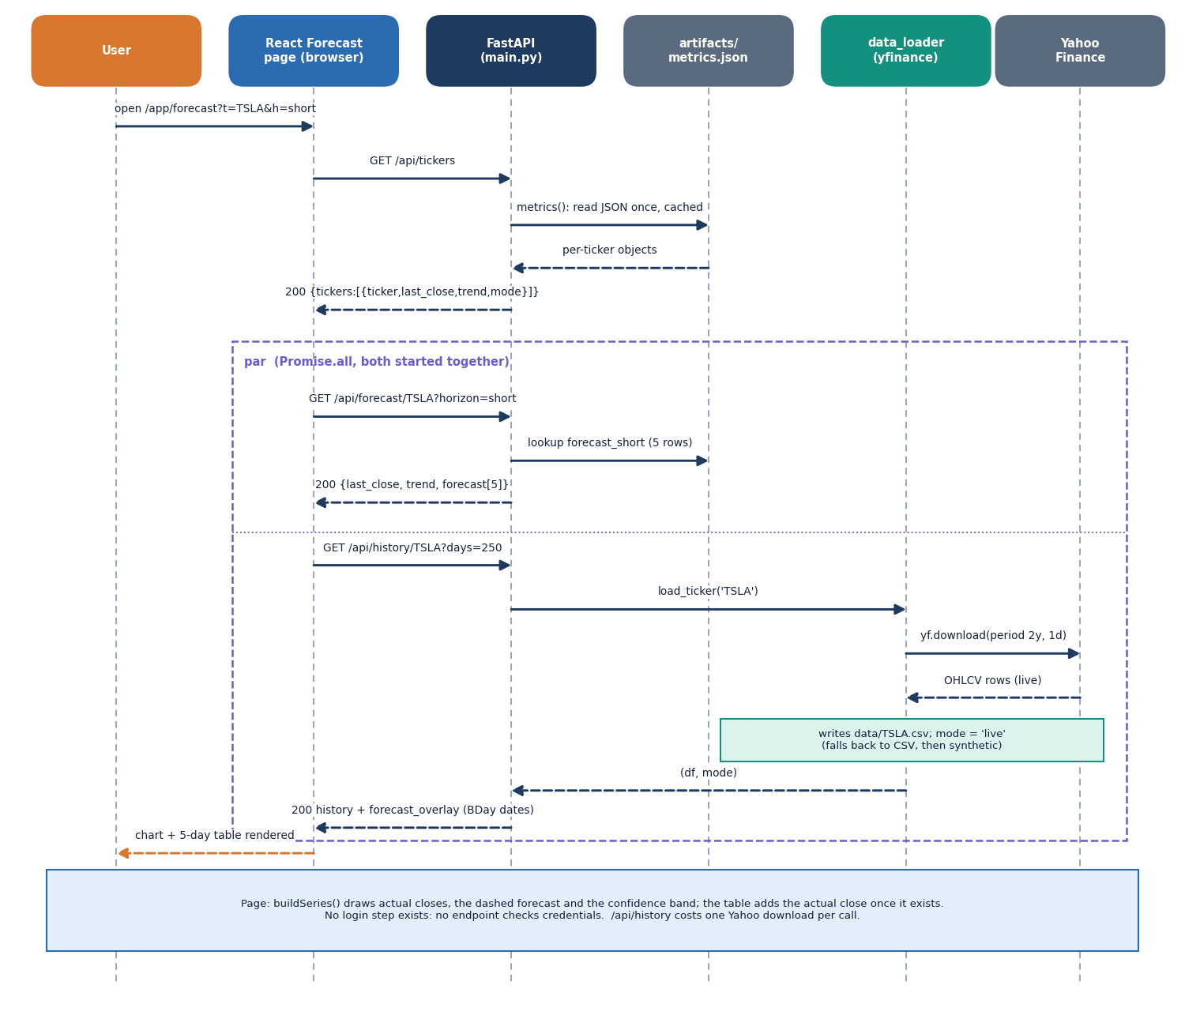
Figure 7: Sequence diagram: the user opens the Forecast screen; the page calls /api/tickers, then /api/forecast and /api/history in parallel; history goes live to Yahoo Finance.
Opening /app/forecast makes the React page call GET /api/tickers; main.py loads artifacts/metrics.json once, caches it and returns each ticker's last close, trend and data mode. The page then starts two requests together. GET /api/forecast/TSLA?horizon=short looks up the stored five forecast rows. GET /api/history/TSLA?days=250 calls load_ticker, which downloads two years of daily prices from Yahoo Finance, rewrites data/TSLA.csv and returns the latest 250 rows together with the stored forecast placed on the next business days. The page draws the actual closes, the dashed forecast and the confidence band, and the table shows the actual close once it exists. No request carries credentials, and the history call costs one Yahoo Finance download every time.
Opening the Forecast screen triggers /api/tickers, then /api/forecast and /api/history together; the history call goes live to Yahoo Finance and rewrites the price CSV, so it is the slowest of the three.

5.4.3 Use-case diagram
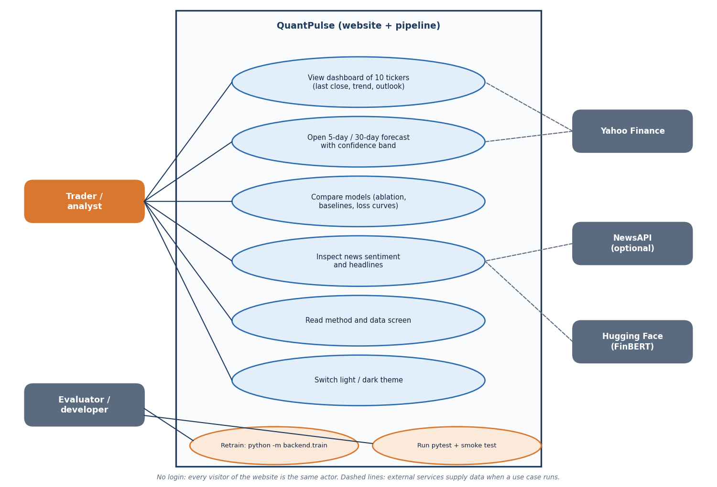
Figure 8: Use-case diagram with the trader or analyst, the evaluator or developer, and three external services.
There is one human role, the trader or analyst, who needs no login, and one technical role, the evaluator or developer; no administrator exists because there is no authentication.

5.5 Data Design
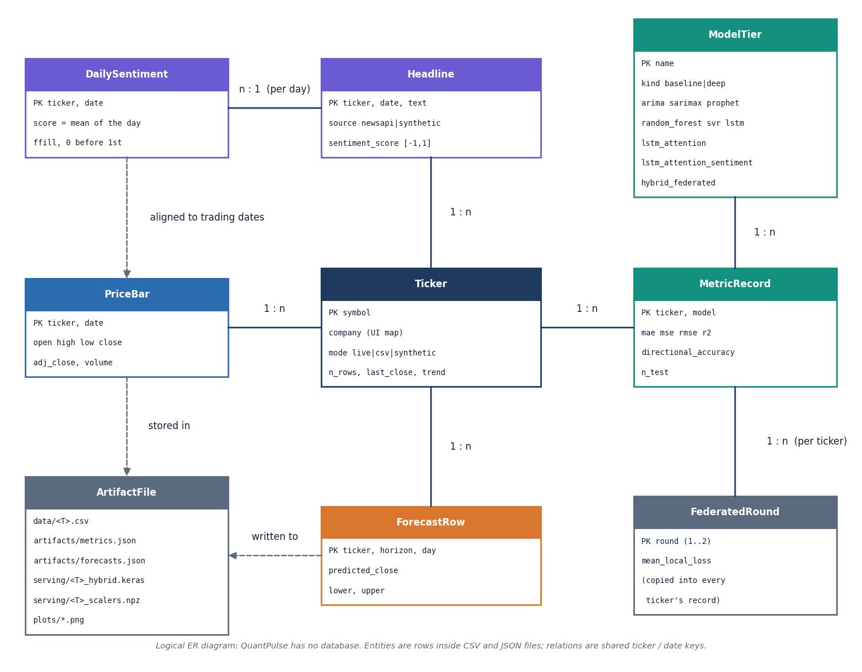
Figure 9: Logical entity-relationship diagram: QuantPulse has no database, so the entities are rows inside CSV and JSON files.
There is no database, so the entities are rows inside CSV and JSON files and the diagram is logical. The shape of artifacts/metrics.json is the de facto schema of the product; the table lists the parts of one ticker's record.
Table 19: Contents of one ticker's record in artifacts/metrics.json.
Field | Content | Written by
mode, n_rows | Price source (live, csv, synthetic) and number of daily rows used (501 for every ticker in the shipped run) | train_ticker
baselines | ARIMA, SARIMAX, Prophet, Random Forest, SVR: MAE, MSE, RMSE, R2, directional accuracy, n_test (101) | baselines.run_all
sentiment | Source (newsapi or synthetic-fallback), scorer (finbert, lexicon), headline count (166 to 191), note | get_daily_sentiment
deep | Four tiers with the same metric set and n_test = 97 | train_ticker, main
histories | Training and validation loss per epoch for three local tiers | train_model
forecast_short, forecast_long | 5 and 30 rows: day, predicted close, lower, upper | recursive_forecast
last_close, trend | Last training close and up/down flag (day-5 forecast against last close) | main
headlines | Eight headlines with their scores for the sentiment screen | recent_headlines
federated_rounds | Mean local loss for round 1 and 2 (same for every ticker) | run_federated

Price files are CSV with a date index and the columns Open, High, Low, Close, Adj Close and Volume (a synthetic file starts with # synthetic: true); the Keras files and scalers in artifacts/serving/ are saved per ticker. The API loads each JSON file once and keeps it in memory until restart.

5.6 Core Algorithm Design
Three algorithms carry the product and each has a flowchart; they are derived formally in Chapter 6.

5.6.1 Recursive forecast
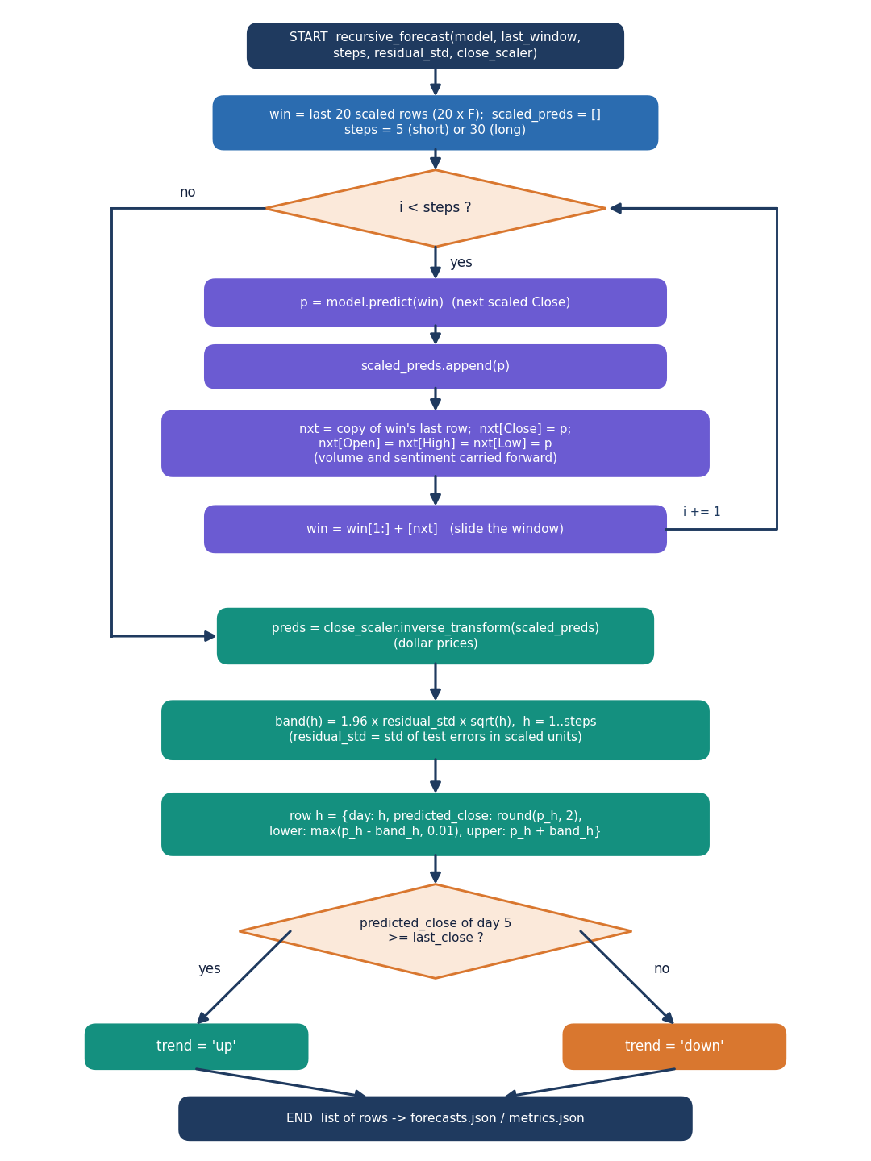
Figure 10: Flowchart of recursive_forecast: predict, roll the window, repeat, inverse-scale, add the 1.96 x residual std x sqrt(h) band and set the trend.
Each step feeds the prediction back as the next Close (and Open, High, Low) with volume and sentiment held constant, so after day one the forecast is driven by the model's own outputs; the band widens with the square root of the horizon.

5.6.2 Sentiment path
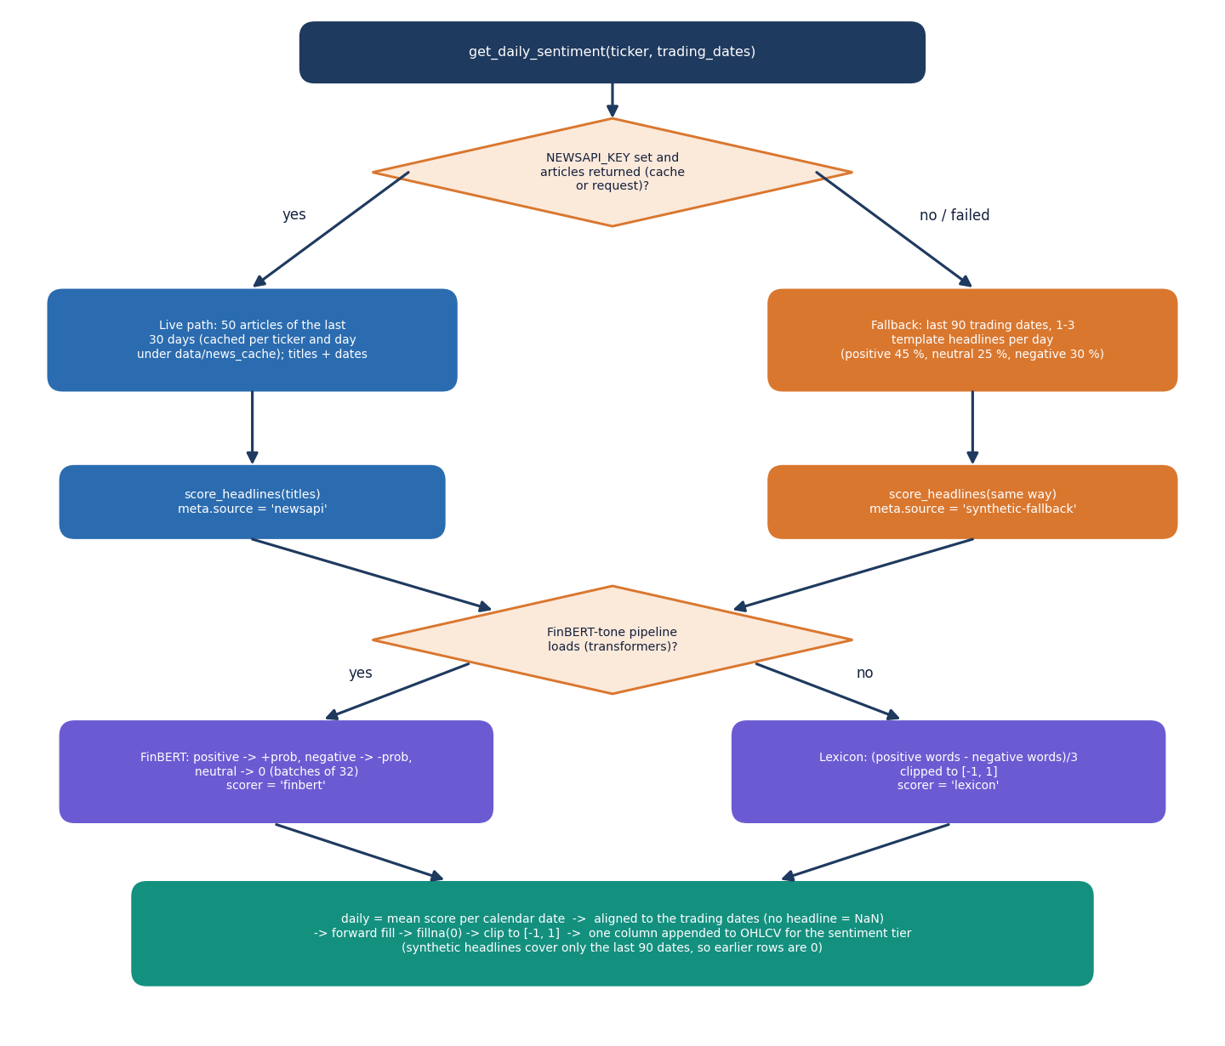
Figure 11: Flowchart of get_daily_sentiment: live NewsAPI headlines or the labelled synthetic fallback, FinBERT-tone or lexicon scoring, and alignment to the trading dates.
No key was configured in the shipped run, so every ticker used the synthetic path: 166 to 191 headlines per ticker from eleven fixed templates, which say nothing about real news. The screen labels this; the base paper's own NewsAPI limit of one month [1] is why live responses are cached per day.

5.6.3 Network architecture
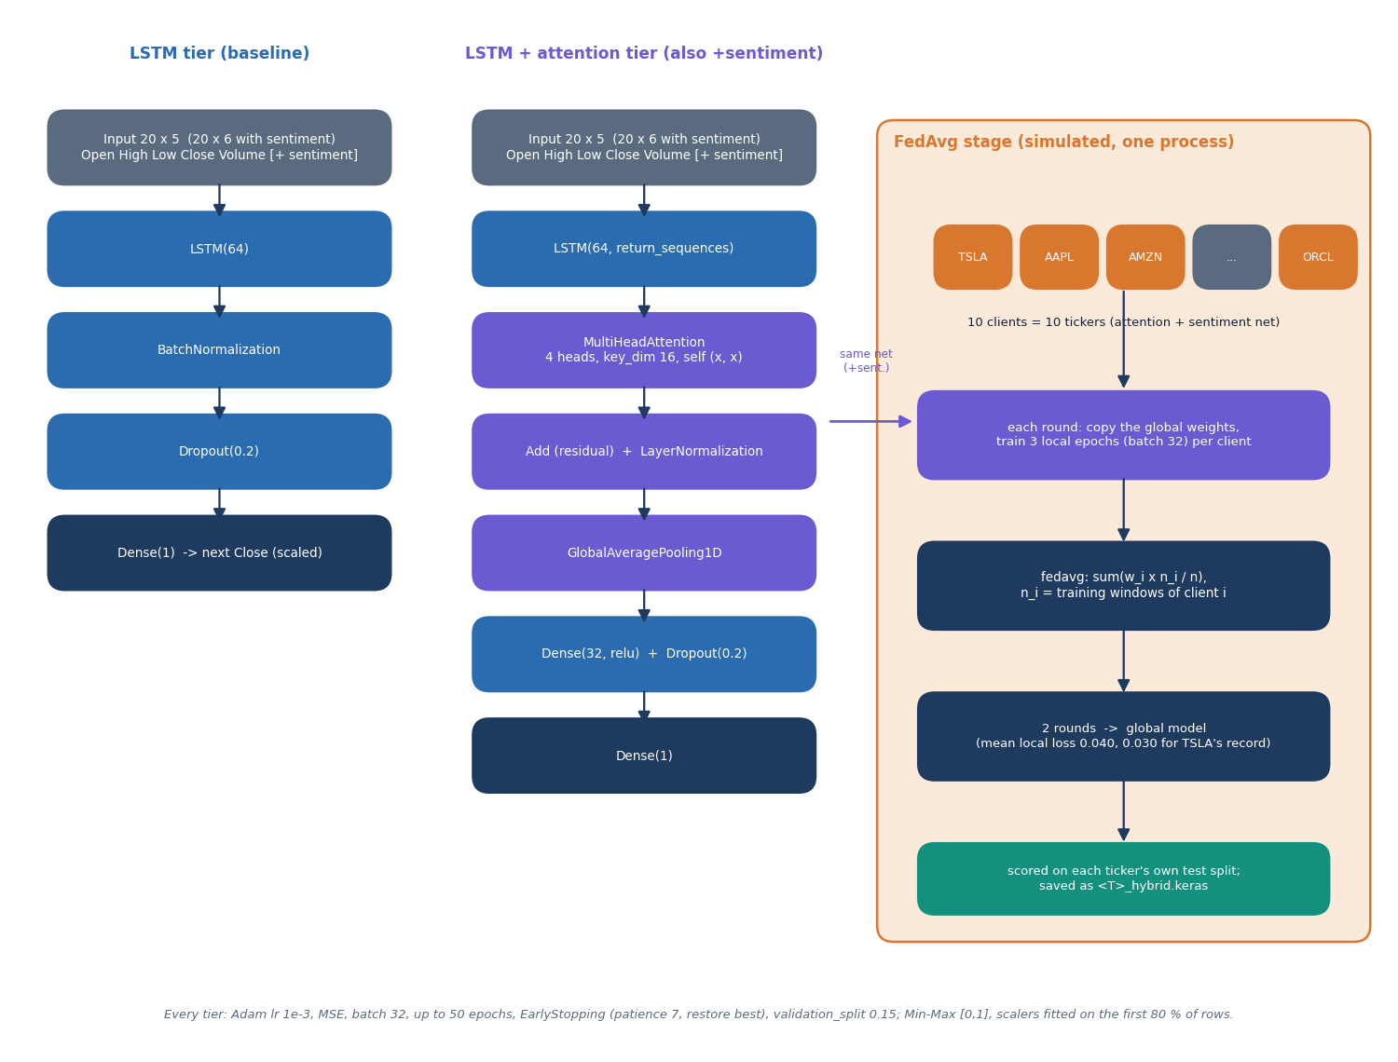
Figure 12: Architecture of the two network families (LSTM, and LSTM with four-head attention) and of the simulated FedAvg stage.

5.7 Module Design of the Website
The website is a single-page React 19 application (Vite 8, React Router 7, Recharts 3, Framer Motion) on the "Soft Pastel Calm" kit, with six lazily loaded screens; each asks the API through one hook and renders loading, error, empty and data states.
Table 20: Website modules.
Module | File(s) | Role
Router and shell | App.jsx, components/ui/Layout.jsx | Routes / (landing) and /app/*; sidebar, top bar with the API status pill, theme toggle
Landing | pages/Landing.jsx | Hero with a live price chart of the first ticker, feature sections, call to action
Dashboard | pages/Dashboard.jsx | Four KPI cards, ten ticker cards with sparklines, sortable universe table
Forecast | pages/Forecast.jsx | Ticker tabs, horizon and history selectors, KPIs, chart with band, forecast table with actual closes, stale-model banner
Model comparison | pages/Models.jsx | KPIs, ablation chart, all-model MAE chart, deep and baseline tables, loss curves, federated rounds
News sentiment | pages/Sentiment.jsx | Source, headline count, 30-day mean, daily chart, searchable headline list with tone filter
Method and data | pages/About.jsx | Pipeline timeline, installation facts from the API, data table per ticker
API client | lib/api.js | fetch wrapper with a 30 s timeout (240 s for sentiment), abort support and ApiError
Hooks and helpers | lib/hooks.js, market.js, format.js, palette.js, theme.jsx | useAsync, useRefresh, model labels, buildSeries (aligns forecast and history), number and date formats, light and dark tokens
UI kit and charts | components/ui/*, components/charts/index.jsx | Buttons, cards, tables, tabs, toasts, skeletons; area, bar, line, grouped-bar and forecast charts with accessible labels

The most delicate front-end logic is buildSeries: the stored forecast starts from the last training close, which can be older than the live history, so the function anchors the forecast on the history row with that close, lays it on the following business days and adds the actual close and percentage miss for every forecast day that has already happened. If no row matches it shows the stale warning.

5.8 API Design
The API is read-only JSON: seven routes under /api, with the same process serving the built website. Request and response shapes are in Chapter 6.
Table 21: API routes.
Route | Purpose | Errors
GET /api/health | Readiness, tickers, whether artefacts exist, news source | none
GET /api/tickers | Universe with last close, trend and data mode | none
GET /api/metrics | All records | 503 when not trained
GET /api/metrics/{ticker} | One record | 400 invalid symbol, 404 unknown
GET /api/forecast/{ticker}?horizon= | 5 or 30 forecast rows | 400, 404, 422 bad horizon
GET /api/sentiment/{ticker} | Meta, 30 daily scores, headlines | 400
GET /api/history/{ticker}?days= | OHLCV rows and forecast overlay | 400, 422 days outside 20 to 500

5.9 User Interface Design
Four rules guide the interface. Calm and legible: warm off-white surfaces, pastel tones by category (lavender deep models, blue baselines, mint positive, rose negative) and tabular figures. Honest states: skeletons, error states with retry, empty states and an "API online, models ready" pill. Accessible: charts carry an aria-label, tabs and segmented controls use tab and radio roles, and motion respects reduced-motion. Two themes share the same tokens; the choice is stored in the browser.
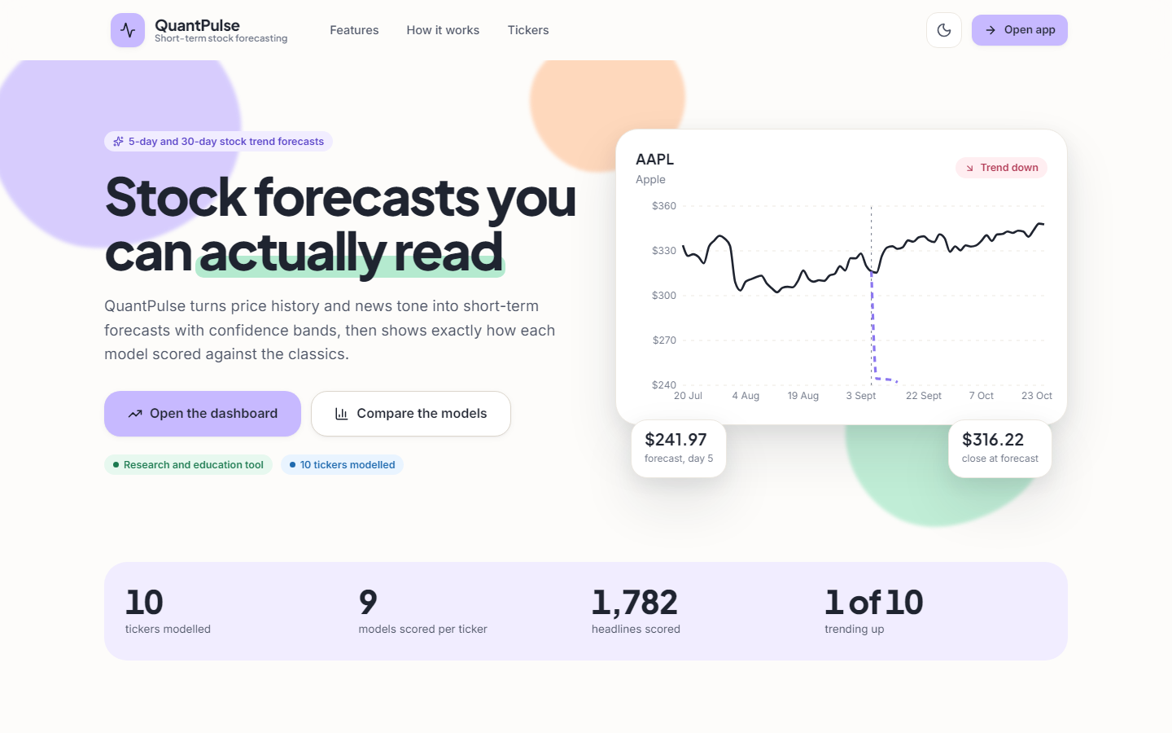  Figure 13: Landing page in the light theme. | 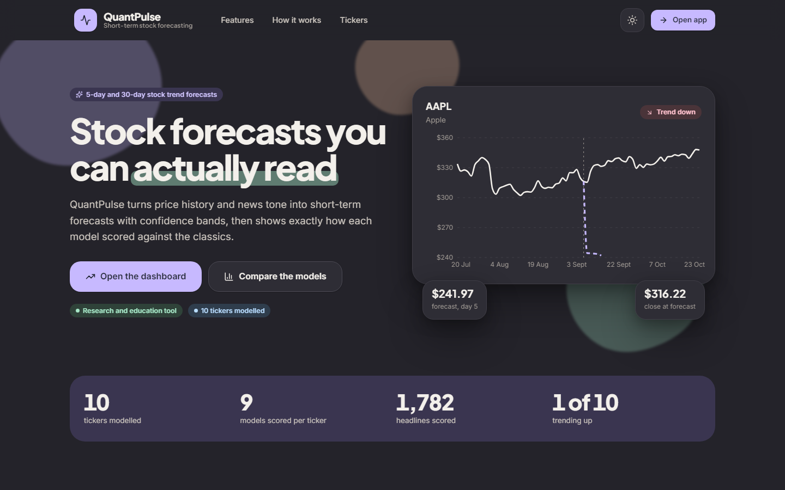  Figure 14: Landing page in the dark theme.

Table 22: Screens and their data sources.
Screen | Route | API calls | What the user can do
Landing | / | tickers, metrics, history (first ticker, 250 days) | Read the pitch, open the app
Dashboard | /app | tickers, metrics | Scan ten tickers, sort the table, open a forecast
Forecast | /app/forecast | tickers, then forecast and history together | Pick ticker, 5- or 30-day horizon, 60 to 250 days of history; read the table with actual closes
Model comparison | /app/models | tickers, metrics/{t} | Compare nine models, see loss curves and federated rounds
News sentiment | /app/sentiment | tickers, sentiment/{t} | See source and daily mood, search and filter headlines
Method and data | /app/about | health, metrics | Read the pipeline and per-ticker data modes

5.10 Design Trade-offs and Known Weaknesses
• Precomputed artefacts keep the site fast but go stale: the shipped ones end at 2026-09-08; the Forecast screen says so, only retraining fixes it.
• The history route downloads on every call: the chart stays current at about 140 ms per call (Chapter 7) and depends on Yahoo Finance being reachable.
• Function modules share a few module-level caches (the FinBERT pipeline, two JSON caches) that would need a lock under heavy concurrency.
• No authentication and no database: the API is read-only with no personal data and files suffice for ten tickers; watch-lists or forecast history would need both.
• Simulated federated learning: the clients share one process and one scaling convention; a real deployment would need transport, secure aggregation and per-client scaling.

6. METHODOLOGY AND SOFTWARE IMPLEMENTATION
This chapter explains how QuantPulse works from data to screen: the methodology, the datasets, the preprocessing, the choice of algorithms and their mathematics, the model architecture and training, the offline multiple-instance study, the application and its API, the error handling and the way to install and run it. All hyper-parameters quoted are those in the code, and every statement about data says whether the data are real or synthetic.

6.1 Overall Methodology
QuantPulse is built as one pipeline with two phases. The offline phase (python -m backend.train) loads daily prices for ten tickers, scores five classical baselines, builds a daily sentiment series from headlines, trains three deep-model tiers on 20-day windows, averages the sentiment-tier network across the ten tickers with federated averaging, writes the 5- and 30-day recursive forecasts and stores every metric in JSON. The online phase is a FastAPI service and a React website that read those files and, for the price chart and the sentiment screen, fetch fresh prices and score headlines on demand. The design is that of the base paper [1]; the intent of the project title, a multiple-instance treatment of daily news, is addressed by a separate offline study (Section 6.7) and is not part of the application. The method has eight steps:
1. Acquire prices from Yahoo Finance, with a bundled CSV and a labelled synthetic series as fall-backs.
2. Build sentiment: NewsAPI headlines if a key is set, otherwise template headlines for the last 90 trading days, scored by FinBERT-tone and averaged per day.
3. Score the classical baselines on an 80/20 chronological split.
4. Window and scale: 20-day windows, Min-Max scaled to [0, 1] with scalers fitted on the first 80 % of the rows.
5. Train three deep tiers (LSTM, attention, attention with sentiment): Adam, batch 32, up to 50 epochs, early stopping.
6. Average federatedly: ten clients, two rounds of three local epochs, weights averaged by client size.
7. Forecast 5 and 30 days recursively with a 95 % band and an up or down flag.
8. Serve and display through seven JSON routes and six screens.
Figure 15: Offline training pipeline (python -m backend.train) in two stages, then serving of the JSON artefacts to the website.

6.2 Dataset
Prices. The ten tickers are TSLA, AAPL, AMZN, MSFT, GOOGL, NVDA, META, FDX, IBM and ORCL, the base paper's universe with Airbnb replaced by Meta [1]. The loader asks yfinance for two years of daily bars [33]; the shipped artefacts were trained on 501 rows per ticker, 2024-09-09 to 2026-09-08, all with mode live. If the download fails the loader reuses data/<T>.csv, and if that is missing it generates a geometric-Brownian-motion series with regime shifts and volatility clustering, saved with a # synthetic: true header. Every record carries its mode so that a synthetic series can never be mistaken for a real one. The application overwrites the CSV on each live pull, so the documentation experiments use a pinned snapshot, experiments/data_snapshot/, whose rows up to 2026-09-08 reproduce the stored last closes.
News in the product. No NEWSAPI_KEY was set, so all ten tickers used the built-in fallback: 166 to 191 headlines per ticker (about 1 to 3 per day for the last 90 trading days) generated from eleven fixed templates, 45 % positive, 25 % neutral and 30 % negative in expectation, and then scored by FinBERT-tone [16]. These headlines carry no information about the real market. The free NewsAPI tier returns only about a month of history [34], which is why the base paper's sentiment experiments are limited to 30 days.
Real news for the offline study. The multiple-instance study uses the news portion of FNSPID [11], read from a public mirror: 46,532 headline rows for seven tickers (AAPL, AMZN, FDX, MSFT, NVDA, ORCL, TSLA), of which 40,663 fall in 2022 and 2023; GOOGL and META have no headlines in this portion and IBM has seven. All rows carry day-level time stamps. Each article is tagged with every company it mentions, so a bag holds headlines only loosely about the ticker, the situation multiple-instance learning is meant for. Prices for this study are Yahoo Finance 2016 to 2023.
Table 23: Datasets used and their roles.
Data | Source | Size | Role
Daily prices (product) | Yahoo Finance via yfinance | 10 tickers x 501 rows | Training and serving
Price snapshot | Same, pinned 2024-09-09 to 2026-10-23 | 10 x 534 rows | Re-runs, forward test
Synthetic headlines | Eleven templates (sentiment.py) | 166 to 191 per ticker | Sentiment channel of the product
Real headlines | FNSPID news [11] | 46,532 rows, 7 tickers | Offline multiple-instance study
Prices for the study | Yahoo Finance 2016 to 2023 | 7 tickers, about 2,000 days each | Labels and price features

6.3 Preprocessing
Preprocessing is deliberately small and is the same for every deep tier. The feature matrix has the columns Open, High, Low, Close and Volume, plus the daily sentiment score for the third tier. Each column is scaled separately with MinMaxScaler, fitted on the first 80 % of the rows (400 of 501) and applied to all rows, with the result clipped to [0, 1]. Sliding windows of 20 trading days are cut from the scaled matrix; the target of a window is the Close of the day after it. The 481 windows are split chronologically 80/20 into 384 training and 97 test windows, and the training windows are further divided by Keras with a 15 % validation split taken from their end (326 / 58). The test period is therefore the last 97 trading days of the two-year series.
Three properties of this preprocessing matter for the results. First, the scaler never sees the test period, which avoids leakage, but the clip means that any test price above the training maximum becomes exactly 1.0; in the pinned data this affects 56 to 82 % of the test closes of AAPL, AMZN, GOOGL, NVDA and FDX. Second, the target is the next close itself rather than its change, so a model that merely repeats the last input already scores well on level errors. Third, sentiment alignment averages the headline scores per calendar date, places them on the trading dates, forward-fills the gaps and sets days before the first headline to zero; because the generator writes headlines only for the last 90 trading days, the channel is exactly zero for every training window and non-zero only in the test part.
Baselines are preprocessed differently, as in the base paper: ARIMA, SARIMAX and Prophet fit the close series on the first 80 % and forecast the whole remaining span without refitting; Random Forest and SVR use the previous 20 closes and predict one step ahead from actual lagged values. Headline scores are signed probabilities: +p, -p or 0 for positive, negative or neutral.

6.4 Algorithm Choice and Justification
Each model in the pipeline answers a specific question, and the table records why it was chosen and what the measurements of Chapter 8 showed about it.
Table 24: Algorithms, the reason for each and what was observed.
Algorithm | Role | Reason for choosing it | What the measurements show
ARIMA(5,1,0), SARIMAX [27] | Statistical baseline | Standard linear time-series models, in the base paper | Mean MAE $30.68 and $32.93; multi-step forecast without refit
Prophet [24] | Decomposable baseline | Trend and seasonality model in the base paper | Worst model: mean MAE $62.33
Random Forest, SVR [25], [26] | Machine-learning baselines | Non-linear regressors on lagged closes | Random Forest lowest MAE on 6 of 10 tickers (mean $13.18)
LSTM [12] | Sequence model | Captures temporal dependence in the price window | Mean MAE $44.11 (shipped scoring)
Multi-head attention [13] | Weights the time steps of the window | Base paper adds it to the LSTM to model long-range dependence | Best deep tier, mean MAE $22.36
FinBERT-tone [16], [17] | Headline sentiment | Pretrained on financial text, inference only, no labels needed | Works as a scorer; the channel it feeds is synthetic and empty during training
FedAvg [14] | Simulated decentralised training | Base paper's privacy argument; one client per ticker | Worse than local tiers (mean MAE $44.72)
Gated-attention MIL [10], [9] | Bag-level news model (offline study) | Only the day's outcome labels a bag of headlines, as the title requires | No gain over price-only on 1,309 test samples

The LSTM with attention was kept because it is the base paper's architecture and the tier comparison is the paper's ablation, not because it is expected to beat a persistence forecast. FinBERT-tone in inference mode was chosen because no labelled headlines exist for the ten tickers; the cost is a download of several hundred megabytes on first use.

6.5 Mathematical Formulation

6.5.1 Windows and scaling
Let x_t be the vector of the five price columns (and the sentiment score) on trading day t. Each column j is scaled with the minimum and maximum of its first 80 % of rows, and the input window and target are
x̃_t,j = clip((x_t,j − min_j) / (max_j − min_j), 0, 1), X_t = [x̃_(t−20), …, x̃_(t−1)], y_t = x̃_t,Close (1)

6.5.2 LSTM cell
The recurrent layer is the standard LSTM [12] with 64 units. With σ the logistic function and ⊙ the element-wise product, at each step
f_t = σ(W_f[h_(t−1), x_t] + b_f), i_t = σ(W_i[h_(t−1), x_t] + b_i), o_t = σ(W_o[h_(t−1), x_t] + b_o) (2)
C̃_t = tanh(W_C[h_(t−1), x_t] + b_C), C_t = f_t ⊙ C_(t−1) + i_t ⊙ C̃_t, h_t = o_t ⊙ tanh(C_t) (3)

6.5.3 Multi-head attention
The attention tier keeps the whole LSTM sequence H = [h_1, …, h_20] and applies four-head self-attention [13] with key size 16, adds the result back (residual connection), normalises and averages over time:
Attention(Q, K, V) = softmax(Q Kᵀ / √d_k) V, Z = LayerNorm(H + MultiHead(H, H, H)), z̄ = (1/20) Σ_t Z_t (4)
The vector z̄ passes through a 32-unit ReLU layer, dropout 0.2 and one linear output.

6.5.4 Daily sentiment
For ticker k and date d, let S_(k,d) be the set of headlines. FinBERT-tone returns a label and a probability p for each headline, and the headline score is s = +p for positive, −p for negative and 0 for neutral. The daily value is the mean, forward-filled and clipped:
σ_(k,d) = clip( mean_(h ∈ S_(k,d)) s_h , −1, 1 ), σ_(k,d) = σ_(k,d−1) if S_(k,d) = ∅, σ = 0 before the first headline (5)

6.5.5 Federated averaging
Each ticker i is a client with n_i training windows. In every round each client copies the global weights, trains for three local epochs and returns its weights; the server forms the weighted mean [14]:
w^(r+1) = Σ_(i=1..10) (n_i / n) w_i^(r), n = Σ_i n_i (6)
Because every ticker has 384 training windows the weights are equal and the average is a plain mean. The global model is then scored on each ticker's test windows using that ticker's own scalers.

6.5.6 Evaluation metrics and forecast band
For test targets y_i with predictions ŷ_i (inverse-scaled to dollars) and n test windows:
MAE = (1/n) Σ |y_i − ŷ_i|, MSE = (1/n) Σ (y_i − ŷ_i)², RMSE = √MSE, R² = 1 − Σ (y_i − ŷ_i)² / Σ (y_i − ȳ)² (7)
DA = (1/(n−1)) Σ_i 1[ sign(y_i − y_(i−1)) = sign(ŷ_i − y_(i−1)) ] (8)
The directional accuracy compares the sign of the actual move with the sign of the predicted level against the previous actual. For the multi-step forecast the recursion feeds each prediction back as the next input and the band widens with the square root of the horizon h, using σ_res, the standard deviation of the test residuals:
ŷ_(T+h) = f(window with ŷ_(T+h−1) appended), band_h = ŷ_(T+h) ± 1.96 σ_res √h, trend = up if ŷ_(T+5) ≥ y_T (9)
Two further quantities are used in Chapter 8 and are not computed by the application. The persistence baseline forecasts ŷ_t = y_(t−1). The true-target scoring computes the same metrics against the real closes instead of the clipped scaled targets.

6.5.7 Multiple-instance formulation (offline study)
In multiple-instance learning [9] the label belongs to a bag, not to its members. Here the bag B_(k,d) = {x_1, …, x_n} is the set of headlines of ticker k published before the close of day d, each instance x_i is represented by FinBERT-tone probabilities and a 64-component projection of its [CLS] vector, and the bag label is y = 1 if the close of day d+1 is above the close of day d. With an instance encoder h_i = ReLU(W_e x_i) the gated attention pooling of Ilse et al. [10] is
a_i = softmax_i( wᵀ ( tanh(V h_i) ⊙ sigmoid(U h_i) ) ), z = Σ_i a_i h_i, p(y = up) = sigmoid( f([LSTM(price window), z]) ) (10)
Mean pooling (a_i = 1/n) and max pooling are the simpler alternatives; an empty bag is replaced by a learned vector. The attention weights say which headlines the model relied on, which is the explainability the problem statement asks for.

6.6 Model Architecture and Training
Figure 16: Architecture of the two network families (LSTM, and LSTM with four-head attention) and of the simulated FedAvg stage.
Table 25: Hyper-parameters (config.py, models_dl.py, federated.py, forecast.py).
Setting | Value
Window / split / batch / maximum epochs | 20 trading days / 80 % chronological / 32 / 50
LSTM tier | LSTM(64), BatchNorm, Dropout 0.2, Dense(1): 18,241 parameters (18,113 trainable)
Attention tier | LSTM(64, sequences), MultiHeadAttention(4 heads, key size 16), residual, LayerNorm, global average pooling, Dense(32, ReLU), Dropout 0.2, Dense(1): 36,801 parameters (37,057 with the sentiment column)
Optimiser and loss | Adam, learning rate 1e-3 [28]; mean squared error
Early stopping | Monitor validation loss, patience 7, restore best weights; validation split 15 %
Federated stage | 10 clients, 2 rounds, 3 local epochs per round, weighted average of weights
Seeds | TensorFlow and NumPy seed 42 in the product; seeds 42 to 46 in the documentation re-run
Forecast horizons / band | 5 and 30 trading days / 1.96 σ_res √h
Classical baselines | ARIMA(5,1,0); SARIMAX(1,1,1)(1,1,1,5); Prophet with daily and weekly seasonality; Random Forest 200 trees on 20 lags; SVR RBF C = 10, ε = 0.5

Training is cheap. In the five-seed re-run the three local tiers stopped after about 20 (LSTM), 17 (attention) and 17 (attention and sentiment) epochs on average, and one ticker and one seed (four local networks plus that ticker's share of the federated stage) took about 41 seconds on the six-core CPU used here, which was shared with other jobs. The shipped run saved one loss curve per local tier, and the federated stage logs the mean local loss of each round (0.0400 in round 1 and 0.0305 in round 2).

6.7 Multiple-Instance Learning Study (Offline)
The batch objectives ask for news treated as bags, directional prediction scored with accuracy, precision, recall and F1, and a comparison with a price-only baseline. The application does none of these, so the study was run as a separate script, scripts/mil_study.py, using real headlines. Its design is summarised below; its results are in Chapter 8.
Table 26: Design of the study.
Item | Choice
Bag and instance | All headlines of one ticker published before a day's close; instance = 3 FinBERT-tone probabilities + 64 PCA components of the [CLS] vector (PCA fitted on training headlines only)
Label | 1 if the next trading day's close is above today's close; bag-level only
Tickers and period | AAPL, AMZN, FDX, MSFT, NVDA, ORCL, TSLA; news era 2022 to 2023
Folds | Three expanding windows tested on Q2, Q3 and Q4 2023; validation = the two months before each test quarter; test predictions pooled (1,309 samples)
Price branch | LSTM(32) over 20 days of return, high-low range and log volume ratio (z-scored)
Bag models | Flat mean sentiment; MIL mean, max and gated-attention pooling (hidden size 32, attention size 16, at most 24 instances per bag); news-only attention; placebo with bags of other days
Training | AdamW, learning rate 2e-3, weight decay 1e-3 [29]; batch 128; at most 60 epochs; early stopping patience 7; five seeds
Metrics | Accuracy, precision, recall, F1 (up = positive), ROC-AUC; paired bootstrap against the price-only LSTM
Leakage controls | A headline is placed in the bag of the first trading day whose close is not earlier than its time stamp; scaling and PCA fitted on training data; the placebo gives each day the bag of another day of the same ticker

6.8 Evaluation Protocol
Five measurements are used in Chapter 8: the shipped metrics of artifacts/metrics.json; a five-seed re-run of the shipped pipeline on the same 501 rows; true-target scoring and the persistence baseline, which expose what the shipped scoring hides; the forward test of the stored forecasts (from the 2026-09-08 close) against the closes of the following 30 trading days, the only genuinely out-of-sample check; and the multiple-instance study of Section 6.7. Timings come from scripts/measure_api.py on 127.0.0.1.

6.9 Application Architecture
The application is one Python process plus a static website. main.py creates the FastAPI object with a CORS middleware, defines seven routes and, when frontend/dist exists, serves /assets and a catch-all that returns index.html for client-side routes. Nothing is loaded at start-up: the first request reads artifacts/metrics.json (and later forecasts.json) into a module-level cache. In development Vite serves the website on port 5404 and proxies /api to 127.0.0.1:8404; otherwise the API serves the built website itself.
Figure 17: Sequence diagram: the user opens the Forecast screen; the page calls /api/tickers, then /api/forecast and /api/history in parallel; history goes live to Yahoo Finance.
The /api/history route calls load_ticker, which tries a live download, then the CSV, then the synthetic generator, so a chart can always be drawn; the route then places the stored forecast on the next business days after the last bar. The /api/sentiment route calls get_daily_sentiment for the ticker's dates, which loads FinBERT-tone on first use into a module-level singleton and is the slowest call of the system.
The training script is the other half of the application. train_ticker runs the baselines, builds the sentiment series and calls an inner run_tier three times (LSTM, attention, attention with sentiment); each call builds the features, fits the scalers, makes the windows, trains with early stopping and scores the test windows. The recursive forecasts come from the third tier. After the ten tickers, main runs two federated rounds over the third tier, scores the global model on every ticker, replaces each ticker's 5-day forecast and trend with the global model's, saves the Keras files and scalers, draws four plots for TSLA and writes metrics.json and forecasts.json; the stored 30-day forecast therefore still comes from the local attention and sentiment model.

6.10 API Design
Table 27: Routes, parameters and responses.
Route | Parameters | Success response | Errors
GET /api/health | none | {status, product, tickers[], trained, news_source} | none
GET /api/tickers | none | {tickers:[{ticker, last_close, trend, mode}]} | none
GET /api/metrics | none | {<TICKER>: record} for ten tickers (about 76 KB) | 503 not trained
GET /api/metrics/{ticker} | symbol of 1 to 6 letters | {ticker, ...record} | 400 invalid, 404 unknown
GET /api/forecast/{ticker} | horizon = short or long (default short) | {ticker, horizon, last_close, trend, forecast:[{day, predicted_close, lower, upper}]} | 400, 404, 422
GET /api/sentiment/{ticker} | symbol | {ticker, meta, daily:[{date, score}] (30), headlines:[{headline, sentiment_score}]} | 400
GET /api/history/{ticker} | days 20 to 500 (default 120) | {ticker, mode, history:[{date, open, high, low, close, volume}], forecast_overlay:[{date, predicted_close, lower, upper}]} | 400, 422

GET /api/forecast/TSLA?horizon=short
{"ticker": "TSLA", "horizon": "short", "last_close": 368.16, "trend": "down", "forecast": [{"day": 1, "predicted_close": 316.57, "lower": 316.28, "upper": 316.86}, {"day": 2, "predicted_close": 314.58, "lower": 314.17, "upper": 314.99}, "..."]}

GET /api/forecast/T5LA -> 400 {"detail": "Invalid ticker 'T5LA'. Use 1-6 letters, e.g. TSLA."}
GET /api/forecast/ZZZZ -> 404 {"detail": "No forecast for 'ZZZZ'. Train the pipeline first."}
GET /api/forecast/TSLA?horizon=weekly -> 422 (query validation)

The record returned for a ticker has the fields listed in Section 5.5. Every route is a plain GET with no body; the API is read-only and idempotent, which makes it safe to cache and to test. Interactive documentation is available from FastAPI at /docs.

6.11 Front-End Implementation
Each page calls useAsync with a function that receives an abort signal (so changing the ticker cancels the request) and renders a skeleton while loading, an ErrorState with a retry button on failure and an EmptyState when there are no rows. The API client sets a 30-second timeout (240 seconds for sentiment, because the first call loads FinBERT) and turns every failure into an ApiError. Charts are Recharts components with an aria-label, and animation is off when the user prefers reduced motion. buildSeries in lib/market.js anchors the stored forecast on the history row with the training last close and annotates every forecast day that already has an actual close.

6.12 Security and Error Handling
• Input validation. A ticker must match ^[A-Za-z]{1,6}$ before any file or network access; horizon must be short or long and days between 20 and 500, enforced by FastAPI query validation (HTTP 422).
• Errors. Invalid symbol 400 with a message, unknown ticker 404 listing the configured tickers, missing artefacts 503 with the command to run; unknown /api/... paths return 404 instead of the single-page fallback.
• Network failure. A failed Yahoo download falls back to the CSV and then to a labelled synthetic series; a missing FinBERT model to a word-list scorer (scorer: lexicon); a failed NewsAPI call to the synthetic headlines.
• No authentication, no personal data. The API is read-only and binds to 127.0.0.1; CORS is limited to localhost origins. A public deployment would need rate limiting and a reverse proxy. The optional NEWSAPI_KEY is read from the environment or .env (ignored by Git) and never sent to the browser.
• Honesty features. The mode of every price series, the news source and the stale-forecast banner are displayed; the README states that forecasts are not financial advice.

6.13 Installation and Execution
The one-click path is run.bat. In six steps it finds Python 3.11, creates or repairs .venv, installs backend/requirements.txt once, trains the models only if artifacts/metrics.json is missing (five to ten minutes on a CPU), installs the website packages, and opens the API on port 8404, the website on port 5404 and the browser; ports come from .env.
1. Install Python 3.11 and Node.js 20 or newer; optionally put a NEWSAPI_KEY in .env.
2. Run run.bat, or manually: py -3.11 -m venv .venv, activate it, python -m pip install -r backend\requirements.txt, python -m backend.train, python -m uvicorn backend.app.main:app --host 127.0.0.1 --port 8404.
3. For live reload: cd frontend, npm install, npm run dev (port 5404, proxying /api).
4. Without Node.js the API serves the prebuilt frontend/dist at http://localhost:8404.
5. With Docker: docker compose up --build; the image serves the prebuilt site and API on port 8000 (the Docker route was not exercised in this work).
6. Check the stack with python scripts/smoke_test.py (26 checks) and the unit tests with pytest tests (56 tests).
Retraining with python -m backend.train rewrites artifacts/ and is the only way to move the forecast origin to the latest price. The documentation experiments are separate scripts (run_experiments.py, mil_study.py with extract_news.py and mil_features.py, measure_api.py, fetch_snapshot.py).

7. SYSTEM TESTING

7.1 Testing strategy
QuantPulse was delivered with one end-to-end smoke script (scripts/smoke_test.py) and a screenshot script. The documentation run added an automated pytest suite and the measurement scripts. The pipeline modules in backend/app/ are mostly plain functions (loader, windowing, scalers, metrics, FedAvg, recursive forecast, sentiment scoring), so they are tested at unit level with exact or tolerance assertions on small constructed inputs. The FastAPI application is tested through its test client against the shipped artefacts, with the network replaced by a stub, and through the smoke script against the running servers. The predictive quality of the models is a different question from software correctness: it is not something a unit test can settle, so it is measured by the multi-seed re-run, the forward test and the multiple-instance-learning study of Chapter 8.
Table 28: Test levels, tools and results.
Level | Tool and scope | Count | Result
Unit | pytest: tests/test_pipeline.py (loader, windows, scalers, metrics, FedAvg, forecast, baselines, sentiment) | 29 cases | All passed
API / component | pytest with FastAPI TestClient: tests/test_api.py (every endpoint, validation, error codes, artefact completeness) | 27 cases | All passed
Integration | scripts/smoke_test.py against the running API (127.0.0.1:8404) and website (localhost:5404) | 26 checks | 26 of 26 passed
Functional / screens | scripts/capture_screens.py (Playwright, Chrome, 1440 x 900) over every route with real data | 16 captures | Rendered with real data
Performance | scripts/measure_api.py (127.0.0.1) | 11 endpoint groups | Section 7.7
Model validation | scripts/run_experiments.py (5 seeds, forward test), scripts/mil_study.py | 10 tickers; 7 tickers x 3 folds | Chapter 8

All tests ran on one machine: Intel Core i5-12500 (6 cores, 12 threads), 15.7 GB RAM shared with other programs, Windows 11, Python 3.11.9, TensorFlow 2.16.2, scikit-learn 1.9.0, FastAPI 0.141.1. The full pytest run finished in about 14 s. Timings in Section 7.7 are indicative because the machine was shared.

7.2 Unit testing
The pytest suite has 56 test cases in two files, and all 56 passed. tests/conftest.py imports TensorFlow before anything else, because on the test machine TensorFlow's DLLs fail to initialise if scikit-learn or SciPy are loaded first.
Table 29: Unit tests of the pipeline modules, grouped (tests/test_pipeline.py).
Group | What is asserted
Data loader (invalid symbols, synthetic series, CSV and synthetic fallbacks, universe, ticker list) | Seven invalid symbols (empty, blank, digits, over six letters, None) raise ValueError; the synthetic series is a valid OHLCV frame (High above Open/Close, Low below), identical for the same seed; with yfinance unavailable the loader reads a bundled CSV (mode = csv) or writes a labelled synthetic file (# synthetic: true, mode = synthetic); QP_TICKERS is parsed and defaults to ten tickers
Windows, scalers and split (make_windows, scale_split, fit_scalers, prepare_features) | A 60-row array gives 40 windows of 20 x 5 whose target is the next Close; scalers fit on training rows map the training range to [0, 1] and clip a rising future to exactly 1.0 (this is the behaviour that Chapter 8 shows to distort the evaluation); the split is chronological 80/20; the sentiment column is appended as feature six
Metrics (evaluate_dl, baseline metrics, lag features) | A perfect prediction gives MAE 0, R² 1 and directional accuracy 1; a constant prediction above every price scores the up-day share; baseline _metrics, the 80/20 _split and the lag-20 design matrix have the expected shapes and values; RF, SVR and ARIMA run on a random walk and return finite metrics
Models and FedAvg (build_lstm, build_attention_lstm, train_model, fedavg, run_federated) | Both Keras models output (n, 1) and train for two epochs; FedAvg weights the clients by sample count (1 : 3 gives 0.75 of the second client); two federated rounds over two clients return a global model and finite per-round losses
Forecast (recursive_forecast) | 30 steps with day numbers 1-30; the band widens monotonically with the horizon, always brackets the prediction, and the lower bound is floored at 0.01 under huge uncertainty
Sentiment (lexicon, scorer fallback, daily alignment, headline schema) | The lexicon gives positive, negative and zero scores in [-1, 1]; with FinBERT unavailable the scorer falls back to the lexicon; without a news key the module reports synthetic-fallback with the key hint, the first rows of the daily series are 0 and only the last 90 trading days carry values; recent_headlines returns headline and sentiment_score only

The 27 API cases drive the real FastAPI application through TestClient on the shipped artifacts/, with data_loader.load_ticker and the sentiment function replaced by offline stubs so that no network call is made. They check the health payload (ten tickers, trained = true, news source), the ticker list (trend, last close, mode), the full and per-ticker metric payloads (four deep tiers, five baselines, two federated rounds, the six metric fields), the 5- and 30-day forecast shapes and the default horizon, the 422 for an unknown horizon, the 400 for twelve invalid symbols across four routes, the 404 for an unknown ticker, the sentiment and history payloads (history overlay starts after the last bar), the 422 for history lengths 5 and 501, the 503 when artefacts are missing, and that every ticker has a .keras model, a scaler file and a 5- and 30-row forecast on disk.

7.3 Integration testing
scripts/smoke_test.py drives the running API and website over HTTP with no mocks; it finished with 26 of 26 checks passed and none failed (log docs/metrics/smoke_run.txt). The checks cover readiness (health OK and trained, ticker list equal to the health list), the metric payload for all ten tickers with four deep tiers and five baselines, short and long forecasts with bands that bracket the prediction, the history route (requested number of days, OHLCV fields, overlay dates equal to the front end's business-day calendar), the sentiment payload with scores inside [-1, 1], the error codes (400, 404, 422 twice, unknown /api path stays 404), and the website (app shell served, /api proxied to the backend by Vite, the API serving the built site and the client routes by SPA fallback). The smoke script exercises the live Yahoo download and the FinBERT load, so it also shows that those two external dependencies worked on the test day.

7.4 Functional testing of the screens
scripts/capture_screens.py walks every screen of the website in a real Chrome browser, with the shipped artefacts and live Yahoo prices on screen, and saves 1440 x 900 captures. The captures are the evidence used in Chapter 8: dashboard, forecast (5- and 30-day, table, dark theme), model comparison (ablation charts, metrics table, training curves), news sentiment and the method page. The React components have no unit tests or automated accessibility audit; the screen walk shows that the screens render and respond with real data, nothing more.

7.5 Security testing
QuantPulse has no authentication, no accounts and no database; it is a single-user research tool served on localhost. Security testing is therefore limited to input validation and the cross-origin policy. The tests confirm that ticker symbols must match one to six letters (twelve invalid symbols over four routes return 400 with a message), that the horizon and history-length parameters are validated by FastAPI (422), that unknown tickers answer 404 with a message and not a stack trace, and that the CORS policy allows only the localhost origins of the website and the API (5173, 5404, 8000, 8404).
Not tested: any authorisation (none exists, so every route is public), rate limiting (none), transport security (plain HTTP), dependency vulnerabilities, the NewsAPI key handling beyond reading it from the environment, and any penetration test. The application stores no personal data, which bounds the risk but is not a defence; a deployment beyond localhost would need authentication and TLS first.

7.6 Validation and edge cases

7.6.1 Validity of the evaluation
The most important validation result of this project is not a passed test but a failed assumption. Checking the evaluation code with a constructed example (test_scalers_are_fit_on_train_rows_only_and_clip_test_values) shows that scalers fitted on the first 80 % of rows map a later, higher price to exactly 1.0. The deep-tier metrics are then computed against these clipped targets. Chapter 8 measures the consequence on the real data: for tickers whose test prices rise above the training maximum, the target is flat and the directional accuracy is inflated. A second check, that the sentiment channel is non-zero in the training part, fails for all ten tickers: the synthetic headline generator covers only the last 90 trading days, so no training row carries a value. Neither finding made a unit test fail, because the unit tests assert the code does what it was written to do; both were found by looking at the data, and both are recorded as limitations.

7.6.2 Validation of the forecasts
A forecast that cannot be checked is not testable, so the stored forecasts were scored against the closes that followed. The shipped forecasts start at the 2026-09-08 close (verified: the snapshot close on that date equals each ticker's stored last_close), and thirty trading days of real closes follow. The result (Chapter 8, forward test) is a 5-day mean absolute error of $59.04 against $11.09 for 'no change', and a correct trend call for 4 of 10 tickers. The Forecast screen itself shows this comparison (actual close, forecast miss) and carries a banner that the models were trained up to 8 September 2026.

7.6.3 Edge cases exercised
Table 30: Edge cases and their handling.
Case | Handling | Tested by
Empty, blank, numeric, over-long or None symbol | ValueError in the loader; 400 'Invalid ticker' from the API | Unit and API tests (twelve API cases)
Unknown but valid symbol (ZZZZ) | 404 with a message to train the pipeline or listing the configured tickers | API test
Horizon other than short or long; history length 5 or 501 | 422 from FastAPI validation | API tests
Model artefacts missing | 503 from /api/metrics and trained = false in health | API test (artefacts stubbed away)
No NewsAPI key | Labelled synthetic headlines; meta carries the key hint; first rows zero | Unit test; screen walk
Yahoo unreachable | Bundled CSV (mode = csv), else labelled synthetic series (mode = synthetic) | Unit tests with the network stubbed
FinBERT cannot load | Lexicon scorer, reported as scorer: lexicon | Unit test
Forecast with huge residual spread | Lower band floored at 0.01 so prices never go negative | Unit test
Synthetic CSV read back on a second call | The comment header makes the file unreadable, so a new series is generated; because Python's hash(ticker) seeds the generator, it differs between processes | Checked by hand while writing the loader tests (second call reports synthetic again); not asserted

7.7 Performance testing
scripts/measure_api.py calls each endpoint repeatedly against http://127.0.0.1:8404 (the numeric address, because localhost adds about two seconds per call on this machine through an IPv6 fallback) and records the first call, the median and the 95th percentile.
Table 31: API response times (milliseconds, 127.0.0.1, one uvicorn worker).
Endpoint | Status | Bytes | First | Median | p95 | Calls
GET /api/health | 200 | 169 | 101.6 | 2.1 | 16.0 | 50
GET /api/tickers | 200 | 680 | 23.1 | 2.2 | 15.9 | 50
GET /api/metrics (all ten tickers) | 200 | 76,413 | 33.2 | 13.1 | 31.7 | 30
GET /api/metrics/TSLA | 200 | 7,572 | 25.2 | 11.7 | 16.3 | 50
GET /api/forecast/TSLA?horizon=short | 200 | 408 | 19.4 | 11.3 | 16.0 | 50
GET /api/forecast/TSLA?horizon=long | 200 | 2,046 | 17.8 | 7.3 | 16.4 | 50
GET /api/history/TSLA?days=120 (live Yahoo download) | 200 | 11,877 | 680.3 | 139.4 | 190.0 | 8
GET /api/sentiment/TSLA (FinBERT scoring) | 200 | 2,043 | 5954.3 | 4581.9 | 4827.6 | 8
GET /api/forecast/T5LA (400) | 400 | 63 | 27.4 | 1.5 | 14.3 | 30
GET /api/forecast/ZZZZ (404) | 404 | 62 | 16.4 | 1.9 | 15.9 | 30
GET / (built React page) | 200 | 1,437 | 26.7 | 2.2 | 16.1 | 30

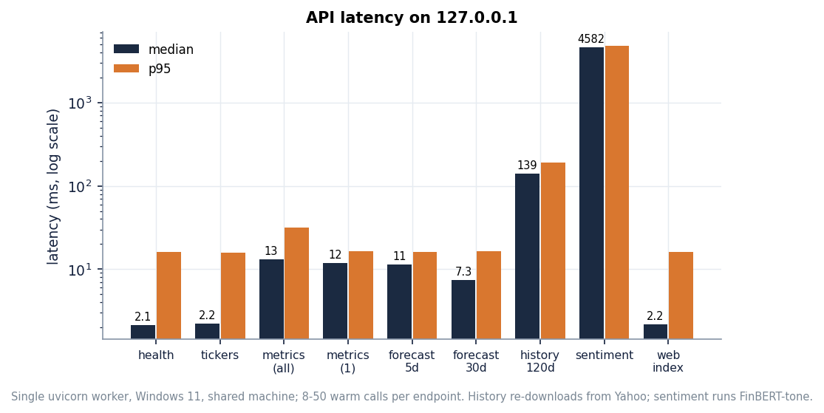
Figure 18: Median and 95th-percentile response time of each endpoint (log scale).
The routes that serve stored results (health, tickers, metrics, forecasts, errors, the built page) answer in a median of about 1 to 13 ms; the 95th percentile of about 16 ms across them is the resolution of the Windows timer, not a real tail. Two routes are different in kind. /api/history re-downloads the prices from Yahoo Finance on every request and rewrites a CSV, which costs a median of 139 ms (680 ms on the first call). /api/sentiment scores the headlines with FinBERT on the CPU on every request: median 4.6 s and 6.0 s for the first call, which is why the website shows a patient progress state and allows a 240-second timeout. Neither is cached, so both would be the first things to fix before real use (Chapter 10).
The training pipeline (python -m backend.train) is not a latency problem but a set-up cost: the README quotes 5 to 10 minutes on a CPU for ten tickers; the five-seed re-run of the same pipeline took 34 minutes while the machine was also running other jobs. No load test with many simultaneous users was run; the API holds its caches in module globals and has no state that concurrent readers would corrupt, but that was not tested.

7.8 User acceptance
No formal user-acceptance test was carried out. There was no panel of traders or analysts, no questionnaire and no usability metric. What exists is a repeatable walkthrough: open the dashboard, pick a ticker, read the 5-day outlook, compare it with the actual closes on the same chart, switch to 30 days, open the model comparison and read the ablation, open the sentiment screen and read its source banner. Each step was executed by the screen-capture script with real data, so it is known to work, but whether a trader would find the forecasts useful is answered by Chapter 8, not by acceptance testing, and the answer is that they would not have been: the stored forecasts missed the realised moves.

7.9 Findings from testing
Writing the tests and running the experiments produced findings that are recorded rather than hidden. They change how the product should be described rather than how it passes its tests.
• The evaluation clips its targets (Section 7.6.1): directional accuracy of 67 to 68 % in the shipped table is 53 % on the real closes.
• The sentiment tier is trained on an all-zero channel, so the ablation cannot show an effect of sentiment.
• The stored forecasts were wrong in direction for six of ten tickers over five trading days (Chapter 8).
• Reads overwrite data: every /api/history call rewrites data/<T>.csv, so the experiments use a pinned snapshot; the API also never loads the saved .keras models, it serves stored JSON.
• No multiple-instance component and no precision, recall or F1 in the product; they exist only in the offline study.

7.10 Limits of the testing done
• The unit tests assert intended behaviour. 56 passing pytest cases and 26 passing smoke checks show the software does what it was written to do; they say nothing about whether the forecasts are good.
• The React components are untested apart from the screen walk; no accessibility or cross-browser audit beyond Chrome/Chromium.
• External services were live during the smoke run (Yahoo Finance, Hugging Face); the unit and API tests use stubs.
• Statistical power is small: ten tickers, 97 test windows each, five seeds; the forward test covers one 30-day period after one training date.
• No concurrency, endurance, Docker, clean-machine (`run.bat`) or security audit was run.

8. RESULTS AND OUTPUT SCREENS

8.1 Experimental set-up
All measurements were made on one machine: Intel Core i5-12500 (12 threads), 15.7 GB memory, no GPU, Windows 11, Python 3.11.9, TensorFlow 2.16.2, scikit-learn 1.9.0, PyTorch 2.5.1 (CPU) for FinBERT-tone and the MIL models, FastAPI 0.141.1. The machine was shared with other jobs, so timings are indicative; accuracy numbers do not depend on load. Every table and figure comes from stored JSON written by the scripts in scripts/ or from the shipped artifacts/metrics.json; no result was typed in by hand.
Table 32: Data used in the evaluation.
Item | Content | Source and status
Prices (product and re-run) | Ten tickers, daily OHLCV, 501 rows each, 2024-09-09 to 2026-09-08; 400 / 101 chronological split, 97 deep-model test windows | Yahoo Finance through yfinance; pinned snapshot experiments/data_snapshot/ reproduces every stored last close
Prices (forward test) | The same ten tickers, 30 trading days after 2026-09-08 (to 2026-10-20) | Same snapshot; used only to score the stored forecasts
Headlines in the product | Synthetic template headlines, 166-191 per ticker, last 90 trading days only, scored by FinBERT-tone | news_source = synthetic-fallback (no NewsAPI key)
Headlines in the MIL study | 46,532 real headlines for 7 tickers, dense from 2022; bags of mean size 19.1 on test days with news | FNSPID news [11], public mirror; all stamps day-level; GOOGL, META, IBM absent or too sparse
Prices in the MIL study | The seven tickers, 2016-01-04 to 2023-12-29 | Yahoo Finance snapshot experiments/data_snapshot/mil/

Protocol: the shipped code is re-run unchanged on the same 501 rows with 5 seeds (42, 43, 44, 45, 46); the ten-ticker mean is taken per seed, then mean and standard deviation over seeds. 'Shipped scoring' is the product's own evaluate_dl; 'true scoring' compares the same predictions with the real closes; 'persistence' forecasts today's close as yesterday's. The MIL study uses three expanding-window folds tested on Q2, Q3 and Q4 2023 (1,309 pooled test samples) and five seeds. Nothing was tuned on test data.

8.2 Output screens
The screens are real captures of the running website (1440 x 900) with the shipped artefacts and live Yahoo prices. QuantPulse has no login, so the landing page leads straight to the dashboard.
Figure 19: Landing page: live price chart and entry to the application. | 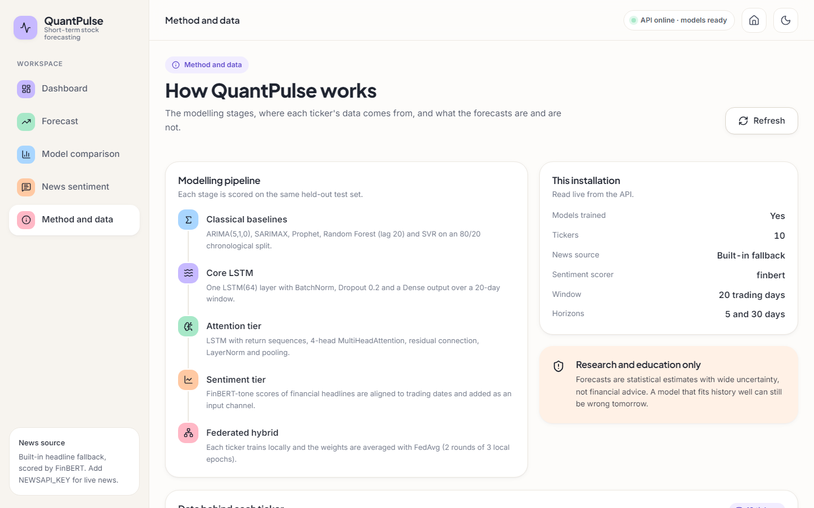  Figure 20: Method and data screen: universe, pipeline and model table.

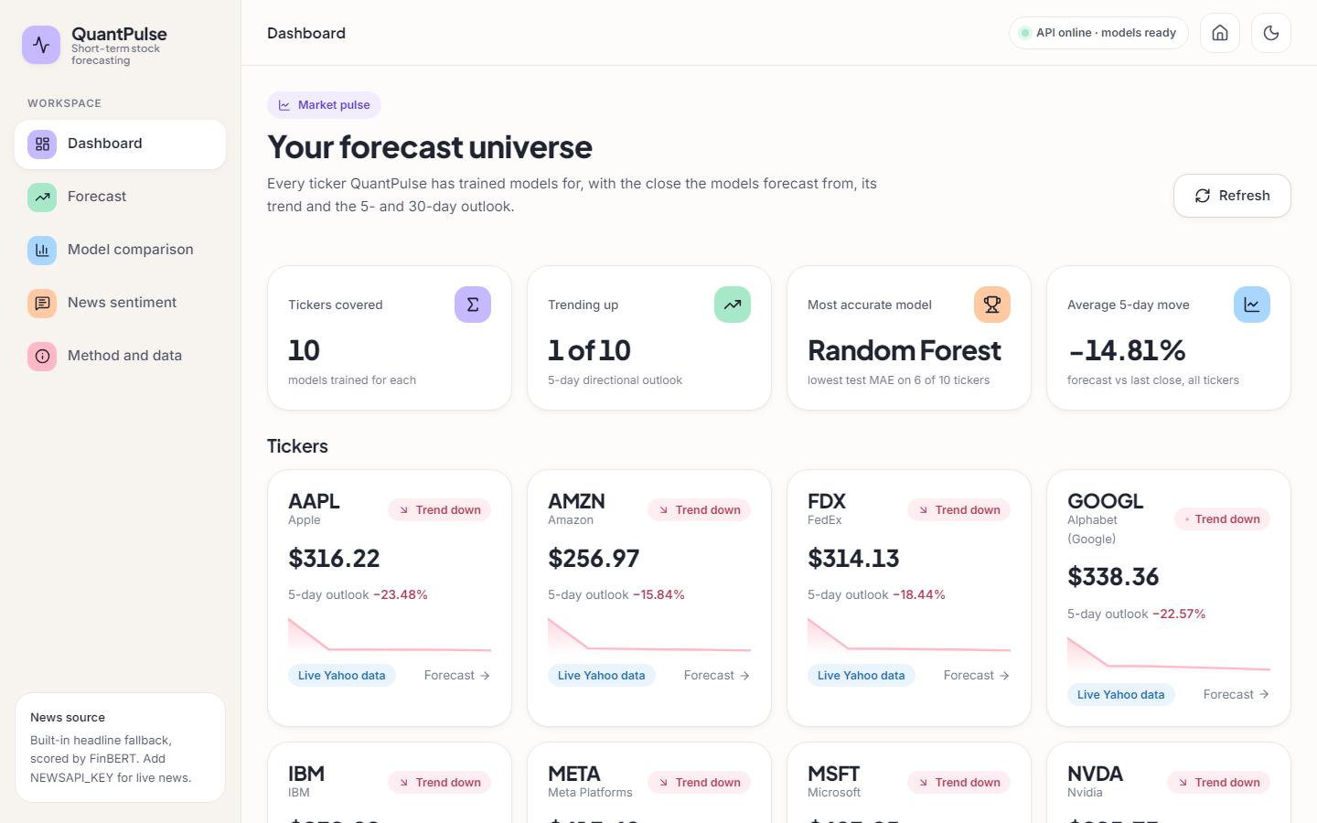  Figure 21: Dashboard: one card per ticker with last close, trend, 5-day outlook and data mode. | 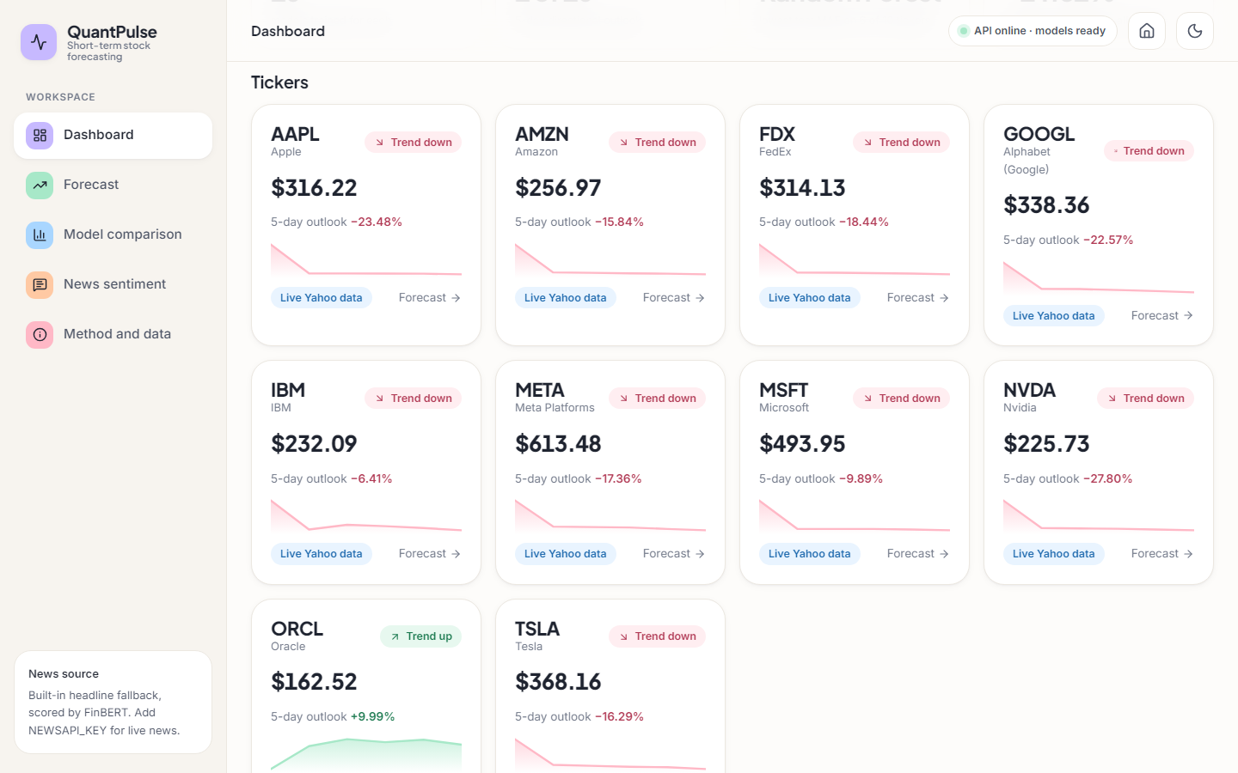  Figure 22: Dashboard scrolled to the ticker grid.

The dashboard reads: ten tickers covered, 1 of 10 trending up, 'Most accurate model: Random Forest' (lowest test MAE on 6 of 10 tickers) and an average 5-day move of -14.81 %. 9 cards show 'Trend down', with outlooks from -27.8 % to +10.0 %, which already looks implausible for five days; Section 8.5 scores them.
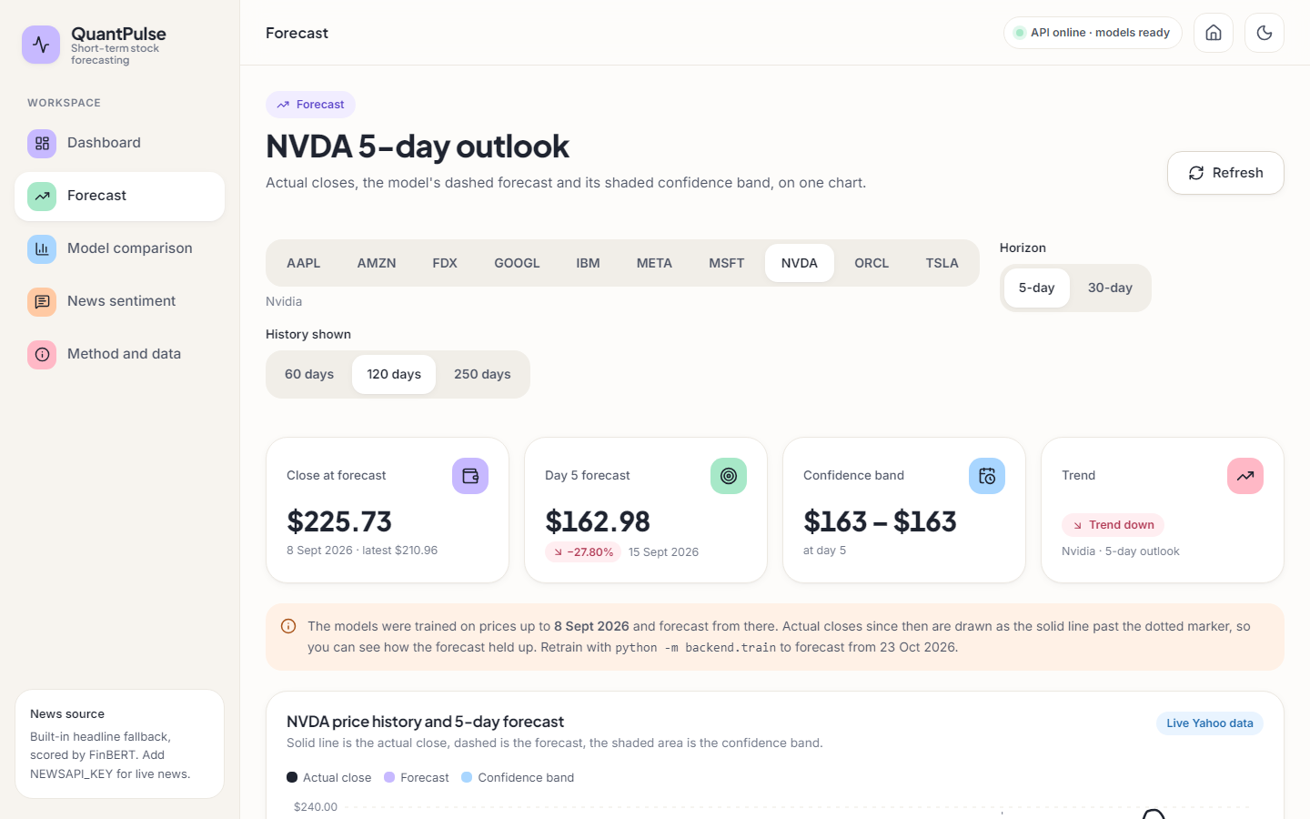
Figure 23: Forecast screen for NVDA: close at forecast, day-5 forecast, band, trend, controls and the notice about the training date.
For NVDA the tiles read: close at forecast $225.73 (8 September 2026), day-5 forecast $162.98 (-27.80 %), a band that rounds to $163 - $163, and 'Trend down'. An orange notice says the models were trained up to 8 September 2026 and that actual closes since then are drawn past the dotted marker. The band is narrow because it is built from the one-step residual spread; it does not express the uncertainty of a multi-step forecast.
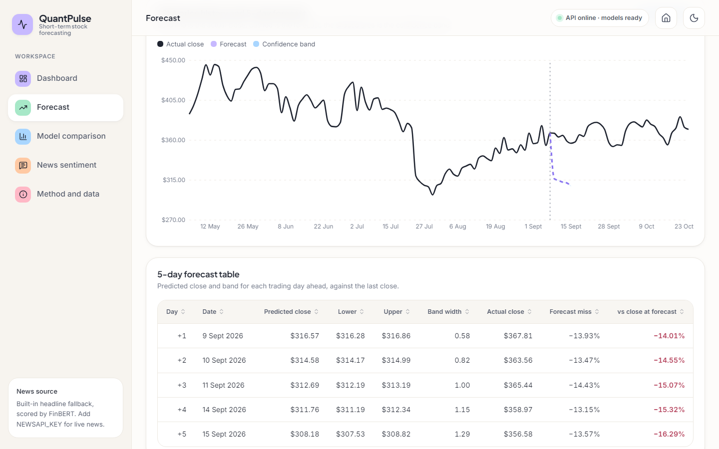  Figure 24: TSLA 5-day forecast: actual closes (solid), forecast (dashed), band. | 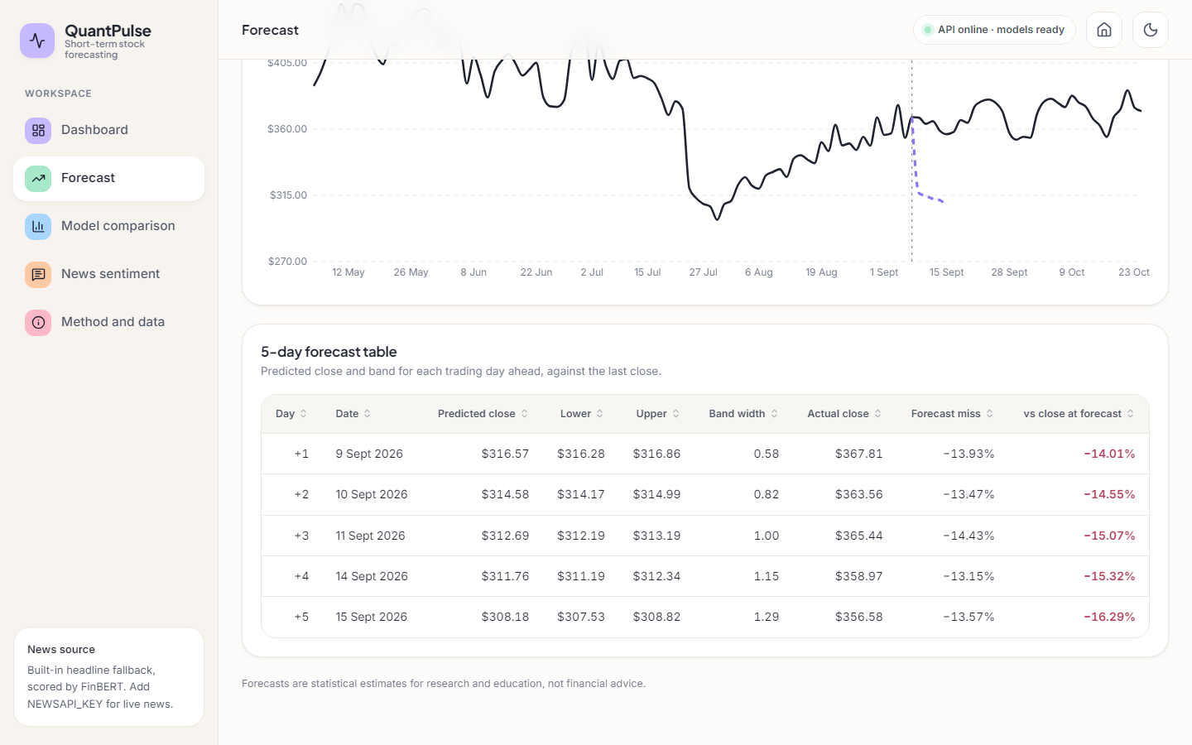  Figure 25: TSLA forecast table: predicted close, band, actual close and forecast miss.

The TSLA forecast falls from $368.16 to $308.18 in five days while the actual close stays between about $355 and $370. The table adds the realised close for each day: the day-1 forecast is $316.57 against an actual $367.81, a miss of about 14 % that does not shrink. The screen documents its own error; that view was added by the front end, not by the model.
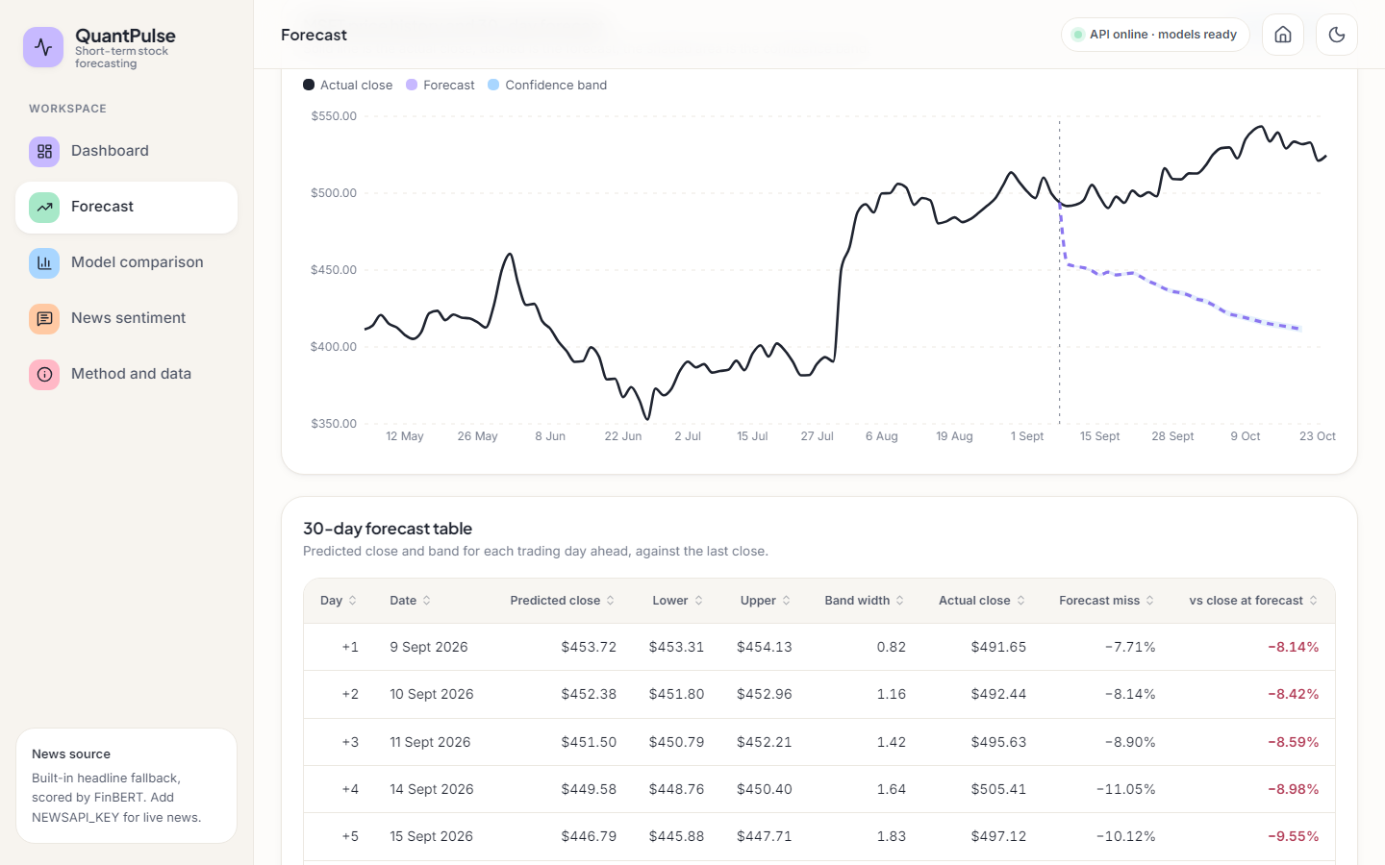
Figure 26: MSFT 30-day forecast (horizon = long).
The stored 30-day forecast for MSFT is -16.7 % at day 30; the realised change over the same 30 trading days was +7.7 %.
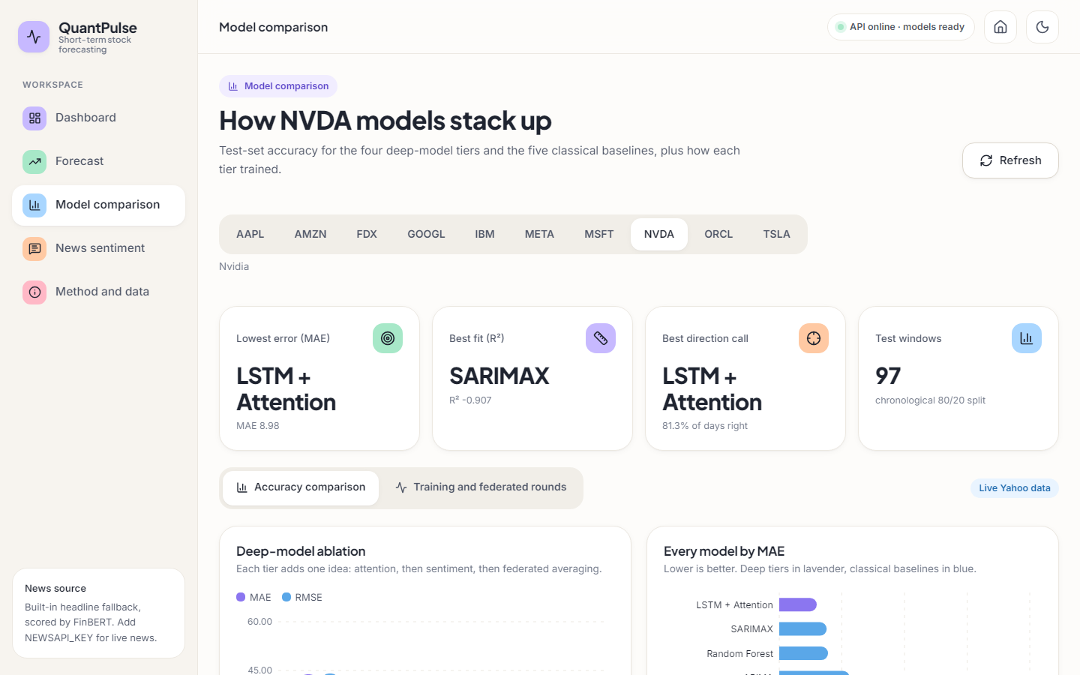  Figure 27: Model comparison for NVDA: best-model tiles and deep-model ablation chart. | 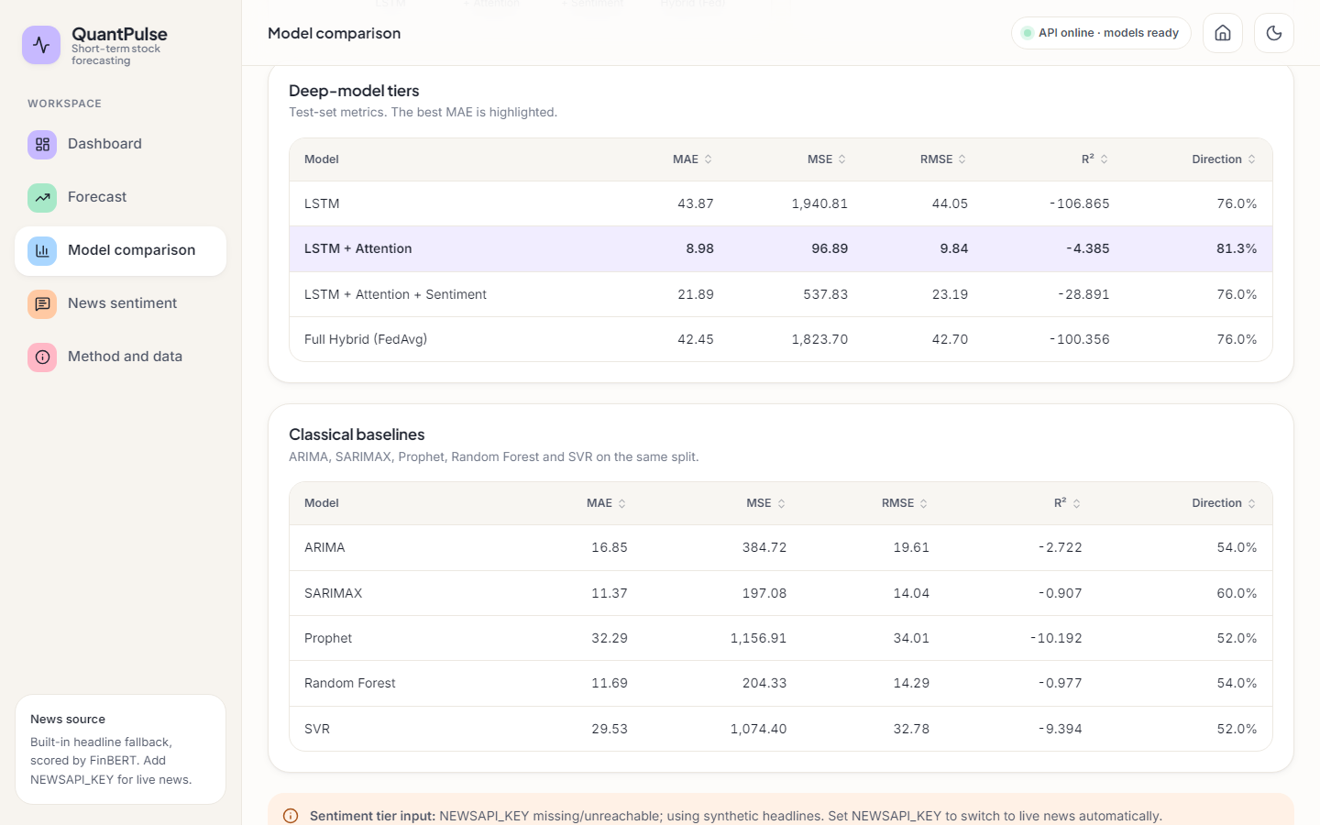  Figure 28: Deep-model metrics table for NVDA with the best MAE highlighted.

For NVDA the tiles name LSTM + attention as the lowest-error model (MAE 8.98) and SARIMAX as the best fit (R² -0.907) on the 97 test windows; the table lists the four deep tiers with MAE, MSE, RMSE, R² and direction.
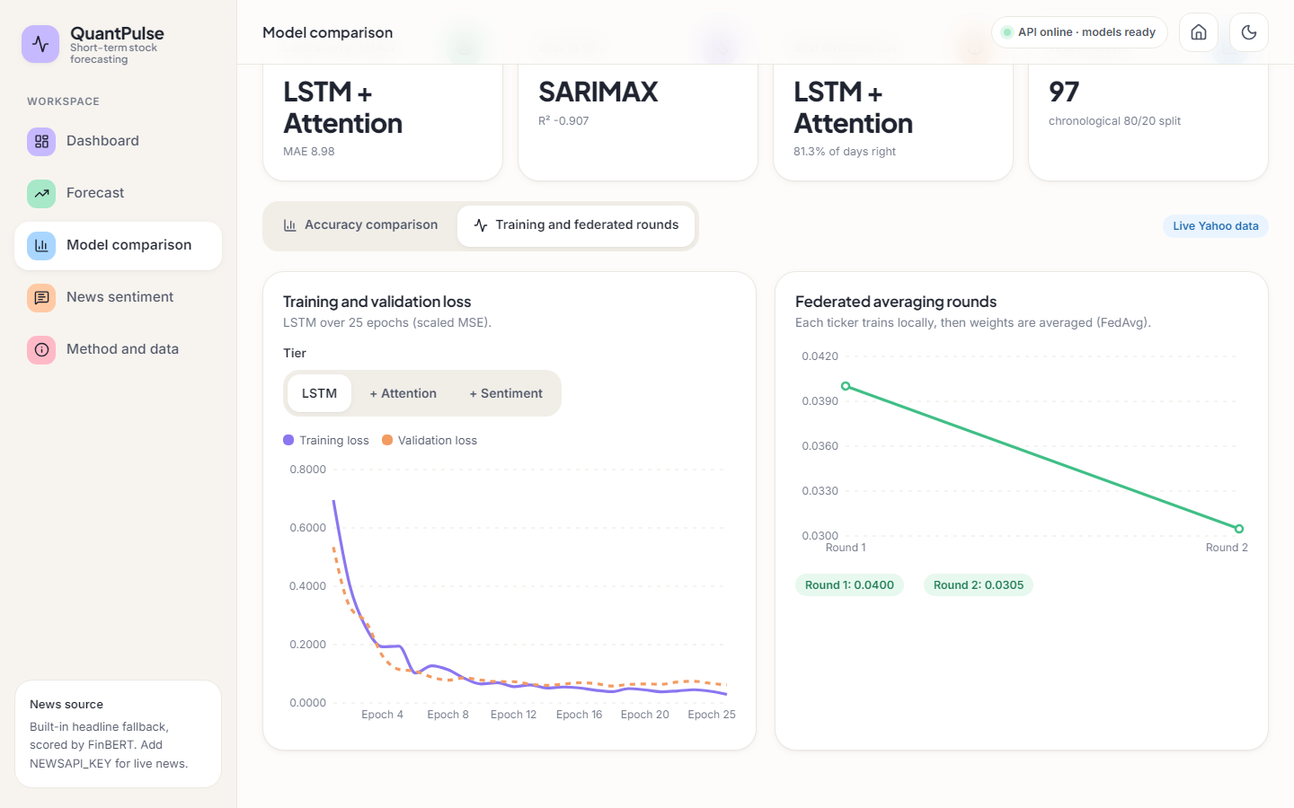  Figure 29: Training tab: loss curves and federated rounds. | 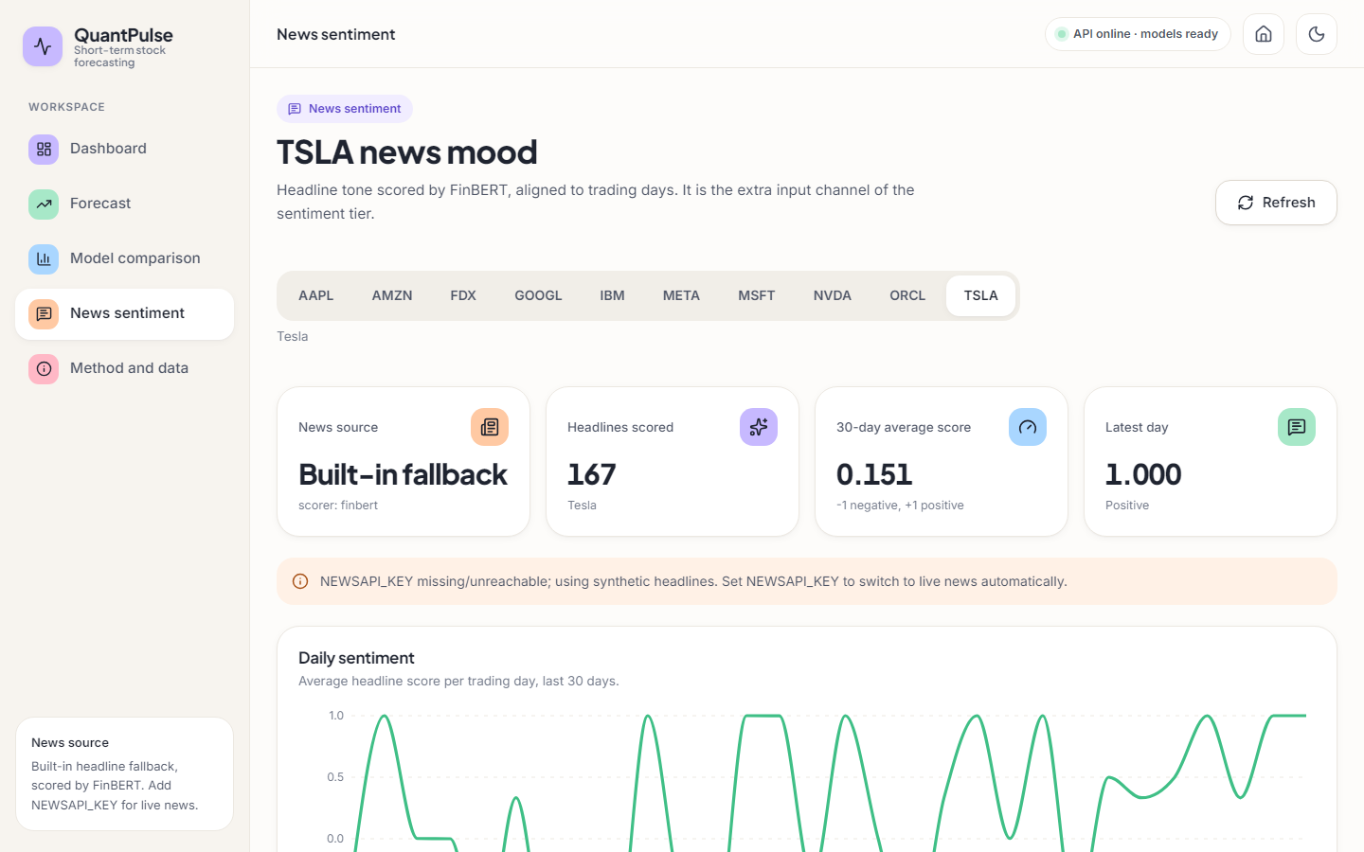  Figure 30: News sentiment for TSLA: source, headlines scored, average score.

Mean local loss falls from 0.0400 in federated round 1 to 0.0305 in round 2; this shows the clients fit their own data, not that the averaged model predicts well (Section 8.4). The sentiment screen is explicit about its source: 'Built-in fallback', scorer FinBERT, and a banner that NEWSAPI_KEY is missing. The headlines are template sentences ('TSLA hits record revenue on enterprise adoption surge'), so the daily score swings between -1 and +1. The screen shows 167 headlines for TSLA while the stored artefact records 183: the generator is seeded with Python's per-process string hash, so the headlines are not reproducible between runs.

8.3 Model performance as shipped
The numbers the application displays come from artifacts/metrics.json, written once by python -m backend.train on data ending 8 September 2026 (seed 42, 97 test windows per ticker). Table 8.1 averages them over the ten tickers.
Table 33: Shipped test metrics, mean over ten tickers (MAE and RMSE in dollars; direction is the product's own figure).
Model | MAE | MAE range | RMSE | R² mean | R² median | Direction
ARIMA(5,1,0) | 30.68 | 12.0 - 64.7 | 36.52 | -1.72 | -0.93 | 53.8 %
SARIMAX | 32.93 | 11.4 - 82.4 | 38.84 | -1.60 | -1.01 | 50.1 %
Prophet | 62.33 | 32.3 - 144.0 | 68.94 | -9.47 | -9.79 | 50.5 %
Random Forest (lag-20) | 13.18 | 6.3 - 23.5 | 17.16 | -0.12 | -0.08 | 52.3 %
SVR (rbf) | 27.79 | 11.6 - 59.5 | 32.63 | -4.70 | -2.91 | 51.1 %
LSTM | 44.11 | 14.9 - 92.2 | 47.84 | -89.81 | -2.34 | 67.9 %
LSTM + attention | 22.36 | 9.0 - 50.9 | 26.34 | -15.77 | -1.32 | 67.2 %
LSTM + attention + sentiment | 29.33 | 7.4 - 46.6 | 33.77 | -18.58 | -1.61 | 58.9 %
Hybrid (FedAvg) | 44.72 | 21.4 - 79.1 | 49.34 | -67.73 | -11.21 | 66.9 %

Three points stand out. The Random Forest on lagged closes has the lowest MAE for 6 of ten tickers and the lowest mean MAE (13.18), better than every deep tier. Attention helps (LSTM 44.11 to 22.36), but sentiment (29.33) and FedAvg (44.72) make the error larger again, the opposite of the base paper's staircase. Almost every mean R² is negative and is dominated by single tickers (LSTM mean -89.8, median -2.34), so medians are fairer.

8.4 Re-run on the same training rows: true scoring, persistence and seeds
The unchanged pipeline was re-run on the same 501 rows with 5 seeds. It reproduces the shipped picture (LSTM + attention is the best deep tier; sentiment and FedAvg make it worse) and adds a persistence baseline, scoring against the real closes, and seed-to-seed spread.
Table 34: Re-run, ten-ticker mean per seed, then mean ± std over 5 seeds (dollars).
Model | MAE (shipped scoring) | MAE (true scoring) | R² (true) | Direction (true) | Direction (shipped)
LSTM | 47.81 ± 1.07 | 53.71 ± 1.07 | -17.67 ± 0.83 | 53.1 % | 68.2 %
LSTM + attention | 23.47 ± 1.38 | 29.37 ± 1.39 | -3.49 ± 1.17 | 53.0 % | 68.3 %
LSTM + attention + sentiment (synthetic headlines) | 31.67 ± 7.68 | 37.55 ± 7.69 | -4.76 ± 1.92 | 52.0 % | 67.4 %
Placebo: attention + time-shuffled sentiment | 23.20 ± 1.76 | 29.09 ± 1.76 | -2.88 ± 0.87 | 52.9 % | 68.3 %
Hybrid (FedAvg of the sentiment tier) | 37.80 ± 11.14 | 43.70 ± 11.14 | -8.35 ± 4.74 | 51.7 % | 67.0 %
ARIMA(5,1,0) | - | 30.68 | -1.72 | 53.8 % | -
Random Forest (lag-20, one step) | - | 13.18 | -0.12 | 52.0 % | -
SVR (rbf, one step) | - | 27.79 | -4.70 | 51.1 % | -
Persistence (yesterday's close) | - | 6.24 | - | up-day share 49.1 % | -

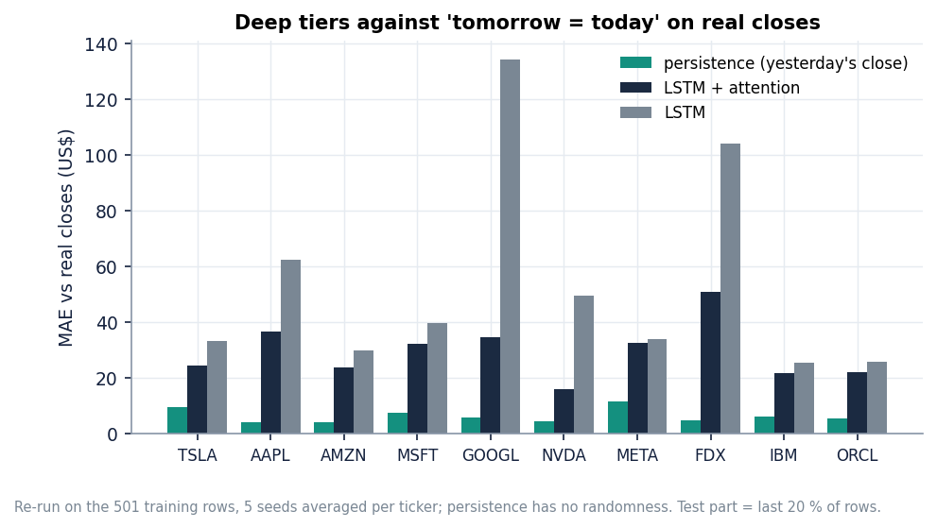
Figure 31: True-target MAE of LSTM + attention (five seeds) against persistence, per ticker.
Persistence beats every deep tier. Predicting that tomorrow's close equals today's gives a mean absolute error of $6.24; the best deep tier, LSTM + attention, scores $29.37 on the same days, about 4.7 times larger, for every one of the ten tickers. The lag-20 Random Forest ($13.18) is closest and is still about twice persistence: the deep networks learn a smoothed level of the price, not the next price.
The product's scoring flatters the deep tiers. evaluate_dl compares predictions with targets that passed through the training-range scaler; for a ticker whose test prices rise above the training maximum the target is clipped to 1.0 and is flat. Shipped directional accuracy is about 67 to 68 % for every deep tier, while the same predictions scored on the real closes give 52 to 53 %, a coin flip against an up-day share of 49 %. The MAE is understated by about $6 for the same reason.
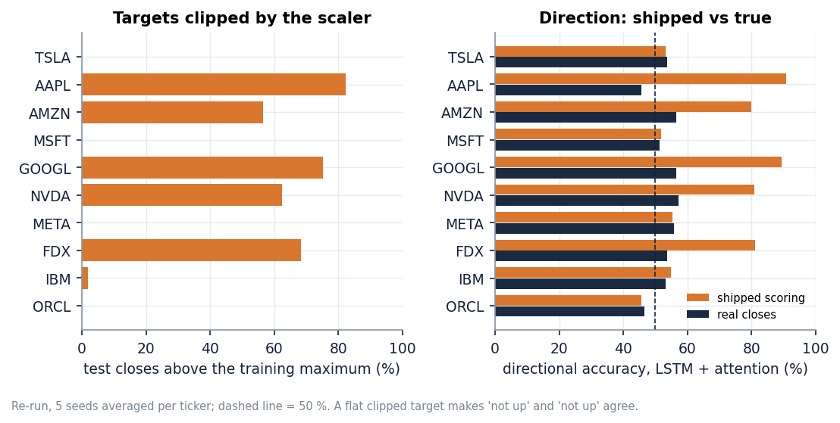
Figure 32: Share of test closes above the training maximum per ticker, and shipped against true directional accuracy.
The five tickers that rallied above their training range (AAPL, AMZN, GOOGL, NVDA, FDX) are exactly those with shipped directional accuracy above 75 %; for TSLA, MSFT, META, IBM and ORCL the shipped figure (46 to 57 %) is close to the true one. The high numbers are the result of agreeing on 'not up' when both the clipped target and the saturated prediction are flat.
Seed spread matters for the tiers with sentiment and federation: the standard deviation of the ten-ticker MAE is 1.4 for LSTM + attention but 7.7 with the sentiment channel and 11.1 for the federated model, as large as some of the differences, so a single-seed ablation can rank them either way.

8.5 Forward test: the stored forecasts against the closes that followed
The only evaluation that mirrors how the product is used is to forecast from a date and wait. The shipped forecasts start at the 2026-09-08 close; the real closes of the next 30 trading days (to 2026-10-20) come from the pinned snapshot, whose close on 8 September equals the stored last_close for all ten tickers.
Table 35: Stored 5- and 30-day forecasts against what happened (change in % from the 8 September close; MAE in dollars over the horizon).
Ticker | Close | 5d fcst | 5d actual | 5d MAE | Persist. | Trend ok | 30d fcst | 30d actual | 30d MAE | Persist.
TSLA | 368.16 | -16.3 % | -3.1 % | 49.72 | 5.69 | yes | +12.8 % | +1.5 % | 46.52 | 8.02
AAPL | 316.22 | -23.5 % | +4.8 % | 84.12 | 11.85 | no | -2.8 % | +7.4 % | 35.71 | 19.67
AMZN | 256.97 | -15.8 % | -3.3 % | 34.99 | 4.36 | yes | -9.8 % | +2.2 % | 22.23 | 5.20
MSFT | 493.95 | -9.9 % | +0.6 % | 49.78 | 4.02 | no | -16.7 % | +7.7 % | 81.44 | 21.02
GOOGL | 338.36 | -22.6 % | +2.0 % | 71.87 | 6.25 | no | -6.5 % | +0.6 % | 24.74 | 7.53
NVDA | 225.73 | -27.8 % | -6.0 % | 51.06 | 9.04 | yes | -41.4 % | -4.1 % | 68.79 | 6.23
META | 613.48 | -17.4 % | +9.3 % | 141.53 | 42.91 | no | +6.6 % | +13.2 % | 63.60 | 100.47
FDX | 314.13 | -18.4 % | -1.9 % | 52.59 | 3.37 | yes | -20.4 % | -4.9 % | 41.27 | 18.81
IBM | 232.09 | -6.4 % | +7.0 % | 24.49 | 10.85 | no | +2.7 % | +4.2 % | 10.07 | 6.76
ORCL | 162.52 | +10.0 % | -13.6 % | 30.28 | 12.52 | no | -5.7 % | -19.3 % | 16.65 | 21.16

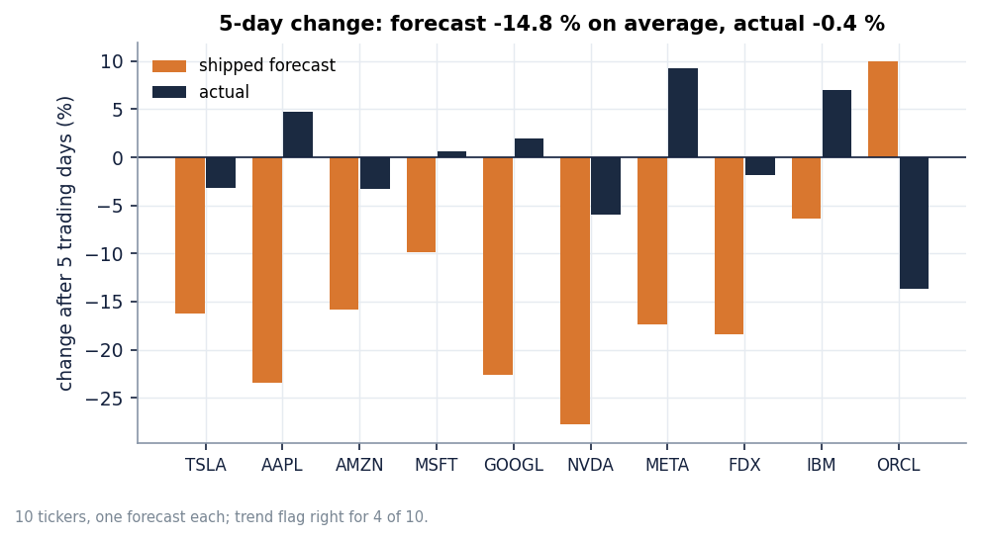
Figure 33: Predicted against actual 5-day change per ticker.
Over five trading days the stored forecasts have a mean absolute error of $59.04 (MAPE 17.7 %), against $11.09 for 'no change'. They predicted an average move of -14.8 %; the stocks moved -0.4 % on average. The up/down flag shown on the dashboard was right for 4 of 10 tickers, fewer than a coin flip would give on average. Over 30 days the error is $41.10 against $21.49 for 'no change', with a correct trend call for 6 of 10.
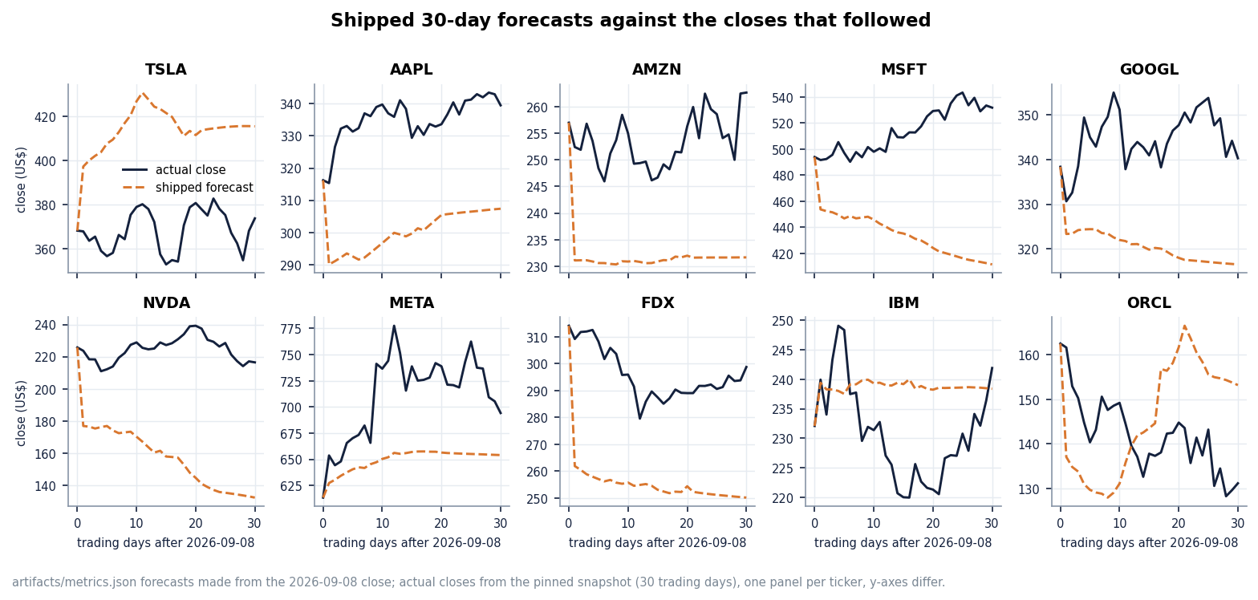
Figure 34: Actual closes and the stored 30-day forecast for each ticker (forecast starts at the 8 September close).
Table 36: Forward test of the re-trained tiers (ten tickers x five seeds) and of the shipped artefact: mean absolute error in dollars and mean predicted 5-day change.
Model | 5-day MAE | 30-day MAE | Mean 5-day change
LSTM | 53.92 | 66.04 | -15.3 %
LSTM + attention | 26.81 | 37.06 | -6.6 %
LSTM + attention + sentiment (synthetic headlines) | 38.59 | 53.14 | -4.6 %
Placebo: attention + time-shuffled sentiment | 27.63 | 37.17 | -7.8 %
Hybrid (FedAvg of the sentiment tier) | 42.37 | 57.75 | -9.2 %
Persistence ('no change') | 11.09 | 21.49 | 0.0 %
Shipped artefact (seed 42) | 59.04 | 41.10 | -14.8 %

Re-training does not change the verdict: every tier is several times worse than 'no change'. The stored forecasts are biased downwards because the recursive forecast feeds each predicted close back as Open, High, Low and Close while the scaler has clipped the recent window to the training range, so the window the model sees after a rally is not the window of a rally.

8.6 What the sentiment channel contains
The product's sentiment path is: NewsAPI if a key is set, otherwise template headlines; FinBERT-tone scores; a daily mean; forward fill; zero before the first headline. No key was set, so the channel is built from templates, and the generator only writes headlines for the last 90 trading days.
Table 37: Sentiment channel per ticker in the training run (rows of the 501-row series).
Ticker | Synthetic headlines | Non-zero rows in the training part (400 rows) | Non-zero rows in the test part (101 rows)
TSLA | 183 | 0 | 83
AAPL | 185 | 0 | 89
AMZN | 182 | 0 | 86
MSFT | 176 | 0 | 89
GOOGL | 181 | 0 | 90
NVDA | 170 | 0 | 83
META | 180 | 0 | 88
FDX | 181 | 0 | 86
IBM | 189 | 0 | 88
ORCL | 181 | 0 | 89

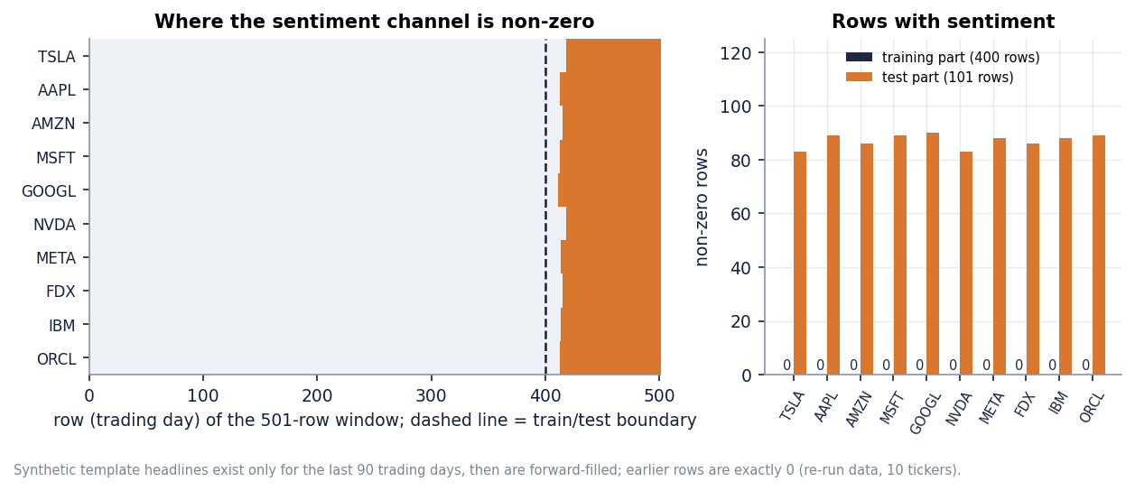
Figure 35: Non-zero sentiment rows in the training and test parts for each ticker, and the TSLA channel over time.
For every ticker the channel is exactly zero throughout training and non-zero only in the test part. The 'sentiment' tier is trained on a constant input and evaluated on random template values, which is why it is worse than the attention tier (MAE 37.55 ± 7.69 against 29.37 ± 1.39) and unstable across seeds; a placebo with time-shuffled sentiment, non-zero in training too, scores 29.09 ± 1.76, the same as no sentiment. The row 'LSTM + attention + sentiment' therefore measures nothing about news and must not be read as 'sentiment hurts' or 'helps'.

8.7 Comparison with the base paper
The base paper [1] reports an average R² of 0.91 for its hybrid model over ten companies (all above 0.84), for Tesla MSE 0.039, MAE 0.179 and R² 0.888 (scaled units), and an average trend accuracy of 65.36 % for its baseline LSTM (Airbnb 94 %, Google 86 %; Tesla 34.9 %, IBM 18 %). The datasets and protocols are not the same, which this table makes explicit.
Table 38: Base paper against this project: what is comparable and what is not.
Aspect | Base paper | QuantPulse (this project)
Data window | one month (30 days of NewsAPI headlines) for the hybrid; three months for the 5-day LSTM trend accuracy | Two years of daily bars; 97 test windows per ticker
News | NewsAPI headlines, 30 days | Synthetic template headlines (no key); real headlines only in the offline MIL study
Hybrid R² (mean) | 0.91 | -67.7 (median -11.2); best deep tier -15.8 (median -1.32)
Trend / direction | 65.36 % (LSTM, 100 runs per company) | Shipped 67.9 % (clipped scoring); 53.1 % on the real closes
Ablation order | Each addition improves the result | Attention helps; sentiment and FedAvg do not (sentiment channel empty in training)

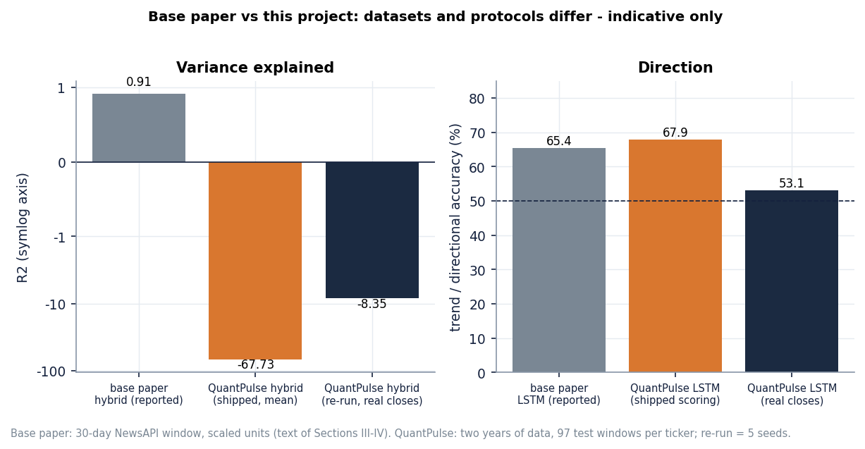
Figure 36: Base paper's reported figures next to the measured ones. The datasets and protocols differ, so the bars are not a like-for-like comparison.
The base paper's R² of 0.91 was not reproduced here, and these experiments do not show that it is wrong: a short window, scaled targets and a test period inside the training range can give a high R² to a level forecaster, while a two-year window with a rally in the test period gives a negative one. What they do show is that on the longer window the same architecture does not beat 'no change' and that the staircase from LSTM to the full hybrid does not hold when the sentiment channel is empty in training. The paper itself notes that sentiment was limited to 30 days and that federated learning was only simulated; both limits apply here too.

8.8 Multiple-instance learning on real headlines (offline study)
The batch objectives ask for each trading day to be a bag of news instances with a bag-level label, evaluated with accuracy, precision, recall and F1 against a price-only baseline. QuantPulse does not contain this, so the study was run separately (scripts/mil_study.py). A bag is all FNSPID headlines of one ticker published before a trading day's close; an instance is its three FinBERT-tone probabilities plus a 64-component projection of its [CLS] vector; the label is whether the next close is above today's. Seven tickers have enough headlines (AAPL, AMZN, FDX, MSFT, NVDA, ORCL, TSLA); the news is dense only from 2022, so three expanding-window folds are tested on Q2, Q3 and Q4 2023 and pooled (1,309 samples, 53.6 % up days). 94 % of test-day bags are non-empty, with a mean of 19.1 headlines (95th percentile 44; capped at 24).
Table 39: Directional prediction on 1,309 pooled test samples (mean ± std over 5 seeds; threshold 0.5; positive class = up).
Model | Accuracy | Precision | Recall | F1 | ROC-AUC | Predicted up
Majority class (train) | 0.513 ± 0.000 | 0.574 ± 0.000 | 0.355 ± 0.000 | 0.438 ± 0.000 | 0.525 ± 0.000 | 33 %
Logistic regression, price (C=0.01) | 0.473 ± 0.000 | 0.514 ± 0.000 | 0.315 ± 0.000 | 0.390 ± 0.000 | 0.495 ± 0.000 | 33 %
Logistic regression, price (C=1) | 0.486 ± 0.000 | 0.530 ± 0.000 | 0.362 ± 0.000 | 0.430 ± 0.000 | 0.497 ± 0.000 | 37 %
LSTM, price only (same window) | 0.488 ± 0.011 | 0.544 ± 0.017 | 0.330 ± 0.203 | 0.374 ± 0.146 | 0.518 ± 0.019 | 33 %
LSTM, price only (all history since 2016) | 0.536 ± 0.005 | 0.538 ± 0.004 | 0.955 ± 0.034 | 0.688 ± 0.007 | 0.494 ± 0.007 | 95 %
LSTM + flat mean sentiment | 0.491 ± 0.005 | 0.553 ± 0.007 | 0.272 ± 0.075 | 0.358 ± 0.066 | 0.524 ± 0.016 | 26 %
LSTM + MIL mean pooling | 0.500 ± 0.011 | 0.543 ± 0.008 | 0.451 ± 0.196 | 0.472 ± 0.101 | 0.505 ± 0.016 | 45 %
LSTM + MIL max pooling | 0.501 ± 0.007 | 0.536 ± 0.001 | 0.521 ± 0.087 | 0.525 ± 0.044 | 0.497 ± 0.005 | 52 %
LSTM + MIL gated-attention pooling | 0.498 ± 0.007 | 0.556 ± 0.023 | 0.335 ± 0.043 | 0.415 ± 0.029 | 0.514 ± 0.012 | 33 %
MIL attention, news only (no prices) | 0.514 ± 0.018 | 0.536 ± 0.007 | 0.683 ± 0.192 | 0.589 ± 0.079 | 0.486 ± 0.007 | 68 %
Placebo: MIL attention with other days' bags | 0.498 ± 0.013 | 0.558 ± 0.021 | 0.315 ± 0.103 | 0.393 ± 0.077 | 0.513 ± 0.015 | 30 %

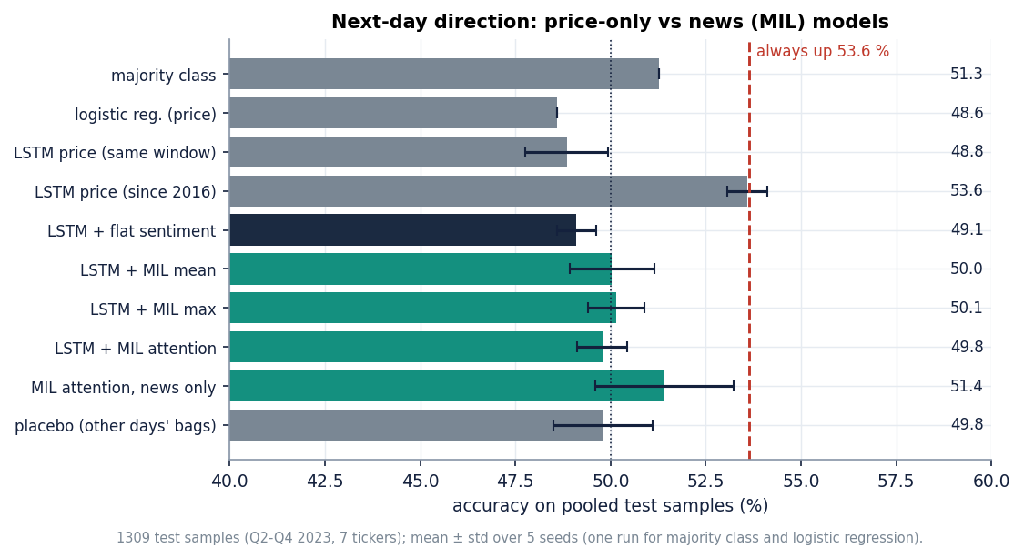
Figure 37: Accuracy of each model in the MIL study; the dashed line is the always-up rate (53.6 %).
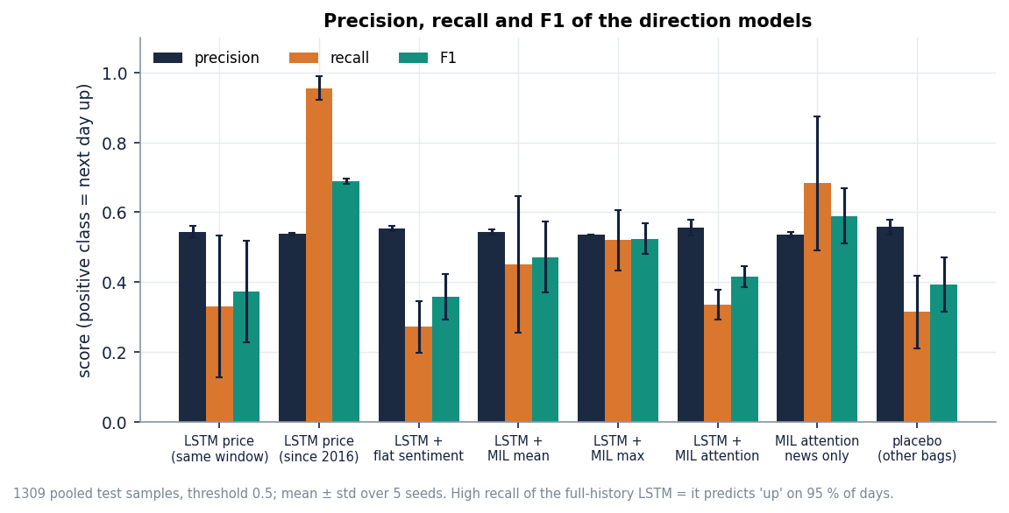
Figure 38: Precision, recall and F1 of the models in the MIL study.
No model beats always predicting 'up' (53.6 %). The LSTM on the same short window scores 48.8 % accuracy; the MIL variants score 49.8 % (gated attention), 50.0 % (mean) and 50.1 % (max), with AUC between 0.50 and 0.51. The full-history price LSTM reaches 53.6 % only by predicting 'up' on 95 % of days (recall 0.96, which also explains its F1 of 0.69); the F1 column of the other models mostly reflects how often each one happens to say 'up'. The placebo, which gives each day the bag of a different day of the same ticker, scores the same as the real bags, which is what a model without news signal should do.
Table 40: Paired bootstrap against the same-window price-only LSTM: accuracy difference in percentage points (95 % interval, 2,000 resamples of the seed-averaged predictions).
Model | Difference (points) | 95 % interval
LSTM, price only (all history since 2016) | +5.1 | [+0.2, +10.1]
LSTM + flat mean sentiment | +1.3 | [-0.7, +3.1]
LSTM + MIL mean pooling | +2.1 | [-0.9, +5.2]
LSTM + MIL max pooling | +1.2 | [-2.1, +4.8]
LSTM + MIL gated-attention pooling | +1.3 | [-1.5, +4.0]
MIL attention, news only (no prices) | +2.4 | [-1.8, +6.3]
Placebo: MIL attention with other days' bags | +0.8 | [-1.9, +3.4]

Every news-based variant is one to two points above the same-window price LSTM and every interval includes zero; the only interval that excludes zero belongs to the full-history price model, whose gain is the always-up effect. With 1,309 test samples a difference of three points is within noise: the reading is no evidence of a gain from news in this data, not evidence of no gain.
What does the gated attention look at? The examples below, taken from the last fold, list the two highest-weighted headlines for three test days. The weights are close to the uniform weight 1/n of a bag of n headlines (in the eight stored examples the top-weighted headline never exceeds 1.2 times its bag's uniform weight), the predicted probability of an up day stays near 0.50, and the highest-weighted headlines are not obviously about the ticker: the instances are noisy because FNSPID assigns an article to every company it names or lists. This is the situation multiple-instance learning is meant for, but with this data and sample size the attention did not learn to pick out informative instances.
Limits: seven tickers and one year of dense news; day-level stamps only; headlines cut to their first line; no social-media source; small models with no tuning beyond early stopping. A negative result does not show that multi-source MIL cannot work, only that a reasonable first implementation found nothing at this scale.

8.9 Sample inputs and outputs
A request is a ticker symbol and optionally a horizon or a history length; there is no other input. A call to GET /api/forecast/TSLA?horizon=short returns the stored forecast (first two of five rows shown):
{
"ticker": "TSLA",
"horizon": "short",
"last_close": 368.16,
"trend": "down",
"forecast": [
{
"day": 1,
"predicted_close": 316.57,
"lower": 316.28,
"upper": 316.86
},
{
"day": 2,
"predicted_close": 314.58,
"lower": 314.17,
"upper": 314.99
}
]
}

A request that fails validation returns a readable message: GET /api/forecast/T5LA gives status 400 with 'Invalid ticker', GET /api/forecast/TSLA?horizon=weekly gives 422 and an unknown valid symbol such as ZZZZ gives 404.

8.10 Success and failure analysis

8.10.1 Where it worked
• The software. Seven endpoints, six screens, 56 unit and API tests and 26 smoke checks pass; stored results answer in a median of 2 to 13 ms.
• Classical baselines. The Random Forest has the lowest shipped MAE for 6 of ten tickers and is the closest model to persistence in the re-run.
• Attention over the price window lowers the deep-model error against the plain LSTM (about 48 to 23 in the re-run), the only part of the base paper's ablation that held.
• Transparency. The Forecast screen shows actual closes beside the forecast and the sentiment screen states its news source; a pinned snapshot, five seeds and stored JSON make every number here reproducible.

8.10.2 Where it failed
• Forecast accuracy. No tier beats 'no change' on real closes ($6.24 mean error against about $29 for the best tier); the stored forecasts missed the direction for 6 of 10 tickers over five days.
• Evaluation validity. Clipped targets inflate direction metrics from about 53 % to 67 - 68 %.
• Sentiment and federation. A channel that is zero in training cannot be learned from, and averaging weights of ten models trained on different price scales is worse than any local model (MAE 43.70 ± 11.14).
• MIL and the base paper. No MIL variant beat always-up and the attention stayed near uniform; the base paper's R² of 0.91 was not reproduced.

8.11 Limitations of the results
• One data window and one training date: the forward test covers 30 trading days after one date; five seeds vary only the initialisation.
• Synthetic sentiment in the product: nothing about real news can be drawn from its sentiment tier.
• The MIL study is small: 1,309 test samples, seven tickers, one year of dense news, day-level stamps, headlines only; a difference below about three accuracy points is within noise.
• Mixed protocols: ARIMA, SARIMAX and Prophet forecast 101 days without refitting, whereas Random Forest and SVR use actual lags one step ahead.
• No economic evaluation: no trading rule or transaction cost was tested; the product is a research and education tool, not financial advice.

8.12 Objectives against outcomes
Table 41: The six objectives of the batch against what was achieved.
Objective | Outcome | Evidence
1. Collect prices, financial news and social-media text | Partly met | Prices: ten tickers, two years, Yahoo Finance. News: NewsAPI optional but not used; synthetic template headlines in the product; real FNSPID headlines (46 thousand rows, seven tickers) in the offline study. Social media: no source, not implemented.
2. Preprocess and align into daily instances per trading day | Partly met | Prices are cleaned, scaled and windowed; headlines are aligned to trading days, but the product collapses them to one daily mean. Bags of instances exist only in the offline study.
3. Represent each day as a bag (Multiple Instance Learning) | Not met in the product; met offline | No MIL in QuantPulse. The offline study builds bags (mean 19.1 headlines on days with news) with mean, max and gated-attention pooling.
4. Hybrid model: sequence learning over prices with attention | Met (price attention); news attention offline | LSTM + 4-head attention + sentiment channel + FedAvg implemented as in the base paper; attention runs over the price window. Attention over news instances only in the offline study.
5. Predict direction; report accuracy, precision, recall, F1 | Partly met | The product forecasts price level and a trend flag and reports direction accuracy (inflated by clipping). Accuracy, precision, recall and F1 are reported in the offline study: accuracy about 50 % against 53.6 % always-up.
6. Compare multi-source with a price-only baseline | Done; no gain found | Offline: all news-based variants within about two points of the price-only LSTM, intervals include zero, placebo equal. In the product the ablation is invalid because the sentiment channel is empty in training.

In short: the engineering objectives were met and the scientific ones were measured honestly. QuantPulse is a working, tested implementation of the base paper's pipeline; the experiments show that this pipeline, on two years of data, does not forecast better than 'no change', and that real news bags did not add directional signal in the one-year study run alongside it.

9. CONCLUSION

9.1 Summary of the work
The project set out to predict stock direction from prices, news and social media with multiple instance learning. It delivered QuantPulse, a working forecasting product that implements the base paper's hybrid pipeline [1]: ten tickers, five classical baselines, four deep-model tiers (LSTM, attention, sentiment, simulated FedAvg), 5- and 30-day forecasts with bands, a FastAPI backend and a six-screen React website, with 56 passing tests and 26 passing smoke checks. In the documentation phase the product was evaluated far more strictly than the base paper evaluates its own: five seeds, a persistence baseline, scoring against real closes, and a forward test against the closes that followed the stored forecasts. Because the title asks for multiple instance learning and the product has none, an offline MIL study was added on 46,532 real FNSPID headlines.
The work therefore has two layers. The first is the product layer: what a user sees and can run, which behaves as the base paper's design says it should and is robust against bad input (invalid symbols return 400, unknown ones 404, missing artefacts 503). The second is the evidence layer: what the numbers say about the forecasts, which is mostly negative. Keeping the two apart is the main discipline of this report, and the same split is used in every chapter: Chapter 6 and Chapter 5 describe what was built, Chapter 7 and Chapter 8 describe what was measured.

9.2 Objectives achieved and not achieved
Table 42: Batch objectives against the outcome
Objective | Status | Evidence
1. Collect prices, financial news and social-media text | Partly | Prices yes (Yahoo Finance, 10 tickers). News only as NewsAPI headlines when a key is set; the shipped run used a synthetic fallback. No social-media source.
2. Align the data into daily instances per trading day | Partly | Daily alignment yes, but headlines are reduced to one mean score per day; the offline study builds true bags of headlines.
3. Represent each day as a bag (MIL) | Offline only | Not in the product. The offline study bags 46,532 real headlines and trains mean, max and gated-attention pooling.
4. Hybrid of sequence learning on prices and attention over news | Partly | LSTM + attention over the 20-day price window + a daily sentiment channel (product); attention over news instances only in the offline study.
5. Predict direction; accuracy, precision, recall, F1 | Offline only | The product reports MAE/R2 and a direction figure; precision, recall and F1 are computed only in the offline study.
6. Compare multi-source against a price-only baseline | Done, no gain | Offline: best MIL variant +2.1 points [-0.9, +5.2] over the price-only LSTM; the product's own ablation is not valid because its sentiment is synthetic and zero in training.

Two of the six objectives are met only partly by the product and two only by work done outside it; none is claimed beyond what the table says.
The statuses are deliberately strict. 'Partly' means that the product contains a simpler version of the step; 'Offline only' means that the step exists as a script that is not part of the application; 'Done, no gain' means the comparison was made and showed no improvement.

9.3 Key findings
1. No deep tier beats persistence. Against the real closes the best tier (LSTM plus attention) has a mean absolute error of $29.37 ± 1.39 over five seeds, and persistence $6.24; R2 is -3.5. Random Forest is the best of the shipped models on 6 of 10 tickers.
2. The shipped scoring is optimistic. Test targets are clipped to the training range, which affects 5 of 10 tickers strongly; directional accuracy reads 68.3 % in the product and 53.0 % against real closes.
3. The stored forecasts failed a forward test. From 2026-09-08 the 5-day forecasts averaged -14.8 % while prices moved -0.4 %; the 5-day MAE was $59.04 against $11.09 for no change, and the trend flag was right for 4 of 10 (30-day: 6 of 10).
4. Sentiment and federation did not help. The sentiment channel is zero during training, so the tier is unstable (MAE $37.55 ± 7.69); a time-shuffled placebo scores $29.09, the same as no sentiment; FedAvg scores $43.70 ± 11.14.
5. Real news bags gave no measurable gain in the offline study. On 1,309 pooled test samples the always-up rate is 53.6 %; the matched price-only LSTM reaches 48.8 %, the gated-attention MIL model 49.8 % (F1 0.42), and a placebo with other days' bags 49.8 %. The largest paired gain over price-only is +2.1 points with a 95 % interval [-0.9, +5.2].
6. The attention weights did not single out headlines. In the 8 test days inspected the highest weight was on average 1.15 times the uniform weight 1/n; for example on MSFT 2023-10-27 (24 headlines) the top three weights were 0.051/0.049/0.047 against a uniform 0.042, and the predicted probability was 0.50, so gated attention behaved almost like mean pooling.
7. The base paper's R2 of 0.91 was not reproduced. Shipped R2 averages -67.7 for the hybrid; datasets and protocols differ (30-day window and scaled units in the paper, two years and dollars here), so this is not a refutation.
Reading the MIL table needs care. Accuracy alone is dominated by the class balance: the test samples are 53.6 % up days, and the price-only LSTM trained on all history since 2016 reaches 53.6 % accuracy only because it predicts 'up' for 95 % of days (recall 0.96, ROC-AUC 0.49, i.e. no ranking skill). The matched-window models lean the other way and call fewer days up, which lowers recall and F1. ROC-AUC, which does not depend on a threshold, sits between 0.497 and 0.524 for every price or price-plus-news model, which is within chance for a sample of this size. Restricting the score to days that have at least one headline (94 % of test days) changes nothing: the MIL attention model scores 49.7 % on those days. The news-only MIL model, which has no price input, reaches 51.4 % accuracy but with ROC-AUC 0.49: it, too, mostly predicts the majority class.
Figure 39: True-target MAE of LSTM + attention (five seeds) against persistence for each ticker.
Figure 40: Stored 5-day forecast change against the realised change for each ticker (forward test from 2026-09-08).
Figure 41: Offline MIL study: accuracy of each model against the always-up rate on the pooled test quarters.
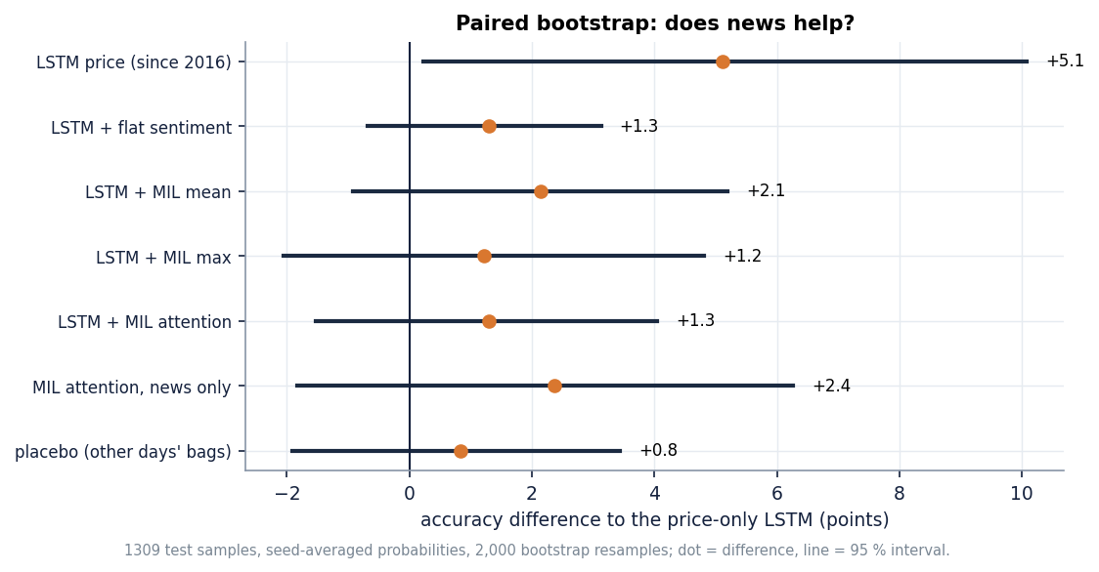
Figure 42: Offline MIL study: accuracy difference to the price-only LSTM with 95 % bootstrap intervals.
Table 43: Headline measurements behind the findings
Measurement | Value | Source
Persistence MAE (yesterday's close), 10-ticker mean | $6.24 | 5-seed re-run, true closes
LSTM + attention MAE / R2 on real closes | $29.37 / -3.5 | 5-seed re-run
LSTM MAE / sentiment tier MAE / FedAvg hybrid MAE | $53.71 / $37.55 / $43.70 | 5-seed re-run
Shipped direction vs true direction (LSTM + attention) | 68.3 % vs 53.0 % | 5-seed re-run
Stored 5-day forecast: mean change vs actual | -14.8 % vs -0.4 % | Forward test, 10 tickers
Stored 30-day forecast: mean change vs actual | -8.1 % vs +0.8 % | Forward test, 10 tickers
MIL study: always-up / price-only LSTM / MIL attention accuracy | 53.6 % / 48.8 % / 49.8 % | 1,309 test samples
Warm API latency, stored forecast / history / sentiment (median) | 11 ms / 139 ms / 4.6 s | measure_api.py
Automated checks | 56 pytest + 26 smoke, all passing | docs/metrics

9.4 Lessons learned
• Add the naive baseline first. Every deep tier looks reasonable on a chart because a price series is smooth; only the comparison with 'tomorrow equals today' shows that none of them forecasts anything useful at the level of dollars.
• Check what the evaluation function does to the data. One np.clip in the scaler step changed both the error and the direction figures for most tickers; the same predictions score 68 % or 53 % depending on whether the target is clipped.
• An ablation needs a working channel. A sentiment input that is zero during training cannot be shown to help or hurt; the placebo made that visible.
• Test the way the product will be used. The stored forecasts look plausible on the screen until the realised closes are drawn next to them, as the Forecast screen now does.
• State what is synthetic and what is missing. The shipped sentiment is template text, the product has no MIL and no social media; the documents say so rather than let the title imply otherwise.

9.5 Practical applications
QuantPulse is a research and education tool. It is useful for teaching the pipeline from price download to forecast screen, for demonstrating how an ablation is built, and as a test bed for evaluation mistakes (clipping, empty channels, missing baselines) that the documents expose. It is not suitable for trading decisions, and every screen states that forecasts are statistical estimates, not financial advice.
A reader should take three things from the findings. First, the numbers that the application displays are not the numbers that a careful evaluation produces, and the difference is large enough to change the story. Second, the multi-source idea in the title is untested by the product and, in the offline study, unsupported at the sample size available. Third, none of this makes the engineering worthless: a clean, tested pipeline with honest diagnostics is exactly what is needed before a better model is attempted.

9.6 Known limitations
The sentiment source is synthetic in the shipped run, the product has no multiple instance learning, social-media text or precision/recall/F1, the data are short (501 rows, 97 test windows per ticker), the federation is simulated, and the multiple-instance study covers seven tickers over two years. Chapter 8 and the Scope and Limitations document list each limit with its evidence.

10. FUTURE SCOPE

10.1 Improvements to the existing system
1. Score against the real closes. Remove the clip from test targets, or fit scalers on a range that includes the test period's growth, and report persistence next to every model; this alone changes the direction figures from 68 % to about 53 %.
2. Predict returns, not levels. A target of next-day log return (or direction) is stationary, does not need level scaling and cannot be clipped away; levels follow by compounding.
3. Fill the sentiment channel for the whole history. Fetch archived headlines (the FNSPID news used in the offline study, or a paid archive) so the channel is non-zero in training, and drop the synthetic fallback from the ablation.
4. Walk-forward validation. Replace the single 80/20 split by rolling or expanding windows with many test periods, and report mean and spread, as the offline study already does for direction.
5. Refresh and retrain. Write the training date into the artefact, retrain on a schedule, and have the Forecast screen compare the stored forecast with the realised closes automatically (the screen already shows a banner and the miss columns).
6. Honest uncertainty. Use residuals from walk-forward folds to build prediction intervals, or conformal intervals, instead of a sqrt(h) band built from one-step residuals.
These six changes are small relative to the model work and each addresses a measured defect. Together they would turn the product's evaluation from a demonstration of the base paper's recipe into a test of whether that recipe has any predictive value on current data.

10.2 Additional features
• A multiple-instance model in the product. Promote scripts/mil_study.py into backend/app/: embed each day's headlines, pool them with gated attention, and show which headlines received the most weight on the Sentiment screen.
• A direction classifier with precision, recall and F1. Add a classification head and report a confusion matrix per ticker, with a probability threshold the user can move.
• A social-media source. Add a licensed or public discussion feed as a second bag per day, so that the multi-source claim is true; keep it optional behind a key.
• A baseline panel. Show persistence and drift on every forecast chart so a user can see at a glance whether a model adds anything.
• More inputs. Technical indicators (moving averages, as in the base paper), volume features, sector indices and macro-economic series.
Each feature should be added behind a flag and scored with the same five-seed, true-target, persistence-relative protocol used in this report, so that a new component is kept only if it beats the baseline by clearly more than the seed-to-seed spread. Across the five seeds the standard deviation of the true-target MAE was about $1.1 for the LSTM and $1.4 for LSTM plus attention, but $7.7 for the sentiment tier and $11.1 for the federated tier, so a difference of a few dollars between two single runs of the unstable tiers means nothing.

10.2.1 How much data the next study needs
The standard error of an accuracy figure measured on n samples near 50 % is about sqrt(0.25 / n). With the 1,309 test samples of the offline study it is 1.4 accuracy points, so a 95 % interval is about +-2.7 points wide, which is the reason the observed gaps of one to two points cannot be told from zero. To detect a real gain of one point the standard error must fall to about 0.5 points, which needs on the order of 10,000 independent test samples; that means more tickers (several hundred rather than seven) and several years of dense headlines, not just more seeds, because seeds repeat the same test days.

10.3 Scalability and deployment
The API is stateless apart from its JSON files, so it scales horizontally behind a reverse proxy once a database or object store replaces the files. Stored forecasts already answer in about 11 ms; the two slow routes are the history download (139 ms median, it calls Yahoo Finance on every request) and the sentiment route (about 4.6 s median, FinBERT inference). Both should move to a scheduled job and a cache. A real deployment also needs authentication, rate limits, a database for prices, headlines and forecasts, a model registry, monitoring of forecast error against realised prices, and a container image (the Dockerfile exists but was not exercised here).
The offline MIL script is a reasonable starting point for the product version: it already builds bags with a no-look-ahead time rule, embeds headlines with FinBERT-tone, pools them with mean, max or gated attention, and reports accuracy, precision, recall and F1 with paired bootstrap intervals. What it lacks is a serving path (embedding a day's headlines on request), an instance-relevance filter and a store for the headline archive.

10.4 Further research
• Real federated learning. Run clients in separate processes or machines, normalise scales across clients, and measure communication cost, drop-out and what federation does to accuracy, since the simulated version made the forecasts worse.
• Longer news history and more tickers. The offline study covers seven tickers in 2022-2023; repeating it with a denser archive and many more tickers would give the statistical power that 1,309 test samples lack.
• Better MIL formulations. Instance-level relevance to the ticker (many headlines mention several companies), transformer instance encoders, and bag-level losses that cope with empty bags.
• Explanation and trust. Attention weights over headlines, calibration of direction probabilities and a comparison with a purely statistical benchmark for every claim.
• Market microstructure and regime effects. Test whether any news effect appears at an intraday horizon, where daily stamps and close-to-close labels hide it; the base paper itself lists larger-scale sentiment datasets and real-world federation as future work [1].

10.5 A suggested order of work
Table 44: Roadmap
Step | Change | Why first | Effort
1 | Persistence baseline and true-target scoring in backend/train.py and the Models screen | Removes the main overstatement; a few lines of code | Small
2 | Train on returns or direction; walk-forward folds | Makes the evaluation honest and the target stationary | Medium
3 | Archived headlines for the full history; drop the synthetic fallback from the ablation | Gives the sentiment tier a chance to learn | Medium
4 | Promote the MIL model into the backend with a classifier head and a P/R/F1 panel | Meets objectives 3 and 5 inside the product | Medium
5 | Social-media feed as a second bag | Meets the multi-source claim | Medium to large
6 | Scheduled retraining, forecast-vs-actual tracking, database, authentication | Production readiness | Large
7 | Real federated clients | Tests whether federation helps at all | Large

Steps 1 to 3 are cheap and decide whether the later steps are worth taking: if returns remain unpredictable once the evaluation is honest, the MIL and federation work should be judged as research questions, not as product features.
A final research question concerns the evaluation itself. A daily direction label is noisy: a one-cent move counts as 'up'. Labels that ignore moves smaller than a cost-aware threshold, or that use the sign of an excess return over a market index, would remove most of the coin-flip component and make any real signal easier to detect. The offline study's pooled up-day share of 53.6 % shows how close to a coin flip the plain label is.
None of these steps should be taken without first adding the persistence baseline and true-target scoring; both are cheap and would have prevented the main overstatements found here.

REFERENCES
[1] Y. Nejatbakhsh and M. Aliasgari, "Enhancing stock market prediction with hybrid deep learning: Integrating LSTM, transformer attention, federated learning, and sentiment analysis," IEEE Access, vol. 14, pp. 3926-3942, 2026, doi: 10.1109/ACCESS.2025.3649668.
[2] "A hybrid artificial intelligence model for stock market prediction using financial news, social media sentiment, and corporate performance indicators," Revista Electronica de Veterinaria, vol. 25, no. 1, 2024 (as listed in the batch literature survey; authors not available in Crossref).
[3] G. Officioso, G. Sperli and A. Vignali, "Financial news sentiment meets market data: A large language model-based approach to stock price prediction," Inf. Sci., vol. 754, Art. no. 123711, Oct. 2026, doi: 10.1016/j.ins.2026.123711.
[4] H. Chang, "Multimodal stock price prediction in the Chinese market via financial sentiment analysis and feature fusion," in Proc. 3rd Int. Conf. Data Anal. Mach. Learn., SCITEPRESS, 2025, pp. 211-216, doi: 10.5220/0014761600004818.
[5] P. Xiao, "Stock market prediction based on financial news, text data mining, and investor sentiment analysis," Int. J. Inf. Syst. Model. Des., vol. 15, no. 1, pp. 1-13, 2024, doi: 10.4018/ijismd.361593.
[6] X. Zhang, S. Qu, J. Huang, B. Fang and P. Yu, "Stock market prediction via multi-source multiple instance learning," IEEE Access, vol. 6, pp. 50720-50728, 2018, doi: 10.1109/ACCESS.2018.2869735.
[7] P.-J. Liao, H.-S. Lee, Y.-F. Cheng, L.-W. Chen, H.-y. Lee and H.-M. Wang, "Generalized stock price prediction for multiple stocks combined with news fusion," arXiv:2603.19286, Mar. 2026.
[8] Y. Deng and S. M. Yiu, "Deep multiple instance learning for forecasting stock trends using financial news," in Artificial Intelligence Trends, AIRCC, 2022, pp. 95-111, doi: 10.5121/csit.2022.121008 (arXiv:2206.14452).
[9] T. G. Dietterich, R. H. Lathrop and T. Lozano-Perez, "Solving the multiple instance problem with axis-parallel rectangles," Artif. Intell., vol. 89, no. 1-2, pp. 31-71, Jan. 1997, doi: 10.1016/S0004-3702(96)00034-3.
[10] M. Ilse, J. M. Tomczak and M. Welling, "Attention-based deep multiple instance learning," in Proc. 35th Int. Conf. Mach. Learn. (ICML), PMLR, vol. 80, 2018, pp. 2127-2136, arXiv:1802.04712.
[11] Z. Dong, X. Fan and Z. Peng, "FNSPID: A comprehensive financial news dataset in time series," in Proc. 30th ACM SIGKDD Conf. Knowl. Discovery Data Mining (KDD), Barcelona, Spain, Aug. 2024, pp. 4918-4927, doi: 10.1145/3637528.3671629.
[12] S. Hochreiter and J. Schmidhuber, "Long short-term memory," Neural Comput., vol. 9, no. 8, pp. 1735-1780, Nov. 1997, doi: 10.1162/neco.1997.9.8.1735.
[13] A. Vaswani et al., "Attention is all you need," in Adv. Neural Inf. Process. Syst. (NeurIPS), vol. 30, 2017, pp. 5998-6008, arXiv:1706.03762.
[14] H. B. McMahan, E. Moore, D. Ramage, S. Hampson and B. A. y Arcas, "Communication-efficient learning of deep networks from decentralized data," in Proc. 20th Int. Conf. Artif. Intell. Statist. (AISTATS), PMLR, vol. 54, 2017, pp. 1273-1282, arXiv:1602.05629.
[15] Q. Yang, Y. Liu, T. Chen and Y. Tong, "Federated machine learning: Concept and applications," ACM Trans. Intell. Syst. Technol., vol. 10, no. 2, pp. 1-19, Jan. 2019, doi: 10.1145/3298981.
[16] Y. Yang, M. C. S. Uy and A. Huang, "FinBERT: A pretrained language model for financial communications," arXiv:2006.08097, Jun. 2020.
[17] D. Araci, "FinBERT: Financial sentiment analysis with pre-trained language models," arXiv:1908.10063, Aug. 2019.
[18] T. Fischer and C. Krauss, "Deep learning with long short-term memory networks for financial market predictions," Eur. J. Oper. Res., vol. 270, no. 2, pp. 654-669, Oct. 2018, doi: 10.1016/j.ejor.2017.11.054.
[19] O. B. Sezer, M. U. Gudelek and A. M. Ozbayoglu, "Financial time series forecasting with deep learning: A systematic literature review: 2005-2019," Appl. Soft Comput., vol. 90, Art. no. 106181, May 2020, doi: 10.1016/j.asoc.2020.106181.
[20] B. Lim and S. Zohren, "Time-series forecasting with deep learning: A survey," Phil. Trans. R. Soc. A, vol. 379, no. 2194, Art. no. 20200209, Feb. 2021, doi: 10.1098/rsta.2020.0209.
[21] P. C. Tetlock, "Giving content to investor sentiment: The role of media in the stock market," J. Finance, vol. 62, no. 3, pp. 1139-1168, Jun. 2007, doi: 10.1111/j.1540-6261.2007.01232.x.
[22] J. Bollen, H. Mao and X. Zeng, "Twitter mood predicts the stock market," J. Comput. Sci., vol. 2, no. 1, pp. 1-8, Mar. 2011, doi: 10.1016/j.jocs.2010.12.007.
[23] E. F. Fama, "Efficient capital markets: A review of theory and empirical work," J. Finance, vol. 25, no. 2, pp. 383-417, May 1970, doi: 10.2307/2325486.
[24] S. J. Taylor and B. Letham, "Forecasting at scale," Amer. Statistician, vol. 72, no. 1, pp. 37-45, 2018, doi: 10.1080/00031305.2017.1380080.
[25] L. Breiman, "Random forests," Mach. Learn., vol. 45, no. 1, pp. 5-32, Oct. 2001, doi: 10.1023/A:1010933404324.
[26] A. J. Smola and B. Scholkopf, "A tutorial on support vector regression," Statist. Comput., vol. 14, no. 3, pp. 199-222, Aug. 2004, doi: 10.1023/B:STCO.0000035301.49549.88.
[27] G. E. P. Box, G. M. Jenkins, G. C. Reinsel and G. M. Ljung, Time Series Analysis: Forecasting and Control, 5th ed. Hoboken, NJ, USA: Wiley, 2015.
[28] D. P. Kingma and J. Ba, "Adam: A method for stochastic optimization," arXiv:1412.6980, Dec. 2014.
[29] I. Loshchilov and F. Hutter, "Decoupled weight decay regularization," arXiv:1711.05101, Nov. 2017.
[30] M. Abadi et al., "TensorFlow: Large-scale machine learning on heterogeneous distributed systems," arXiv:1603.04467, Mar. 2016.
[31] A. Paszke et al., "PyTorch: An imperative style, high-performance deep learning library," arXiv:1912.01703, Dec. 2019.
[32] F. Pedregosa et al., "Scikit-learn: Machine learning in Python," J. Mach. Learn. Res., vol. 12, pp. 2825-2830, 2011.
[33] Yahoo Finance, "Historical market data," accessed through the yfinance Python package, Oct. 2026. [Online]. Available: https://finance.yahoo.com/
[34] NewsAPI, "News API: JSON API for live news and blog articles." [Online]. Available: https://newsapi.org/
[35] Y. Yang, "finbert-tone: FinBERT fine-tuned for financial tone (positive / neutral / negative)," Hugging Face model card yiyanghkust/finbert-tone. [Online]. Available: https://huggingface.co/yiyanghkust/finbert-tone

APPENDIX A: IMPORTANT CODE
The key functions are copied from 8.ProjectCode in the state in which the results were measured (whole statements; the full files are in the repository). The product code is under backend/app/; the last two excerpts are from the experiment scripts added for the evaluation and are not part of the application.

A.1 Windows and scalers (`models_dl.py`)
def make_windows(values: np.ndarray, window: int = 20):
X, y, idx = [], [], []
for i in range(window, len(values)):
X.append(values[i - window:i]); y.append(values[i, 3]) # Close is col 3 of OHLCV
idx.append(i)
return np.array(X, dtype=np.float32), np.array(y, dtype=np.float32), np.array(idx)

def scale_split(X, y, idx, n: int):
k = int(len(X) * config.TRAIN_SPLIT)
return (X[:k], y[:k], idx[:k]), (X[k:], y[k:], idx[k:])

def fit_scalers(train_raw: np.ndarray):
scalers = [MinMaxScaler().fit(train_raw[:, j:j + 1]) for j in range(train_raw.shape[1])]
return scalers

def apply_scalers(raw: np.ndarray, scalers) -> np.ndarray:
out = np.zeros_like(raw, float)
for j, sc in enumerate(scalers):
out[:, j] = sc.transform(raw[:, j:j + 1]).ravel()
return np.clip(out, 0, 1)

A.2 Attention tier and training (`models_dl.py`)
def build_attention_lstm(input_shape) -> "keras.Model":
from tensorflow import keras
inp = keras.layers.Input(shape=input_shape)
x = keras.layers.LSTM(config.LSTM_UNITS, return_sequences=True)(inp)
attn = keras.layers.MultiHeadAttention(num_heads=config.ATTENTION_HEADS, key_dim=16)(x, x)
x = keras.layers.Add()([x, attn])
x = keras.layers.LayerNormalization()(x)
x = keras.layers.GlobalAveragePooling1D()(x)
x = keras.layers.Dense(32, activation="relu")(x)
x = keras.layers.Dropout(0.2)(x)
out = keras.layers.Dense(1)(x)
m = keras.Model(inp, out)
m.compile(optimizer=keras.optimizers.Adam(1e-3), loss="mse")
return m

def train_model(model, Xtr, ytr, validation_split=0.15, epochs=None, verbose=0):
from tensorflow import keras
cb = [keras.callbacks.EarlyStopping(monitor="val_loss", patience=7, restore_best_weights=True)]
h = model.fit(Xtr, ytr, batch_size=config.BATCH_SIZE, epochs=epochs or config.EPOCHS,
validation_split=validation_split, callbacks=cb, verbose=verbose)
return h

A.3 Federated averaging (`federated.py`)
def fedavg(weight_list: list[list[np.ndarray]], counts: list[int]) -> list[np.ndarray]:
total = float(sum(counts))
agg = []
for layers in zip(*weight_list):
agg.append(sum(w * (c / total) for w, c in zip(layers, counts)))
return agg

A.4 Recursive forecast with confidence band (`forecast.py`)
def recursive_forecast(model, last_window: np.ndarray, steps: int, residual_std: float, close_scaler) -> list[dict]:
win = last_window.copy()
scaled_preds = []
for _ in range(steps):
p = float(model.predict(win[np.newaxis], verbose=0).ravel()[0])
scaled_preds.append(p)
nxt = win[-1].copy()
nxt[3] = p # roll Close forward; keep other features coherent
# shift other price cols toward predicted close to stay coherent
nxt[0] = nxt[1] = nxt[2] = p
win = np.concatenate([win[1:], nxt[np.newaxis]], axis=0)
preds = close_scaler.inverse_transform(np.array(scaled_preds).reshape(-1, 1)).ravel()
band = 1.96 * residual_std * np.sqrt(np.arange(1, steps + 1))
return [{"day": i + 1, "predicted_close": round(float(p), 2),
"lower": round(float(max(p - b, 0.01)), 2),
"upper": round(float(p + b), 2)} for i, (p, b) in enumerate(zip(preds, band))]

A.5 Aligning sentiment to trading dates (`sentiment.py`)
daily.index = pd.to_datetime(daily.index)
aligned = pd.Series(index=pd.to_datetime(trading_dates), dtype=float)
for d in aligned.index:
day = d.normalize()
if day in daily.index:
aligned[d] = float(daily[day])
else:
aligned[d] = np.nan
aligned = aligned.ffill().fillna(0.0).clip(-1, 1)
return aligned, meta

A.6 Scoring against the real closes (`scripts/run_experiments.py`)
def _true_metrics(close, idte, yp_scaled, close_scaler, yte_scaled):
"""Errors against the real closes. ``evaluate_dl`` scores against the *clipped* scaled targets, which are flat at the training maximum when the test prices rise above it."""
yp = close_scaler.inverse_transform(np.asarray(yp_scaled).reshape(-1, 1)).ravel()
yt, prev = close[idte], close[idte - 1]
err = yp - yt
return {"mae_true": float(np.abs(err).mean()), "rmse_true": float(np.sqrt((err ** 2).mean())),
"r2_true": float(1 - (err ** 2).sum() / ((yt - yt.mean()) ** 2).sum()), "bias_true": float(err.mean()),
"da_true": float(((yt - prev > 0) == (yp - prev > 0)).mean()),
"target_clipped_pct": float((np.asarray(yte_scaled) >= 0.999).mean() * 100)}

A.7 Gated-attention pooling of a bag of headlines (`scripts/mil_study.py`)
e = self.enc(raw)
if self.mode == "mean":
bag = (e * mask.unsqueeze(-1)).sum(1) / cnt.clamp(min=1)
elif self.mode == "max":
bag = e.masked_fill(~mask.unsqueeze(-1), -1e4).max(1).values
bag = torch.where(cnt > 0, bag, torch.zeros_like(bag))
else:
a = self.aw(torch.tanh(self.av(e)) * torch.sigmoid(self.au(e))).squeeze(-1)
a = a.masked_fill(~mask, -1e4)
att = torch.softmax(a, 1) * mask
bag = (att.unsqueeze(-1) * e).sum(1)
bag = torch.where(cnt > 0, bag, self.empty.expand_as(bag))
parts.append(bag)

APPENDIX B: INSTALLATION AND USER GUIDE

B.1 Requirements
Windows 10 or 11 (the launcher is a batch file; the code is portable), Python 3.11 on PATH, Node.js 20 or newer for live reload (optional: the API serves the prebuilt site), about 3 GB of disk for TensorFlow, PyTorch and the FinBERT-tone weights, internet for the first install and for live prices, and optionally a NewsAPI key in .env or Docker Desktop.

B.2 One-click start
1. Open the folder that contains run.bat; copy .env.example to .env if there is no .env.
2. Double-click run.bat: it creates .venv, installs the dependencies once, trains the models only if artifacts/metrics.json is missing (five to ten minutes) and starts the API on port 8404 and the website on port 5404.
3. The browser opens http://localhost:5404; the top-bar pill should read "API online, models ready". To stop, close the two windows.

B.3 Manual start
py -3.11 -m venv .venv
.venv\Scripts\Activate.ps1
python -m pip install -r backend\requirements.txt
python -m backend.train # first time, or to retrain
python -m uvicorn backend.app.main:app --host 127.0.0.1 --port 8404

# second terminal, live reload
cd frontend; npm install; npm run dev # http://localhost:5404

B.4 Using the screens
Table 45: Screens and how to use them
Screen | What to do | What to look for
Dashboard | Click a ticker card or sort the table | Last close, trend flag, 5-day outlook, data-mode badge
Forecast | Choose ticker, 5- or 30-day horizon, 60 to 250 days of history | Actual line, dashed forecast and band; actual close and forecast miss once a date has passed; stale-model banner
Model comparison | Pick a ticker; switch between the two tabs | Best model per metric, ablation, nine-model MAE chart, loss curves, federated rounds
News sentiment | Pick a ticker; search and filter headlines | News source badge (built-in fallback unless a key is set), daily chart; the first visit can take a minute while FinBERT loads
Method and data | Read the pipeline and data table | Price mode, rows and headlines per ticker

The theme button switches between light and dark; Refresh reloads the current screen. Forecasts are statistical estimates for research and education, not financial advice.

B.5 Checking, retraining and experiments
python scripts\smoke_test.py # 26 checks against the running API and website
pytest tests # 56 unit and API tests (project venv)
python scripts\capture_screens.py # refreshes docs\screenshots\*.png
python -m backend.train # rewrites artifacts/ (forecast origin moves to the latest price)
set PYTHONHASHSEED=0 & python scripts\run_experiments.py # re-run, forward test (after fetch_snapshot.py)
python scripts\extract_news.py ; python scripts\mil_features.py ; python scripts\mil_study.py

B.6 Troubleshooting
Table 46: Common problems
Symptom | Fix
API offline in the top bar, or port in use | Run run.bat again and read the API window; change BACKEND_PORT / FRONTEND_PORT in .env if a port is taken
Screens say the models are not trained (HTTP 503) | Run python -m backend.train with the virtual environment active
Forecast banner: trained on older prices | Expected; retrain to forecast from the latest close
Sentiment shows Built-in fallback | No NEWSAPI_KEY; add one to .env and restart
import tensorflow fails after scikit-learn | Import TensorFlow first (tests and scripts do)

APPENDIX C: ADDITIONAL SCREENS
The screens below complete the set of captures that are not shown in Chapter 8: the dashboard and the forecast screen in the dark theme, and the method and data screen. All were captured from the running application at 1440 by 900 pixels, with the shipped artefacts and live Yahoo Finance prices on them.
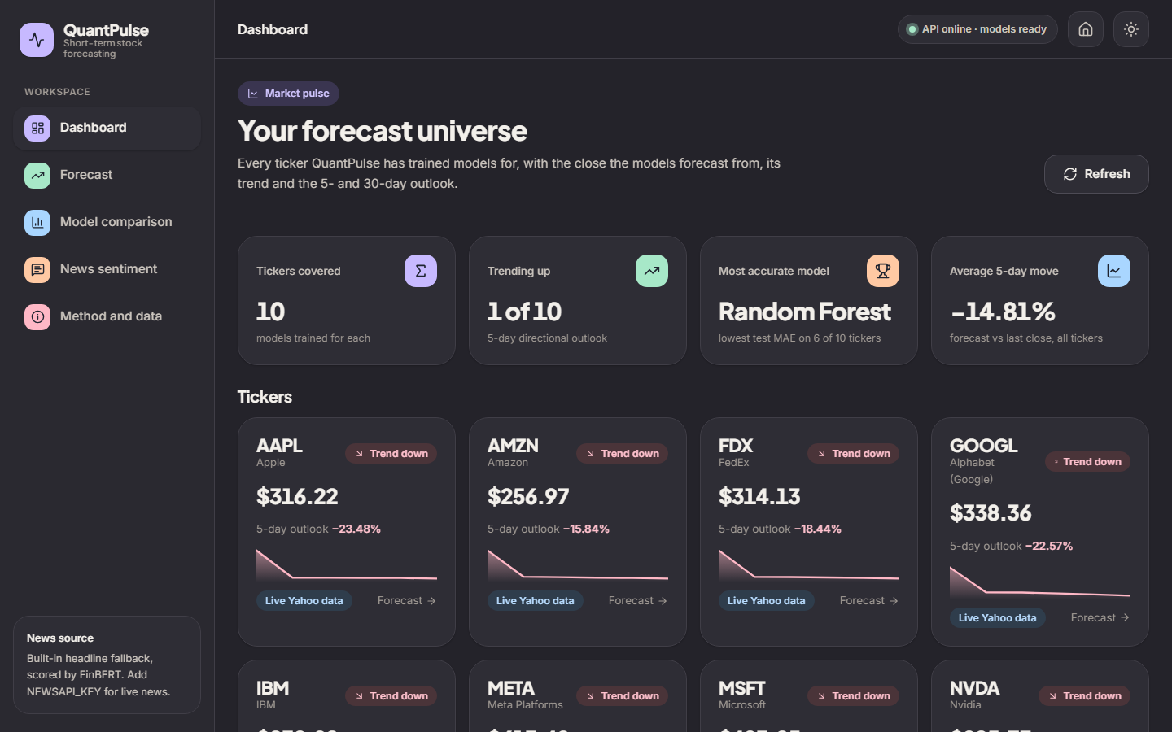  Figure 43: Additional screen: dashboard, dark theme. | 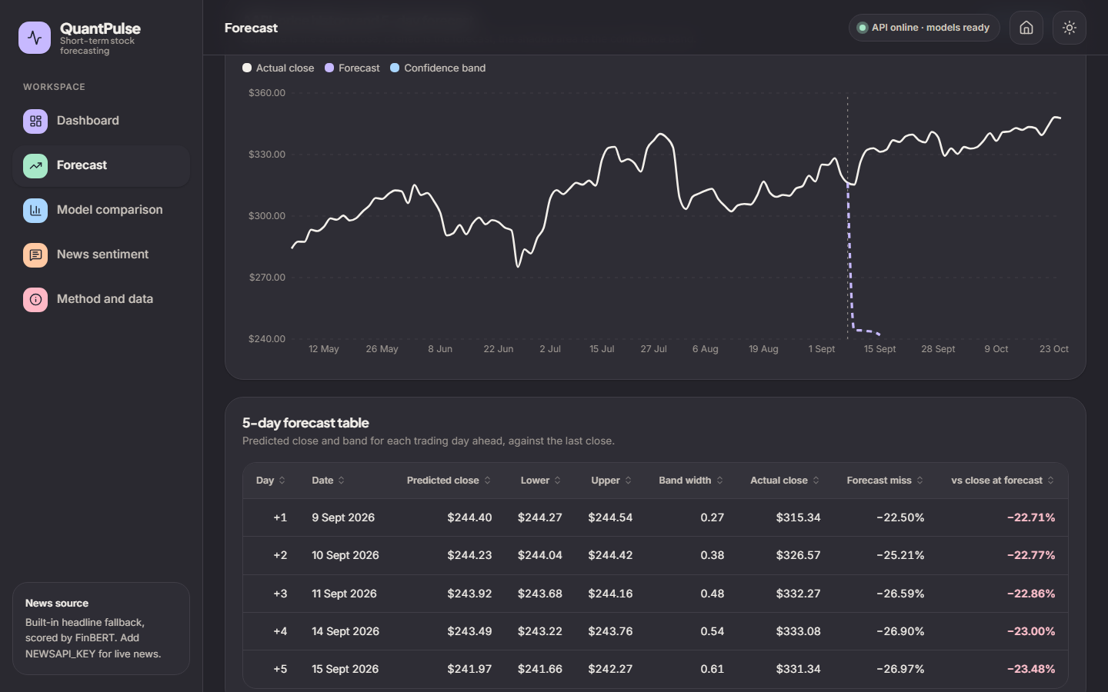  Figure 44: Additional screen: AAPL forecast, dark theme.

Both themes use the same tokens and charts; the choice is stored in the browser. The dark dashboard shows the same four summary cards and ten ticker cards as the light one, and the dark forecast screen the same chart, band and table. In the AAPL capture the dashed forecast starts from the training close of 8 September 2026 and falls well below the actual closes that followed, which is the behaviour measured in Chapter 8.
Figure 45: Additional screen: Method and data, with the modelling pipeline timeline, the live installation facts and the research-and-education notice (the per-ticker data table is below the fold).
The method and data screen reads /api/health and /api/metrics. The panel on the right reports, live from the API, that the models are trained, that there are ten tickers, that the news source is the built-in fallback scored by FinBERT, and the 20-day window and the 5- and 30-day horizons; the table further down the page lists, for each ticker, the price mode, the number of rows and the number of headlines scored, so a reader can verify that all ten price series are live and all ten sentiment sources are the fallback.

